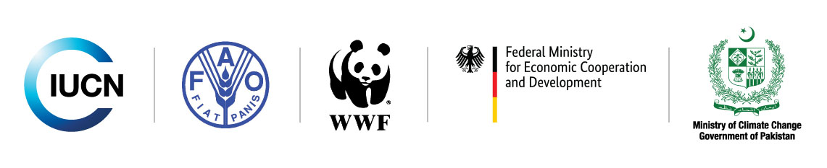
Final Draft Report
Assessment of Mangroves
in Pakistan

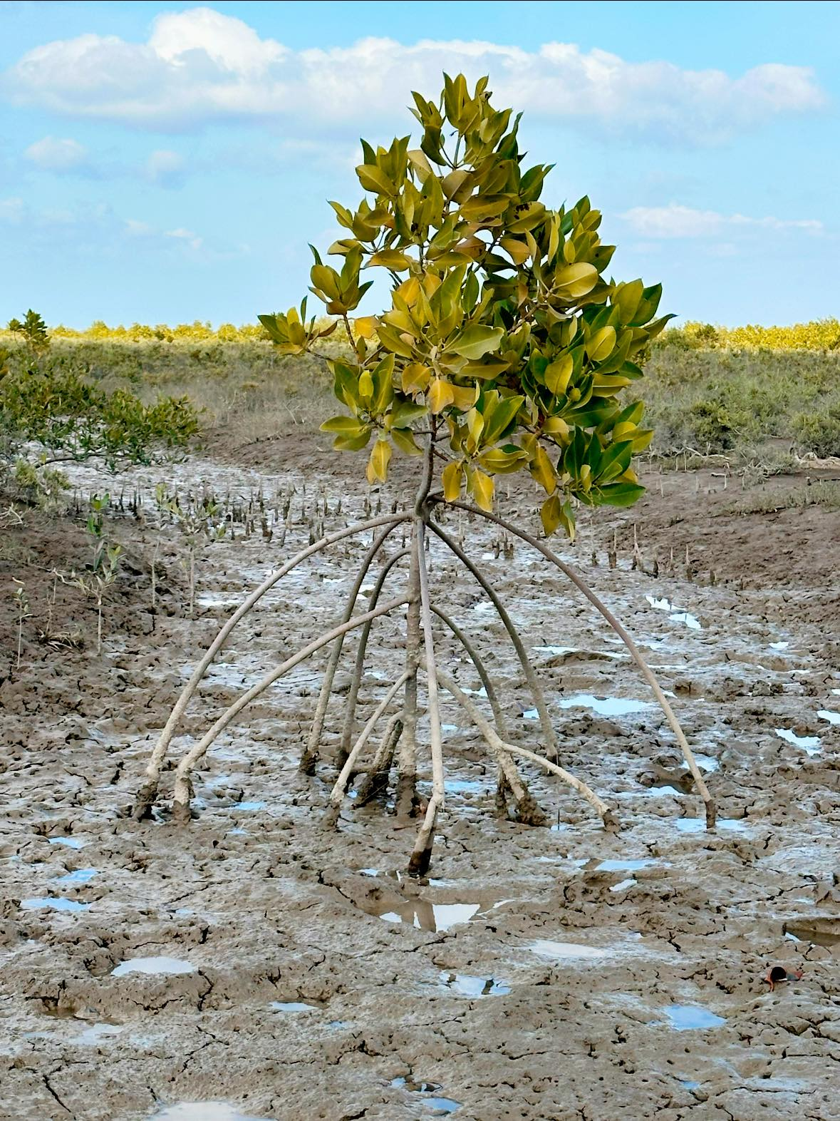

﻿

The designation of geographical entities in this publication, and the presentation of the material, do not imply the expression of any opinion whatsoever on the part of IUCN concerning the legal status of any country, territory, or area, or of its authorities, or concerning the delimitation of its frontiers or boundaries.

﻿The views expressed in this publication do not necessarily reflect those of 3rd Party M&E Consortium of TBTTP.

Produced by: 3rd Party M&E Consortium of TBTTP/Upscaling Green Pakistan Programme (IUCN/WWF/FAO)

Copyright
© 2024 IUCN, International Union for Conservation of Nature and Natural Resources

Reproduction of this publication for educational or other non-commercial purposes is authorised without prior written permission from the copyright holder provided the source is fully acknowledged. Reproduction of this publication for resale or other commercial purposes is prohibited without prior written permission of the copyright holder.

Citation: Macintosh, D. J. (2024). Assessment of Mangroves in Pakistan. 3rd Party M&E Consortium of IUCN/WWF/FAO, TBTTP/Upscaling Green Pakistan Programme. Islamabad. ix + 121 pp. Pakistan.

Cover Photograph
IUCN Pakistan

Coordination:
Asim Jamal

Acronyms and Abbreviations
ADB | Asian Development Bank
AF | Adaptation Fund
AIT | Asian Institute of Technology, Bangkok
BCDA | Balochistan Coastal Development Authority
BFWD | Balochistan Forest and Wildlife Department
BOD | Biological Oxygen Demand
CARD | Coastal Association for Research and Development
CBO | Community-Based Organization
CDM | Clean Development Mechanism
COD | Chemical Oxygen Demand
COP-21 | Conference of the Parties 2021 (in Paris France)
CRAB | The Conservation Restoration Alliance for Biodiversity
DBC-1 | Delta Blue Carbon project phase one
DHA | Defence Housing Authority
ECC&CDD | Sindh Environment, Climate Change and Coastal Development Department
EEZ | Pakistan’s Exclusive Economic Zone
EN | Endangered Species according to the IUCN Red List of Threatened Species
ETS | Emissions Trading Systems
F&CDD | Balochistan Fisheries and Coastal Development Department
FAO | The Food and Agricultural Organization of the United Nations
FDB | Fisheries Development Board
GCF | Green Climate Fund
GDA | Gwadar Development Authority
GEF | Global Environment Facility
GHG | Green House Gas
IDC | Indus Delta Capital
IET | Indus Earth Trust
IUCN | International Union for Conservation of Nature
JCM | Joint Crediting Mechanism
KPT | Karachi Port Trust
LUAWMS | Labella University of Agriculture, Water and Marine Sciences
MAF | million acre-feet
MFF | Mangroves for the Future initiative
MGD | Million gallons per day
MoCC | Ministry of Climate Change, Government of Pakistan
MoMA | Ministry of Maritime Affairs, Government of Pakistan
MPA | Marine Protected Area
MSA | Mangrove Stewardship Agreements
NCB | National Coordinating Body for the Mangroves for the Future initiative
NCMPR | National Centre for Maritime Policy Research of the MFF
NGO | Non-Governmental Organization
NIMA | National Institute of Maritime Affairs
NIO | National Institute of Oceanography
NT | Near Threatened Species according to the IUCN Red List of Threatened Species
PDMAs | Provincial Disaster Management Authorities
PKR | Pakistan Rupee (USD 1 ~PKR 278)
PPAF | Pakistan Poverty Alleviation Fund
PPT | Parts per Thousand
PQA | Port Muhammad Bin Qasim Authority
PRA | Participatory Rural Appraisal
REDD+ | Reducing Emissions from Deforestation and Forest Degradation
SBR | Sindh Board of Revenue
SCDA | Sindh Coastal Development Authority
SDGs | Sustainable Development Goals
SEPA | Sindh Environment Protection Agency
SEPT | Sindh Environment Protection Tribunal
SEQS | Sindh Province Environmental Quality Standards
SFD | Sindh Forest Department
SGF | Small Grants Facility of the MFF initiative
SHEHRI | Shehri-Citizens for a Better Environment
SLR | Sea-level rise
SUPARCO | Space and Upper Atmosphere Research Commission
TBTTP/UGP | Ten Billion Tree Tsunami Programme/Upscaling Green Pakistan Programme
TEV | Total Economic Value
TSS | Total suspended solids
UNESCO | United Nations Educational, Scientific and Cultural Organization
UNFCCC | United Nations Framework Convention on Climate Change
USD | US Dollar
VCM | Voluntary Carbon Market
VU | Vulnerable Species according to the IUCN Red List of Threatened Species
WWF | World Wildlife Foundation
ZPL | Zephyr Power Limited

Acknowledgements
In addition to information gathered from the extensive literature on mangrove forest ecosystems in Pakistan, this report includes findings from field visits to Miani Hor in Balochistan Province and the Sandspit, Phitti Creek, Gharo and Keti Bundar areas of Sindh Province. I am grateful to the many people who were involved in organising these visits and to the local people we met who provided valuable information and insight into the mangrove social-ecological systems that they depend on.
I would like to thank particularly Dr. Babar Hussain (IUCN Pakistan) who facilitated our visit to mangrove plantation sites in Miani Hor and arranged consultations with the local fishers and women’s groups. Also Mr. Kumayl Khaleeli (CEO, Zephyr Power Limited), who kindly made it possible for us to visit the ZPL mangrove plantation sites.
A large number of mangrove institutional stakeholders also contributed to this assessment as participants at consultation workshops held in Karachi and Quetta. And Additional information was provided during several meetings with the Forest Departments of Balochistan and Sindh, and with members of the 3rd Party M&E Consortium of TBTTP/Upscaling Green Pakistan Programme (IUCN/WWF/FAO).
I would particularly like to thank Mr. Riaz Wagan, Chief Conservator of Forests, Sindh and Mr. Syed Ghulam Mohammad, Chief Conservator of Forests, South Balochistan, for their strong personal involvement, valuable advice, and support in freely providing documents, photographs, data and other information.
Among the many other Forest and Wildlife Department staff who assisted me, special thanks are due to Mr. Hyder Raza Khan (CF/Project Director, TBTTP/UGPP Sindh), Mr. Arif Ali Khokhar (CF) and Mr. Shehzad Sadiq Gill (DFO Coastal Forest Karachi) in SFD; and to Mr. Syed Ali Imran (CF/PD-TBTTP/UGPP Balochistan), Mr. Umer Farooq (CF M&E TBTTP/UGPP Balochistan) and Hafiz Muhammad Jan, Conservator Coastal Area in BFWD.
I am also grateful to the Vice-Chancellor, Prof. Dost Muhammad Baloch and faculty members of Labela University of Agriculture, Water & Marine Sciences, and to Dr. Waqar Ahmed of Karachi University, for additional information and assistance.
Mr. Asim Jamal, Project Manager of the 3rd Party M&E Consortium of TBTTP/Upscaling Green Pakistan Programme, provided management support throughout this long assignment, from inception to completion. He also arranged the mangrove stakeholders’ consultation meetings in Karachi and Quetta, facilitated the remote sensing/GIS support, and accompanied me to Miani Hor and Labela University.
I would also like to thank the national consultants, Mr. Rafiul Haq and Mr. Abdul Rahim, for their invaluable help and the sharing of their great knowledge on mangroves in Pakistan. Also Mr. Doost Ali Nawaz (BFWD-TBTTP/UGPP), who stepped in to provide much-needed expertise on satellite remote sensing and GIS analysis.

Special thanks go to Dr. Javed Ahmed, Chief Technical Advisor, 3rd party M&E Consortium of TBTTP/UGPP for providing technical support to shape the study outline and ToRs, and for his encouragement during the assessment.
I would also like to thank Mr. Thomas Nielsen of Aalborg University in Denmark, who assisted with the report’s initial formatting, and Mr. Azhar Saeed of the IUCN Communications Unit who designed and formatted the final document.
Finally, I am most grateful to Mr. Mahmood Akhtar Cheema (Country Representative, IUCN Pakistan) and the many IUCN Pakistan staff in both the IUCN Islamabad and Karachi offices who provided invaluable coordination and organisational assistance throughout this assignment.

Table of Contents
Acronyms and Abbreviations ii
Acknowledgements iv
Table of Contents vi
1. The Coastal Environment of Pakistan 1
1.1 Physical Features 1
1.2 Definition of mangroves 1
2. The Early History of Mangroves in Pakistan 7
2.1 Introduction 7
2.2 The Historical Record 7
2.3 Mangrove Degradation and Deforestation 7
2.3.1 1850-1947 7
2.3.2 1948-1990 8
2.3.3 1991-2000 9
3. Pakistan’s Legal and Policy Framework for Mangroves 12
3.1 Impact of Early Land Policies 12
3.2 The Forest Act 1927 13
3.3 Rules Pertaining to Protected Forests 13
3.4 Mangrove Forest Policy 1955-2005 14
3.4.1 First Mangrove Forest Working Plan 1963-64 to 1983-84 14
3.4.2 Second Mangrove Forest Management Plan 1985-2005 14
3.5 Mangrove Forest Management Policy since 2005 15
4. Current Status of Mangrove Ecosystems: Sindh 16
4.1 Introduction 16
4.2 Mangrove Legal Status and Area Change 16
4.3 Sandspit Wetlands 20
4.3.1 Site Description 20
4.3.2 International and Local Importance 21
4.4 Northwest Indus Delta 21
4.4.1 Site description 21
4.4.2 Mangrove Forest Assessment 21
4.4.3 Mangrove-Associated Fisheries 23
4.5 Gharo Mangroves 23
4.5.1 Site Description 23
4.5.2 Mangrove Forest Assessment 23
4.6 Keti Bundar Mangroves 25
4.6.1 Site Description 25
4.6.2 Mangrove Forest Assessment 26
4.7 Eastern Indus Delta 28
5. Current Status of Mangrove Ecosystems: Balochistan 29
5.1 Introduction 29
5.2 Mangrove Legal Status and Area Change 29
5.3 Miani Hor 29
5.3.1 Introduction 29
5.3.2 Site Description 30
5.3.3 Mangrove Biodiversity, Distribution and Exploitation 31
5.3.4 Mangrove Management in Miani Hor 31
5.3.4 Mangrove Forest and Plantation Assessment 32
5.3.5 Miani Hor Fisheries 34
5.4 Kalmat Khor 35
5.5 Jiwani Coastal Wetlands (Gwatar Bay) 36
5.6 Shabi Khor-Ankra Creek and Shabi and Sawar khors 37
6. Current Threats to Mangroves in Pakistan 39
6.1 Introduction 39
6.2 Wood and Fodder Exploitation 39
6.2.1 Domestic Wood and Fodder Use 39
6.2.1 Illegal Commercial Logging of Mangroves 41
6.3 Freshwater Deficiency 43
6.4 Reduced or Excessive Sediment Supply 44
6.5 Coastal Pollution 44
6.5.1 Status of Coastal Pollution in Pakistan 44
6.5.2 Types of Coastal Pollution and their effect on Mangroves 45
6.6 Climate Change 47
6.6.1 Sea-level rise 47
6.6.2 Storms and Flooding 48
6.6.3 Coastal Erosion 48
6.7 Encroachment and Land Conversion 50
7. Biodiversity of Pakistan’s Mangrove Ecosystems 51
7.1 Introduction 51
7.2 True Mangrove Species in Pakistan Past and Present 51
7.2.1 Mangrove Species Assessment 53
7.2.2 Species Selection for Reintroduction 55
7.3 Mangrove-Associated Macrofauna 56
8. Stakeholder Analysis and Mapping 59
8.1 Institutional Stakeholders 59
8.1.1 Federal Authorities and other National Bodies 59
8.1.2 Provincial Authorities and other Organisations located in Balochistan 60
8.1.3 Provincial Authorities and other Organisations located in Sindh 61
8.1.4 Civil Society Organisations 63
8.1.5 Academic Institutions 64
8.1.6 Donor Organisations 65
8.2 Coastal Community Stakeholders 66
8.2.1 Introduction 66
8.2.2 Indus Delta 66
8.2.3 Miani Hor 68
8.3 Stakeholder Mapping 69
9. Mangrove Resources Use and Sustainable Livelihoods 71
9.1 Introduction 71
9.2 Coastal Aquaculture 71
9.3 Mud Crab Rearing 72
9.3 Mangrove-based Ecotourism 73
9.4 Small Grant Projects for Environmental and Livelihood Improvement 74
10. Mangrove Carbon Sequestration and Carbon Marketing 75
10.1 Introduction 75
10.2 Mangrove Carbon Marketing 75
10.3 Mangrove Carbon and Climate Change Projects 76
11. Capacity Development Needs 78
11.1 Introduction 78
11.2 Decision-Makers and Resource Managers 79
11.2.1 Overview 79
11.2.2 Nature-based Solutions and Ecosystem-based Management 80
11.2.3 Economic Valuation of Mangrove Goods and Services 80
11.2.4 Indicator-based Monitoring 82
11.3 Local Authorities, NGO/CBOs, Village Leaders and Coastal Households 82
11.4 Co-management 83
11.4.1 Definition and Application of Co-management 84
12. Conclusions and Recommendations 85
12.1 Mangroves in Pakistan since 1980 85
12.2 Mangrove Rehabilitation/Afforestation and Conservation 85
12.3 Threats to Mangrove Ecosystems 87
12.4 Future Management Priorities 88
12.5 Mangrove Data Reporting and Information Management 89
12.6 Research Needs 90
12.7 Species Reintroductions 91
12.8 Capacity Development 92
13. References 93
14. Annexes 102
Annex 1: Mangrove Propagation, Planting and Plantation Records by Project since 1980. 102
Annex 2: Lessons Learned from MFF Small Grant Fund Projects 107
Annex 3: Example of Successful Community-Led Mangrove Ecotourism 109
Annex 4: Potential Indicators for Monitoring Mangrove Social-Ecological Systems 113
Annex 5: Mangrove Stewardship Agreement 115

1. The Coastal Environment of Pakistan

1.1 Physical Features
The coastline of Pakistan borders the Arabian Sea in Balochistan and Sindh provinces, extending for approximately 1,050 kms from Sir Creek, which forms Pakistan’s eastern border with India in Sindh, to the western border with Iran in Balochistan. About 778 kms of the coastline is in Balochistan Province (from Jiwani in Gwadar District to the Hub River in Labela District). The remainder, comprising of the Karachi coast (Sandspit-Hawks Bay to Pitti Creek), the lower Indus Delta and a small part of the Raan of Kutch, is in Sindh Province.
The coastline of Balochistan is mainly narrow with rocky or sandy beaches and high coastal cliffs. There are several coastal bays and lagoons where small patches of mangrove forest occur, the largest mangrove area being in Miani Hor in Lasbela District in eastern Balochistan. Pakistan’s largest island, Astola Island, and the country’s first Marine Protected Area (MPA), lies about 35 kms offshore from Pasni on Balochistan’s central mainland coast. The climate on the coast of Balochistan is semi-tropical and very arid, especially in western Balochistan, with diminished rainfall including virtually no precipitation in some years.
The coast of Sindh Province is shallow and is dominated by the wide, fan-shaped Indus Delta with 17 main creeks, plus many distributaries and islands. The Indus Delta receives freshwater from the 3,180 km long Indus River, which is the oldest known river in the Himalayan region (Clift, 2002). The creeks are reworked remnants of former river channels, but they are now tidal inlets because the downstream freshwater flows have been greatly reduced by irrigation infrastructure. Khobar Creek and Khar Creek are the main outlets for freshwater to the Arabian Sea (Inam et al., 2008; Siyal, 2018), except during flood periods. In addition to the network of creeks, the coastal fringe of the delta features sedimentary islands, mudflats, sand bars and beaches formed under tidal and wave influence.
The coast of Sindh has a tropical hot and semi-arid climate with seasonal rain from the southwest monsoon in the months of July to September. However, the average annual rainfall is highly variable; at Keti Bundar, for example, it ranged from 24 to 329 mm in the years 2009 to 2023.
Pakistan’s Exclusive Economic Zone (EEZ), measured from the shoreline to 200 nautical miles offshore, covers an area of about 240,000 km². Provincial Government jurisdiction, including jurisdiction over mangrove forests, other coastal habitats and coastal fisheries, extends out to 12 nautical miles, while the Federal Government has jurisdiction from 12 to 200 nautical miles offshore. The provincial Coastal Development Authorities in Balochistan and Sindh have jurisdiction from the high tide line to 30 kilometres inland, with the exception of Federally-controlled areas, such as the Gadani ship-breaking yard and Khobar Creek.

1.2 Definition of mangroves
Mangroves are a highly specialized but diverse group of salt-tolerant trees and shrubs inhabiting the intertidal zone of primarily tropical and subtropical coastlines. Although less common, there are also mangroves in some warm temperate areas (e.g. Florida, southern China and New Zealand) and in non-tidal settings (e.g. basin mangroves).
The term ‘true mangroves’ (Tomlinson, 1986) is used to describe plant species that show clear adaptations to cope with salt and the other challenges they face in the intertidal zone (Table 1).
True mangroves are facultative halophytes, meaning that they can tolerate saltwater, but they prefer more moderate salinity conditions. It is thought that the world’s true mangrove species adapted to saltwater in order to escape competition from terrestrial plants. The fact that there are only around 70 species of true mangroves, plus some hybrids, illustrates how difficult it has been for higher plants to adapt to intertidal habitats.
The main Family of true mangrove trees, the Rhizophoraceae, includes two of the four species present in Pakistan: Rhizophora mucronata (figure 1a) and Ceriops tagal (figure 2). Two other species in this family, Bruguiera gymnorhiza and R. apiculata, were also recorded previously in Pakistan (Stewart, 1972; Kogo 1980 in Saifullah, 1982).
Figure 1a: Rhizophora mucronata trees, Phitti Creek, Indus Delta. Q Don Macintosh

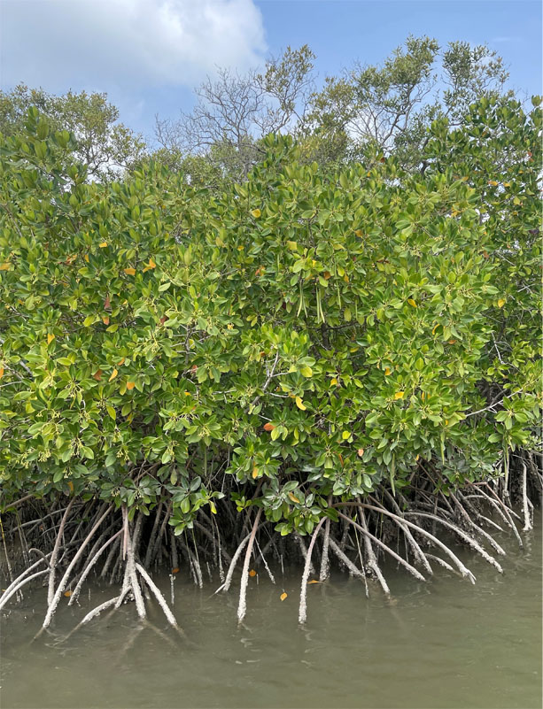
Trees in the Family Rhizophoraceae have aerial prop roots (Rhizophora species) or flanged buttress roots (Bruguiera and Ceriops species) for stability in soft, unstable coastal sediments. Bruguiera and Ceriops trees also produce short above-ground roots (pneumatophores) that have porous glands (lenticels) that enable air intake during low tides. The young prop roots of Rhizophora trees also have lenticels.
Figure 2: Ceriops tagal saplings, Keti Bundar.

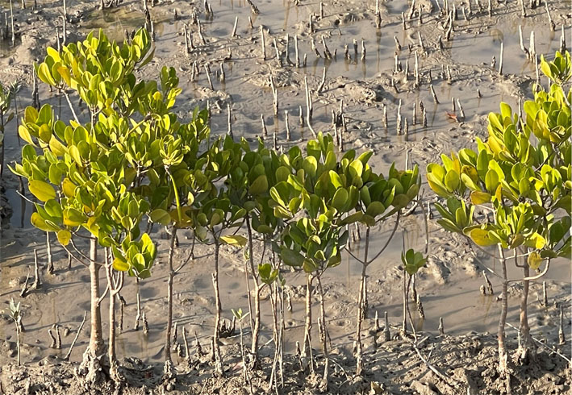
The most common mangrove species in Pakistan, Avicennia marina (Family Avicenniaceae), has long horizontal cable roots for stability, from which numerous vertical pneumatophores with lenticels protrude to enable air intake (figure 3). The fourth mangrove species in Pakistan, Aegiceras corniculatum (Family Myrsinaceae), produces slender, curved fruits encasing long seeds: hence its common name of “goat’s-horn” mangrove (figure 4). This species does not usually produce pneumatophores, but the trunks of Aegiceras trees do have lenticels for air intake. The Avicennia and Aegiceras species also have salt-secreting glands on their leaves to control their internal salt balance as an adaptation to living in saline environments.
Figure 3: Avicennia marina vegetation, Miani Hor. Q Don Macintosh

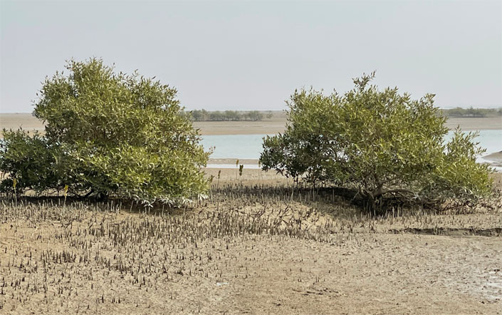
True mangroves have distinctive reproductive adaptations in the form of salt-tolerant viviparous, or crypto-viviparous, seeds. The seeds of Rhizophora mucronata and Ceriops tagal are viviparous and germinate out through the fruit as long, slender propagules while still attached to the parent tree (figure 1b). The collecting and direct planting or nursery rearing of propagules of these two species has greatly facilitated mangrove rehabilitation/afforestation in Pakistan via plantation development or assisted natural regeneration.
Figure 1b: Rhizophora mucronata tree with propagules. Q Don Macintosh

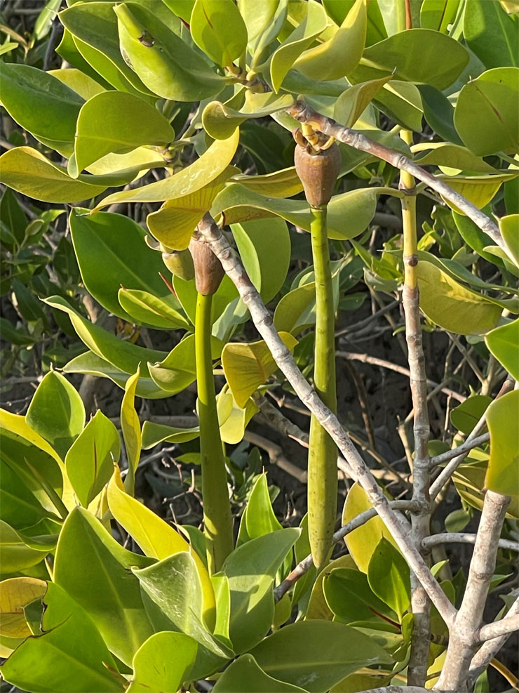
Figure 4: Aegiceras corniculatum tree with flower buds. Q Don Macintosh

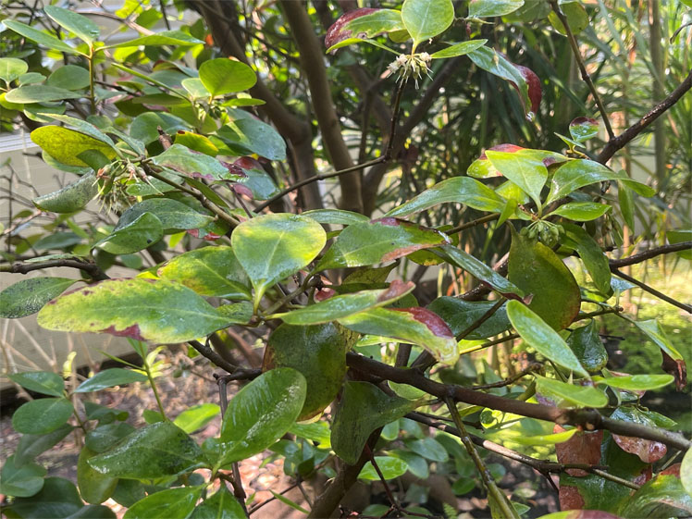
The seeds of Avicennia and Aegiceras are crypto-viviparous, meaning that the embryo emerges from the seed coat, but not from the fruit, when it falls from the parent tree. Once Avicennia fruits fall to the ground, or are potted in a nursery, the embryos develop very rapidly into seedlings (figure 5). This reproductive adaptation makes it possible to scatter sow Avicennia fruits with germinated embryos directly onto plantation sites. Netting can be fixed over the sown area to prevent the fruits being washed away by tides until the embryos have developed roots for anchorage.
Figure 5: An emerging Avicennia marina seedling, surrounded by two fleshy cotyledons. Q Don Macintosh

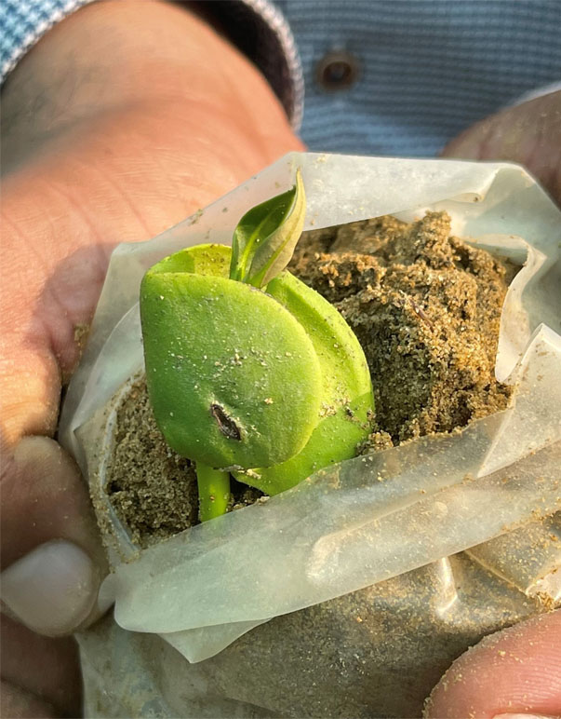
Mangroves normally grow on sheltered shores from mid-tide level to the high-water mark and are most developed in deltas, estuaries, lagoons and coastal bays where there is some dilution of seawater with freshwater. However, a few species (and particularly A. marina) can tolerate salinities well above that of normal seawater (35 parts per thousand salt). It appears that the three common mangrove species in Pakistan: A. marina, R. mucronata and C. tagal have adapted to the arid, highly saline conditions of the country’s coastal zone. Not surprisingly, given Pakistan’s hypersaline coastal environment, A. marina, the most salt-tolerant true mangrove species worldwide, is by far the most naturally widespread mangrove in Pakistan.

Table 1. Characteristics of true mangroves (adapted from Tomlinson, 1986).
- Complete fidelity to the mangrove environment, occurring only in mangal* and do not extend into terrestrial plant communities.
- Play a major role in the structure of the mangrove community and can form pure stands of trees.
- Morphological specializations that adapt them to their environment; the most obvious are aerial roots associated with gas exchange, and viviparity of the plant embryos.
- Some physiological mechanism to exclude or excrete salt so that they can survive and grow in sea water.
- Taxonomic isolation from terrestrial plant relatives, at least at the generic level and often at the subfamily or family level. Main families in Pakistan: Avicenniaceae, Rhizophoraceae, Meliaceae; and previously also Sonneratiaceae represented by Sonneratia caseolaris.
* Macnae (1969) introduced the term ‘mangal’ to describe the community of mangrove plants and associated animals.

Tomlinson (1986) defined the term “mangrove” to mean either the individual plants, or the mangrove community. Similarly, the term “mangrove” is used in this report to mean both the individual trees and the mangrove plant community in general.
The term “mangrove ecosystem” is used here to mean the whole biological community supported by mangroves, plus the many ecological functions that mangroves provide, including coastal protection from storms, wave-generated erosion and carbon storage. Mangrove ecosystems also provide habitat for many intertidal organisms, as well as insects and spiders, reptiles, resident and migratory birds, mammals and aquatic animals, including economically important fishery species.

2. The Early History of Mangroves
in Pakistan

2.1 Introduction
In this report the year 1980 is used as the baseline for a time-series assessment of the changes in the area and ecological condition of the mangroves in Pakistan up to the present time.
However, it is also instructive to review the earlier history of Pakistan's mangroves because of the significance of past human impacts on the coastal environment, especially in the Indus Delta. This look back in time helps to identify the environmental changes that have contributed to the significant current challenges facing the management and sustainable use of mangroves in Pakistan.

2.2 The Historical Record
The earliest historical record describing Pakistan’s mangrove forests dates from 325 BCE when the ships of Alexander the Great of Macedonia (a kingdom on the Greek peninsula) sailed from the mouths of the Indus Delta to the Persian Gulf (Schneider, (2011). The Greeks described the mangroves as marine forests and they mentioned three different types of mangrove tree, which from their descriptions seem to have been Avicennia marina, Rhizophora mucronata and Aegiceras corniculatum.
Having not seen mangroves before, they likened the mangroves to plants that they were familiar with. Thus, Avicennia leaves and fruits were compared with olive leaves and almond fruits, respectively. The leaves and fruits of Rhizophora were likened to bay leaves and olives, while the fruits of Aegiceras were described as resembling lupin pods.
The travelling companions of Alexander also noted that some of the mangrove trees were 30 cubits high (13.7 metres). Moreover, their roots (presumably of Rhizophora trees) were large enough to tie their ships to with mooring ropes (Hort, 2020).

2.3 Mangrove Degradation and Deforestation

2.3.1 1850-1947
In the British period in Pakistan up to Independence in 1947, mangrove wood was exploited heavily for local use and to fuel steam ships and steam engines. Steamships were operating in the Indus Delta from the 1840s, and by 1865 goods from Karachi were taken by steam locomotive to Kotri and then by steam ship via the Chenab River to Multan, before being transported by train again as far as Delhi (Mughal, 2009). As explained by Dewey (2014), wood was freely available, but not coal, “so the boats had to make frequent stops to take on board great stacks of felled trees, whose weight slowed them down, and led to deforestation”.

2.3.2 1948-1990
Surprisingly little information is available about the Indus Delta mangroves in this period, other than general statements that they were extensive, tall and luxuriant (e.g. Khan, 1966; Saifullah, 1997). Saifullah and Rasool (2007) reported that Avicennia marina trees as tall as 10 m or more were once present in the delta, but were cut down for their wood by local people. However, they were able to photograph one tall surviving A. marina tree in an inland freshwater region of Thatta District in 2005.
Old A. marina trees about 6-7 m high, which probably date from this period, are still common in the Phitti Creek area of the delta (figure 6).
Figure 6: An old Avicennia tree in the Phitti Creek area, Indus Delta. Q Don Macintosh

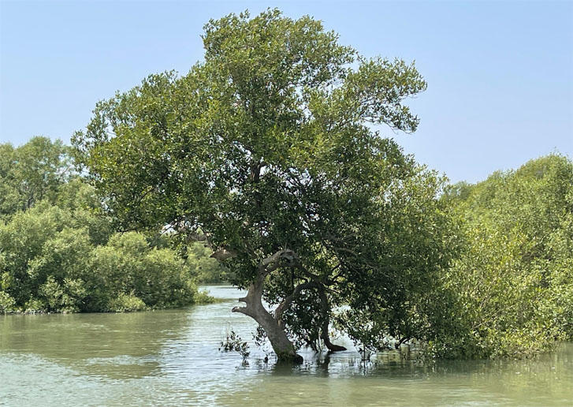
Among the numerous freshwater control structures constructed on the Indus River, both during and after the British period, the Kotri Barrage built in 1955 has had the most severe impact on the downstream flow of river water to the delta. As documented by Chandio et al. (2014), 150 MAF (million acre-feet = 185 x 10⁹ cubic metres year⁻¹) of freshwater used to flow down the Indus River carrying over 400 million tons of silt annually towards the lower delta. But below the Kotri Barrage the water flow was reduced to only 20 MAF carrying 36 million tons of silt; and after the Water Accord of 1991 the annual downstream water allocation was reduced further to 10 MAF, with an estimated silt load of only 30 million tons.
According to these estimates, the flow of freshwater and silt to the Indus Delta was reduced to less than 10% of the natural supply that had supported mangroves in the delta before the barrage was constructed. Chandio et al. (2014) describe this reduction of freshwater flowing below the Kotri Barrage as the “gradual death of the Delta”. Four of the eight mangrove tree species previously reported in Pakistan (see section 7.2) seem to have become locally extinct during this period.
Although shortage of freshwater leading to elevated salinity is commonly cited as a critical cause of the decline of mangroves in the Indus Delta (e.g. Qureshi, 1993; Chandio et al., 2014), the accompanying decrease in sediment supply was also a major factor. Historically, the sediment carried by the Indus River to the Arabian Sea was the fifth largest alluvial sediment load in the world (Giosan et al., 2006).
Deposition of this large volume of alluvial sediment created an extensive fan-shaped delta where mangrove forests could flourish. It is thought that the delta advanced seawards by about 13 kilometres, or almost six metres per year, from the time of Alexander the Great (325 BCE) to the year 1869 (Haig, 1887).
Fine, river-borne sediments are nutrient-rich and have an optimal texture for water-retention and mangrove root development. Thus, it can be concluded that mangrove colonisation and growth accelerated the delta’s progression seawards as recounted by Haig, whereas construction of barrages on the Indus River caused a catastrophic decrease in the volumes of freshwater and alluvial sediment reaching the coast. The result was that the sea could now ingress inland leading to extensive coastal erosion. It is estimated that 20% of the Indus Delta plain has eroded since the first barrage (Sukkur Barrage) was built in 1932 (Giosan et al., 2014).

2.3.3 1991-2000
By the 1990s, Harrison et al. (1994) reported that Avicennia marina was the only common mangrove tree species in the Indus Delta. However, even A. marina, which is by far the most salt-tolerant mangrove species globally, showed signs of salt stress in the form of stunted growth. There were only a few Rhizophora mucronata trees remaining at the delta mouth, while Ceriops tagal also existed in only small patches there.
It is likely that the Rhizophora and Ceriops mangroves were exploited heavily for timber and fuelwood in preference to A. marina, which would have been much less sought after because its wood is less dense and burns too quickly. The density of Rhizophora and Ceriops wood is 0.82 and 0.78 g/cm³ respectively, compared to ≤ 0.60 g/cm³ for Avicennia wood. In this period, it was estimated that local people used 173 kg of fuelwood per month per household on average (Meynell, 1993 cited by Saifullah, 1997).
There were also up to 16,000 camels and 11,000 cattle grazing on mangroves in the delta (Qureshi, 1993). The biggest impact would have been caused by professional herders, each managing hundreds of camels. Research in South Africa has shown that cattle grazing and trampling of A. marina vegetation causes reduced growth, stunting and horizontal spreading of the branches, and lower seedling establishment (Hoppe-Speer and Adam, 2014). In this period, almost complete defoliation of some A. marina forest areas by camels was observed In the Indus Delta by Suda (2013).
Mangrove exploitation in the last century resulted not only in large-scale loss of mangrove forest cover, but also a significant decline in forest quality and ecosystem function. Quamar (2009) estimated that there was 67% loss of the dense mangrove forest cover in the Indus Delta in just 25 years between 1953 and 1978; followed by a further 9% loss of dense mangroves by 2001, resulting in 95% of the dense mangroves being degraded to moderate or sparse vegetation within the second half of the 20th century.
Quamar attributed this dramatic decline in mangrove forest quality to direct human exploitation rather than to environmental changes resulting from the diversion of freshwater upstream for agriculture. However, both forest exploitation and the diversion of freshwater away from the delta are commonly cited together as the main causes of mangrove degradation and loss (e.g. Saifullah, 1997; Abbas et al., 2013).
The mangrove forest area also decreased significantly in Balochistan during the second half of the 20th century. Over-exploitation for wood and fodder led to many blank areas in the mangrove forests in Miani Hor; then the blank areas increased gradually in size to form large mud flats (Muhammad et al., 2022). However, all three species present naturally in the lagoon: A. marina, R. mucronata and C. tagal survived despite the high level of mangrove exploitation during this period.

Table 2. Chronology of mangrove area estimates (Indus Delta/Sindh/National).
Year of estimate | Mangrove area (ha) | Available details of area and methodology of assessment | Source
1950 | 380,000* | Analysis of land use maps | Cited in FAO (2007a)
1958 | 344,870 | Area of Indus Delta mangroves assigned to SFD as PF in 1958 | IUCN (2005)
1965 | 400,000* | Considered to be a rough estimate by FAO (2007a) | Champion et al. (1965)
1966 | 344,870 | Repeats the area of Sindh mangroves designated as PF in 1958 | Khan (1966)
1966-67 | 345,000* | National estimate | FAO (1976)
1977 | 263,000 | Indus Delta | Memon (2005)
1980 | 345,000* | National estimate by former Ministry of Food, Agriculture and Cooperatives | Cited in FAO (2007a)
1983 | 243,000 | Indus Delta; Landsat data | Mirza et al. (1983)
1983 | 249,500* | National: secondary reference | Saenger et al. (1983)
1983 | 281,000 | Sindh mangroves | Amjad and Khan (1983) cited in IUCN (2005)
1984 | 235,564 | Forest cover + water bodies; (forest cover only: 185,698 ha) | IUCN (2005)
1985 | 280,470 | Indus Delta; Landsat data | MFF (2016)
1988 | 250,238* | Indus Delta 242,812; Balochistan 7,426 ha | Mirza et al. (1988) cited in Saifullah et al. (1999)
1990 | 207,000* | Remote sensing national estimate:  medium forest cover 87,000 ha  sparse forest cover 120,000 ha | Pakistan Forestry Sector Master Plan 1992 cited in FAO (2014)
1990 | 158,500 | Indus Delta | Memon (2005)
1990 | 160,000 | Indus Delta | Kella (1999)
1993 | 168,300* | National estimate from 1:1,000,000 scale map | Spalding et al. (1997)
1993-94 | 160,000 | Indus Delta Landsat image analysis | SUPARCO cited by Wagan (2018)
1997 | 159,000* | National estimate | Pakistan Forest Institute (2004)
1998 | 129,000 | Indus Delta | Stedman-Edwards (2000)
2000 | 154,000* | National estimate | World Resources Institute (2000)
2001 | 158,000* | National estimate for FAO Forest Resources Assessment Programme; Landsat image analysis | Pakistan Forest Institute (2004) cited in FAO (2007b)
2003 | 82,669.5* | Indus Delta 81,684 ha + Karachi coast 985.5 ha; SPOT Image analysis | SUPARCO cited in IUCN (2005)
2005 | 157,000* | National estimate for FAO Forest Resources Assessment Program | FAO (2007b)
2008-09 | 98,128* | Indus Delta 92,411 ha  Sandspit 1,056 ha; Balochistan 4,660 ha; ALOS - AVNIR-2 image analysis | Abbas et al. (2013)
2009 | 107,640  106,480 | Indus Delta + Karachi Harbour area  Indus Delta (dense mangrove 25,320 ha; medium 34,700; sparse 46,460) | SUPARCO (2009) cited in Wagan (2018)  SUPARCO (2009) cited in MFF (2009)
2014 | 108,058* |  | Mangroves for the Future
2015 | 125,000 | Indus Delta | IDC (2022)
2021 | 198,466 | Indus Delta | IDC (2022
2022 | 215,000 | Indus Delta | Unpublished data from Sindh Forest Department (2024)
2026 | 334,545 | Indus Delta (projected area from IDC planting schedule 2021-2026) | Data from IDC (2022) and assuming 80% survival of mangroves planted 2021-2026
* National estimate; PF = Protected Forests.

3. Pakistan’s Legal and Policy Framework for Mangroves

3.1 Impact of Early Land Policies
During the British colonial period in South and Southeast Asia (1858-1947) mangrove areas in Perak (Malaysia) and in the Sundarbans (the vast mangrove-dominated delta spread across West Bengal and Bangladesh) were declared from 1903 onwards as Reserved Forests (Watson, 1928). A silviculture system involving selective wood harvesting, clear-felling and replanting on a 30-year rotation cycle was introduced to provide sustainable revenues from mangrove forests. The first Working Plan was established for the Perak mangroves in 1908 and working plans, typically of 10 years duration, have been followed there ever since (Gan, 1995).
The British were much less interested in the Indus Delta mangroves because they saw a higher value in developing agriculture due to the delta’s fertile land and abundant freshwater during the annual monsoon season. It is recorded that there were Dehs (revenue estates) under agricultural production in Keti Bundar, Shah Bundar, Kharo Chan and Jati that generated land revenues (Wagan, 2018).
Under the British-Indian Forest Policy of 1884, areas of the delta that were unsuitable for agriculture, including extensive mangrove forests, were designated as wastelands. Both wastelands and cultivable lands came under the control of the Board of Revenue.
This policy decision by the British to not manage the Indus Delta mangroves as Reserved Forests or Protected Forests had far-reaching impact as an indirect cause of mangrove degradation. Because agriculture became the British focus for generating revenue from the Indus Delta, freshwater was diverted for crop production and no sustainable management plan for mangroves was considered. Instead, the mangroves were exploited heavily for timber and fuelwood as described in section 2.3.1.
As a consequence, there was a rapid rate of mangrove area loss in the Indus Delta during the second half of the 20th century. It is reported that mangrove forests covered 350,000 to 400,000 ha of the Indus Delta up to the 1960s (Champion et al., 1965; Khan, 1966). However, these early estimates, which were based on conventional maps and surveys, probably lacked accuracy. In 1980, a figure of 345,000 ha was provided to FAO by the then Ministry of Food, Agriculture and Cooperatives (FAO, 2007a), and in 1985 the figure reported was 280,470 ha (IUCN, 2016).
The Indus Delta mangrove area estimates for the five years 1988 to 1993 are rather variable, ranging from more than 260,000 ha to only 160,000 ha (Kella, 1999; Memon, 2005). The higher estimates, e.g. 250,233 ha by Mirza et al., (1988), probably included waterbodies and mudflats as well as mangrove forests. Then, within only a decade, there was a further 30-50% reduction to little more than 80,000 ha of mangrove forests by 2003 (Qureshi, 2005; Gilani et al., 2021).
The extreme degradation and loss of mangrove forests during the second half of the 20th century was also accompanied by a severe decline in mangrove ecosystem function. This included a loss of mangrove-supported biodiversity and fishery resources, plus widespread transformation from mangrove habitat to barren, highly saline mud flats and mud banks over extensive areas of the Sindh coast and in Miani Hor (Qureshi, 1990; Muhamad et al., 2022). Although the Indus Delta mangrove cover was estimated to be from 250,000 to 345,000 ha in the 1980s, only 15% of this area actually consisted of healthy mangroves; the rest was reported to be degraded or completely denuded forest habitat (Qureshi, 1990).

3.2 The Forest Act 1927
Although almost 100 years old, the Forest Act 1927 remains the national guiding legislation on forests in Pakistan. Section 29 of the Forest Act 1927 specifies that, by notification, the Government may declare Protected Forest status on any forest-land or waste-land that is the property of Government, or over which the Government has proprietary rights, or to the whole or any part of the forest-produce of which the Government is entitled. The forest-land and waste-lands comprised in any such notification shall be called a “Protected Forest“. The provincial Forest Departments are responsible for notifying on Protected Forests. However, it was not until 1958 that Protected Forest status was applied to the Indus Delta mangroves (see section 3.4).
The Forest Act 1927 defines “forest produce” to include a wide array of both living and non-living materials, including timber, fuelwood and charcoal; any parts of a tree; other plants or parts of plants such grasses, creepers, herbs, medicinal plants; wild animals and animal parts; honey and wax; peat, soil, rock and minerals; and any other produce which may be notified as forest produce by the Government.

3.3 Rules Pertaining to Protected Forests
Sections 26 and 32 of the Forest Act 1927 describe the rules that Government may apply to regulate activities in Protected Forests; and section 33 specifies the penalties for offences relating to Protected Forests. In summary, the main prohibited activities are:
- cutting, sawing and removal of reserved trees and timber;
- collection or removal of any forest produce;
- removing or causing damage to the soil, water, natural vegetation (shrubs, herbs and plants), fish;
- clearing or breaking up of land for cultivation or any other purpose (change of land use);
- cutting of grass and pasturing of cattle [meaning all types of livestock];
- contravening rules relating to hunting, shooting, fishing, poisoning water and setting traps or snares;
- removing or causing damage to the soil, water, natural vegetation (shrubs, herbs and plants), fish or wildlife;
- quarrying or mining of stones or minerals, burning of lime or charcoal;
- Setting fires without taking precautions to prevent fire spreading to any reserved trees;
- constructing buildings, or other structures;
- installing a sawmill, charcoal kiln or any operation to cut, fashion or convert trees or timber into articles for domestic or commercial use.
These provisions of the Forest Act mean that local communities living within or near Protected Forests in Pakistan have no de jure (legally recognized) rights; they are using forest ecosystem goods and services under de facto (in reality) arrangements (Pakistan Forest Institute, 2018). The latter are commonly termed ‘customary rights’ and are the patterns of long-standing community land and resource use. The practical application of the regulations pertaining to mangroves as Protected Forests is discussed further in section 9 in relation to the livelihood and other support needs of mangrove-associated local communities.

3.4 Mangrove Forest Policy 1955-2005
After independence in 1947, the Government of Pakistan enacted a National Forest Policy (1955) that promoted tree-planting, including on wasteland, to expand forest areas in order to increase wood and fodder production. In 1958, 344,870 ha of mangrove land were declared Protected Forest and were transferred to the Sindh Forest Department (SFD). This land covers two large deltaic areas termed the Keti Bundar and Shah Bundar blocks.
In a separate directive issued by SFD, the mangroves were declared to be reserved species as per the Forest Act 1927 (Hussain, 2016 unpublished; cited by Pakistan Forest Institute, 2018). The remaining land area between these blocks, covering 255,130 ha remained under the Sindh Board of Revenue (SBR) as Government wasteland and remains under SBR control today (Table 3).
With the development of major port facilities at Port Qasim in the 1970s (a Federal Government development), 64,400 ha of mangroves were transferred to the Port Muhammad Bin Qasim Authority (PQA), but still retained their status as Protected Forests. In a similar manner, a further 2,000 ha were transferred to the Karachi Port Trust (KPT). Despite having Protected Forest status, significant areas of mangrove have been converted for commercial infrastructure development at these ports.

3.4.1 First Mangrove Forest Working Plan 1963-64 to 1983-84
The first Working Plan for the Indus Delta mangroves was developed by the SFD for the 20-year period 1963-64 to 1983-84. This plan sought to manage mangroves as a coastal protection measure, especially to mitigate storm impacts and reduce saltwater incursion, as well as to increase revenues by planting mangroves on barren mudflats (afforestation) to generate income from auctioning the wood.
A report on Pakistan’s forestry sector by FAO/UNEP (1981) mentioned that regarding mangrove forests “…the aim is to get the highest production of firewood to meet the demand of Karachi, the largest town of the country.” However, this first management plan seems to have had only limited success, in part because of the high cost to potential auction-bidders of extracting mangrove wood relative to its value.

3.4.2 Second Mangrove Forest Management Plan 1985-2005
A second 20-year working plan for mangrove forests was prepared by the SFD for the period 1985 to 2005 and a Coastal Forest Division was created to support implementation of this plan. In addition to afforestation, the plan addressed both the need for sustainable wood and fodder supplies for local communities, and for public awareness-raising about the indirect benefits provided by healthy mangroves. This second working plan is notable, therefore, as the start of efforts to promote understanding of the wider functions and values of mangroves as a vital coastal forest ecosystem, including their coastal protection and fisheries support functions.
The Second Mangrove Forest Management Plan is also significant because it heralded the beginning of large-scale efforts to reverse the earlier massive loss of mangroves in Pakistan. Initially, it was necessary to develop good mangrove nursery production and planting techniques and these were developed from 1986 by Tahir Qureshi and collaborating scientists (Qureshi, 1990). Thereafter, it took several years of planting propagules and seedlings to rehabilitate mangroves on a large scale in the Indus Delta.
Similar developments in seedling production and large-scale mangrove rehabilitation also began in Balochistan around this time, beginning with the establishment of mangrove field nurseries in Miani Hor from 1995 (Rasool and Saifullah, 2000).
Led by the Forest Departments of Sindh and Balochistan, and with international donor financial support and technical assistance, the outcome of these mangrove rehabilitation efforts has been a remarkable increase in the mangrove cover in Pakistan approaching 300% over the past 30 years.
The mangrove propagation activities and rehabilitation/afforestation projects that have contributed to achieving this recovery of the mangrove forests in Pakistan are summarised in Annex 1. Due to the lack of documentation available, the list is not comprehensive, but it may serve as a useful starting point to help improve the recording of current and future projects.

3.5 Mangrove Forest Management Policy since 2005
By Notification F&W (SOII)5(18)/2008, the Government of Sindh Forest Department (SFD) declared the Indus Delta Intertidal Land (Mangrove Areas) of Thatta and Karachi districts to be Protected Forests in 2010. This notification covers 260,000 ha of mangrove land in four tehsils of Thatta District (Keti Bundar, Ghorabari, Kharo Chan and Shah Bundar) and the Karachi towns of Kemari (now Kemari District, including Karachi Port) and Saddar.
In 2022, the Government of Balochistan notified the mangrove forests in Miani Hor, Kalmat Khor and Jawani Wetland, plus mangroves in several smaller lagoons and creeks, as Protected Forests, covering a total area of 5,485.6 ha.
These developments in the management policies for Pakistan’s mangrove forests since the 1980s, together with their impacts on mangrove conservation and afforestation/rehabilitation, as well as on biodiversity and the socio-economic well-being of mangrove-dependent communities, are reviewed in the sections of this report that follow. There are also assessments of the main threats to the country’s mangrove ecosystems; and of the potential to reintroduce mangrove species that are no longer present in Pakistan.

4. Current Status of Mangrove Ecosystems: Sindh

4.1 Introduction
The coastal belt of Sindh Province has two main components: the Karachi coast and the Indus Delta. The Karachi cost extends for about 100 km from the Hub River in the west to Korangi Creek. This western part of the Sindh coast contains the best mangrove forests, especially those at Sandspit and within the Karachi metropolitan and harbour areas, where they benefit from nutrient enrichment from city effluents carried by the Lyari and Malir rivers that flow into the Arabian Sea.
The Indus Delta forms the rest of the coastline stretching for about 150 km eastwards to the border with India at Sir Creek. However, due to the arid environment in the coastal region of Badin District and the Raan of Kutch, the eastern part of Sindh Province consists mainly of salt flats largely devoid of mangroves.

4.2 Mangrove Legal Status and Area Change
The Sindh Forest Department (SFD) took charge of 344,870 ha of mangroves designated as “Protected Forests” in 1958. However, as noted in section 3.1, much of the forest habitat was already degraded and only about 15% of this designated area contained relatively healthy mangroves. The mangrove forest stock continued to decline rapidly due to overexploitation, shrinking to less than 90,000 ha only some 20 years ago (Table 2).
In 2010, SFD notified 260,000 ha of intertidal mangrove land in the districts of Karachi and Tatta as Protected Forests (F&W(SOII)5(18)/2008). The current mangrove land status in the Indus Delta is shown in Table 3.
Table 3. The current legal status of mangrove forest in the Indus Delta.
Name of Authority | Mangrove area assigned (ha) | Land status
Sindh Forest Department (SFD) | 280,470 | Protected Forests (PF) Notified 1958
Sindh Board of Revenue (SBR) | 260,000 | PF (Notified 2010)
Port Qasim Authority (PQA) | 64,400 | Land transferred to PQA, but still PF (Notified 1958)
Karachi Port Trust (KPT); includes land used by the Defence Housing Authority (DHA) | 2,000 | Land transferred to KPT, but still PF (Notified 2010)
Total area | 606,870 | Protect Forests
Source: MFF (2016);

The area of mangrove forests in Sindh Province has increased steadily over the past three decades as a result of large-scale mangrove planting and assisted regeneration. Afforestation and rehabilitation of mangroves received a further major stimulus from 2015 with implementation of the Delta Blue Carbon Project phase 1 (DBC-1) in the Indus Delta. This huge project is designed to sell carbon credits in the voluntary carbon market based on the carbon stored in planted and protected mangroves.
To date, DBC-1 is regarded as a great success and the world’s largest mangrove carbon project. In the period 2015 to 2021, DBC-1 protected 125,000 ha of existing mangrove forest and planted more than 73,000 ha in the delta. In 2022 to 2026, the DBC-1 Project is expected to plant a further 124,000 ha. Thus, by 2027, the mangrove forest cover in the Indus Delta could reach almost 335,000 ha (Table 2).
Although generally lower than other estimates, the time series of mangrove area change provided by Gilani et al. (2021), shows an equivalent rapid rate of increase in mangrove cover in Sindh from 1990 to 2020 of 307% (Table 4).
These achievements are a remarkable contrast to the earlier situation advised by FAO that, without mangrove rehabilitation/afforestation, Pakistan’s mangrove cover would have fallen from 158,000 ha in 2001, and to only 52,000 ha by 2020 (FAO, 2014).

Table 4. Mangrove area change in Sindh Province 1990-2020 (Gilani et al., 2021).
Year | Sandspit (ha) | Indus Delta (ha) | Sindh total (ha)
1990 | 1,209 | 44,575 | 45,784
1995 | 979 | 54,017 | 54,996
2000 | 1,074 | 77,676 | 78,750
2005 | 1,241 | 80,465 | 81,706
2010 | 1,305 | 104,531 | 105,836
2015 | 1,333 | 119,897 | 121,230
2020 | 1,356 | 139,566 | 140,922

Figure 7 illustrates how the mangrove cover in the Indus Delta has reversed from a steep decline to a rapid rise over the past few decades.
The distribution of mangrove forests and other coastal habitats in the delta in 2022 is shown in figure 8.

Figure 7: Regression lines comparing the loss and gain in mangrove area in the
Indus Delta from area estimates 1958 to 2003 and 2003 to 2026 (predicted).

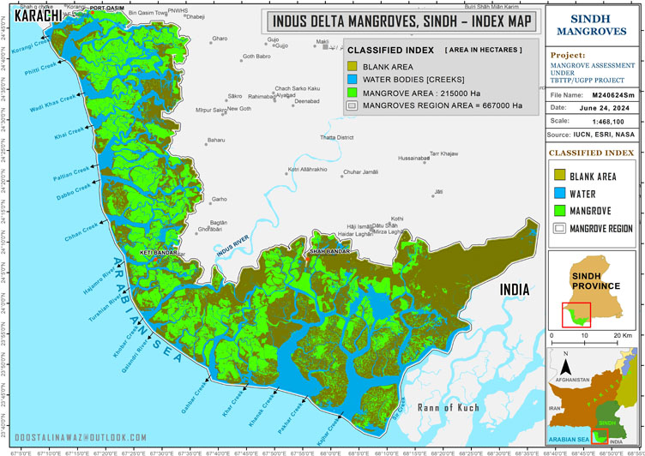
Figure 8: Distribution and area of mangrove forests in the Indus Delta in 2022.

4.3 Sandspit Wetlands

4.3.1 Site Description
The mangroves at Sandspit were visited in November, 2023. This is an important area of urban mangroves in a backwater-lagoonal site located about 18 kilometres southwest of Karachi City. Sandspit consists of a large complex of wetlands, including mangroves, mudflats, saline ponds and salt pans, which are protected behind a long coastal sandspit (hence the name of this area).
Freshwater input to the wetlands is mainly from the Lyari River. The beach at Sandspit is an important tourist beach, but it also provides vital nesting habitat for marine turtles (mainly green turtles, and more rarely olive ridley and leatherback turtles). There is a nearby turtle hatchery managed by the Sindh Wildlife Department.
A Wetland Centre was inaugurated at Sandspit in 2001 on 500 m² of land provided to WWF-Pakistan by the Karachi Port Trust (KPT). The natural mangroves in Sandspit consist entirely of Avicennia marina, which has formed dense vegetation cover. Both A. marina and Rhizophora mucronata are also being planted by the Wetland Centre, with the result that the mangrove cover increased from 979 ha in 1995 to 1,356 ha in 2020 (Gilani et al., 2021). The centre buys mangrove seedlings from the Sindh Forest Department. Local people are hired for nursery work, mangrove planting and the care of the seedlings for six to 12 months after they are planted.
The Wetland Centre also plays an important role in public education and awareness-raising about mangroves and wildlife. There is an elevated mangrove walkway about 100 metres long leading to the centre, which includes an office, conference room and exhibition/display room (figure 9). The centre receives around 5,000 to 6,000 visitors annually, not only from the Karachi area, but also from further afield. The visitors include schoolchildren, students, researchers and families. WWF-Pakistan has plans to renovate the centre and provide additional visitor facilities.
Figure 9: Mangroves and walkway at the Sandspit Wetland Centre near Karachi. Q Don Macintosh

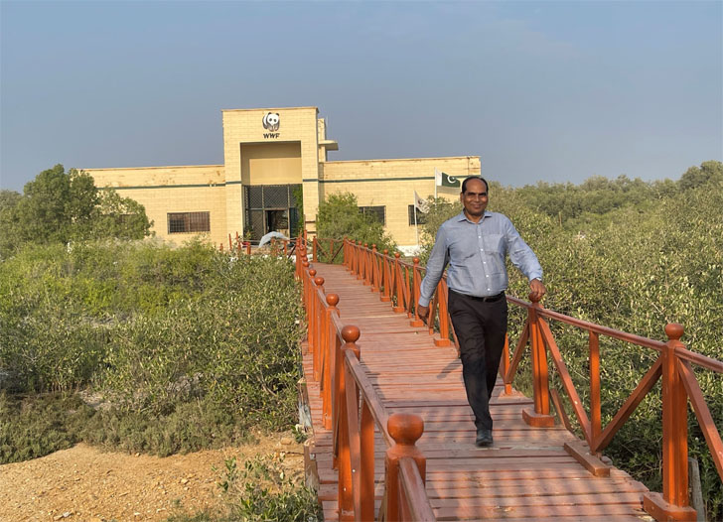

4.3.2 International and Local Importance
Sandspit is a wetland of international biodiversity and ecological significance because it supports large numbers of mainly migratory birds. WWF-Pakistan has estimated that around 20,000 birds visit this wetland during the winter months. In total 114 species of migrant and resident bird species have been reported from the area (Durranee et al., 2008). The saline ponds are particularly important as temporary habitat for migrant species, which include ducks, grebes, avocets and flamingos.
In addition to providing habitat for wildlife, more than 50% of the villagers living in the Sandspit area depend on the mangroves for timber, fuelwood and fodder for their livestock. Their main source of income is from fishing, which is supported indirectly by the mangrove and wetland ecosystem in the form of food, nursery and breeding habitat for fishes, prawns and crabs.
Because of their close involvement with the Sandspit Wetland Centre, local people are aware of the importance of mangrove conservation and sustainable use. However, there is concern about encroachment from urban and commercial developments on the landward side of the wetlands. Moreover, the agreement with KPT for use of the land by WWF is renewed annually, so there is no long-term security for the Wetland Centre.

4.4 Northwest Indus Delta

4.4.1 Site description
The mangroves in the northwest Indus Delta (Karangi-Phitti Creek system) were visited by boat in April, 2024.
This region of the Indus Delta has luxuriant mangroves that are believed to benefit from nutrients discharged from the greater Karachi and harbour areas. There is also a net deposition of alluvial sediment, which provides a suitable fine-textured substratum for mangrove growth. The surface water salinity measured during the visit was 40 ppt. This agrees well with a salinity high of 40.9 ppt in April, and low of 38.1 ppt during the Southwest monsoon period (May to September), reported by Khatoon et al. (2014) in the same creek system.
The creeks, distributaries and islands in this northwestern region of the delta are covered with thick growth of Avicennia marina vegetation. The area has also been planted extensively with Rhizophora mucronata by the Sindh Forest Department. Many of the islands are fringed with Rhizophora trees growing in spaces in front of and among the natural Avicennia vegetation.

4.4.2 Mangrove Forest Assessment
Examination of the mature Rhizophora trees (planted about 15 years ago) confirmed that they are very healthy with well-developed prop roots systems and dense foliage. Rhizophora is particularly suitable for planting at the perimeter edge around the islands and along creek banks in this region of the delta because Rhizophora trees produce prop roots in response to the plants’ need for stability.
The prop roots are more extensive and longer where the shoreline is lower, or the soil is softer, as occurs near the water margin. This feature of root development may also provide Rhizophora mangroves with a valuable adaptive response to sea-level rise as a result of climate change.
There were also natural seedlings growing among the mature trees, confirming that the Rhizophora plantations have the capacity for self-recruitment (figure 10). The production of natural seedling cohorts is a vital process for forest continuance; it also diversifies the forest structure. As to be expected in April, which is the start of the main reproductive season for Rhizophora, the trees had profuse flower buds and many developing propagules.
Figure 10: Natural recruitment of seedlings in a Rhizophora mucronata plantation. Q Don Macintosh

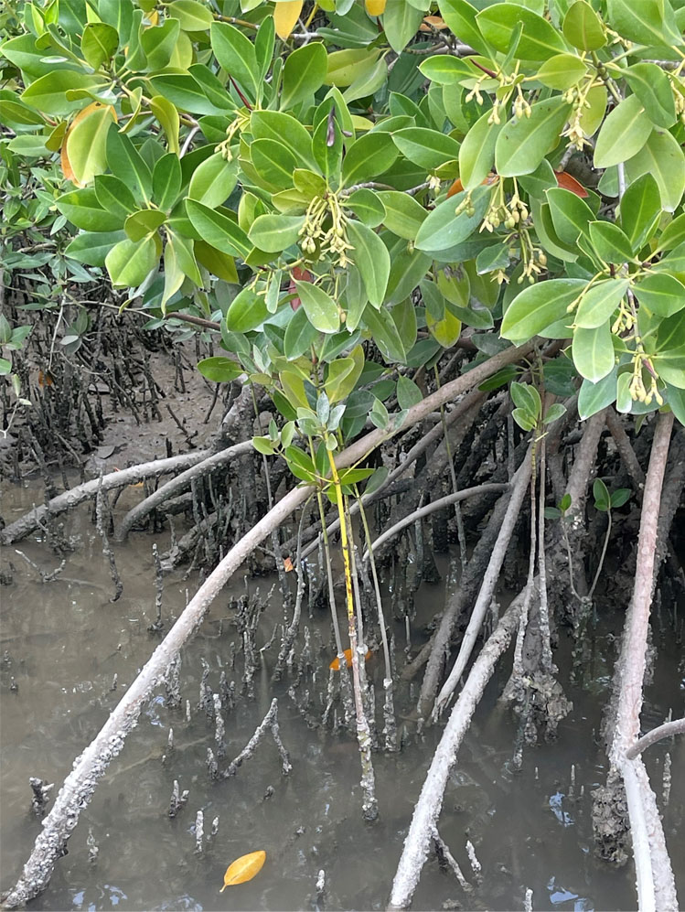
These mangroves are an importance source of propagules for further rehabilitation planting. Propagule collecting is done by local women who receive payments for this work from the SFD (figure 11), while local men are paid to do the planting.
Figure 11: Women collecting Rhizophora propagules for planting. Q Muhammad Khan Jamali

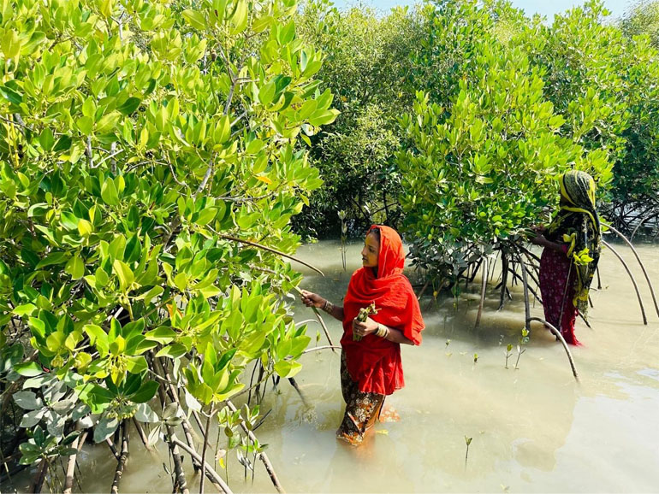
The planted Rhizophora trees are also contributing well to the aquatic component of the ecosystem as evidenced from the growth of barnacles and oysters on the lower prop roots and leaf fall from the trees. Through in situ breakdown on the forest floor, or export into coastal waters, mangrove leaves are chemically and biologically decomposed, which provides nutrient and detritus enrichment to the coastal aquatic ecosystem.

4.4.3 Mangrove-Associated Fisheries
A large number of fishing vessels operate from Korangi Harbour. Although no direct observations of the fisheries associated with the Korangi-Pitti Creek system were possible, some important conclusions can be drawn from a comprehensive study of the fish communities in this creek system by Khatoon et al. (2014). A total of 86 fish species were recorded with two small marine pelagic species, Sardinella gibbose (Goldstripe sardine), Nematalosa nasus (Gizzard shad), being the most abundant species year-round. Fish species more usually associated with mangroves were relatively more common during the wet southwest monsoon season, including mullets (Liza and Mugil species) and Scatophagus argus (Silver scat). These species were also most abundant in the smaller creeks, as was Arius arius (Threadfin sea catfish), another important mangrove-associated finfish.
Although the great reduction in freshwater flow into the Korangi-Phitti Creek system has resulted in a predominantly marine fish community, with only a low abundance of mangrove-estuarine species, Khatoon et al. (2014) concluded that this hypersaline mangrove creek system provides a spawning ground for sardines and shads, suggesting that this habitat may be important for their reproductive success. The fishery in Miani Hor is also dominated by small marine pelagic species especially sardines, shads and anchovies (Saher, 2018).
It will be important to monitor water salinity in the Korangi-Phitti Creek system (and other creeks) in relation to both the mangroves and their associated fisheries. Surface water salinity in this coastal area was 35.5-36.0 ppt in January-February 1977 (Saifullah, 1982), which is about 10% lower than the salinity range of 38.1-40.9 ppt reported in 1999 to 2001 by Khatoon et al. (2014) and in the present assessment. Any further increase in salinity is likely to supress mangrove growth and further decrease the presence of the previously abundant mangrove-associated estuarine fish and prawn communities in the Indus delta creek system.

4.5 Gharo Mangroves

4.5.1 Site Description
A coastal site managed by Zephyr Power Limited (ZPL) near Gharo was visited in January 2024. The ZPL site is on 1,028 ha of land leased by this company for wind power generation. Natural and planted mangroves cover about 243 ha of the site, which receives water from Gharo Creek. The salinity of the creek water on the day visited was 34.5 ppt.

4.5.2 Mangrove Forest Assessment
A plantation of six-year-old Rhizophora mucronata trees planted as propagules was sampled (location 24.6927ºN, 67.4874ºE). The trees were small and branching (average height 70-90 cm), indicating slow growth because of the highly saline environment; however, there were no signs of salinity stress per se. Most of the trees had prop roots and developing flower buds (figure 12). The spacing between trees was 2.8 m on average and there was 100% survival in the area sampled, although some gaps could be seen in other parts of the plantation site. There were many large burrows in the firm, muddy soil, but the animals responsible for this activity were not seen.
Figure 12: A plantation of six-year-old Rhizophora mucronata at ZPL near Gharo. Q Don Macintosh

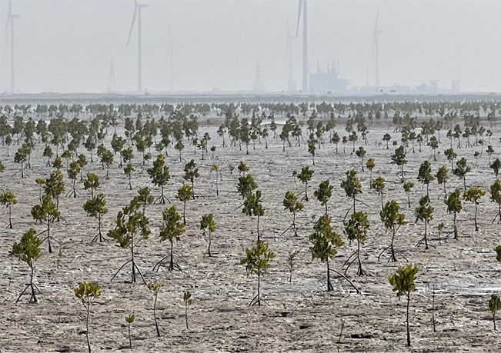
A second plantation area at ZPL was sampled for comparison: this was a higher location with natural salt marsh vegetation (24.7135ºN, 67.4560ºE). Here young R. mucronata seedlings planted as propagules in 2023 showed acute signs of salinity stress and desiccation, and their survival rate was only 61%. Many of the seedlings had malformed stems or leaves (figure 13). Some of the leaves that had developed normally were reddish-brown in colour indicating cell damage, which is associated with salinity stress in this mangrove species (Titah et al., 2019) and possibly also a lack of nutrients.
Figure 13: Young Rhizophora seedlings showing extreme environmental stress; the stick is 50 cm high. Q Don Macintosh

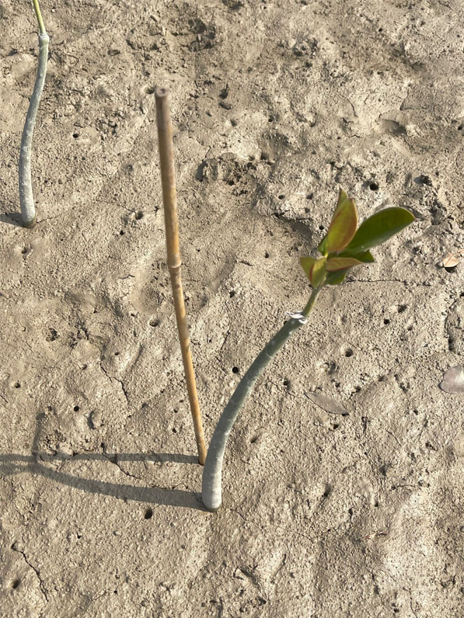
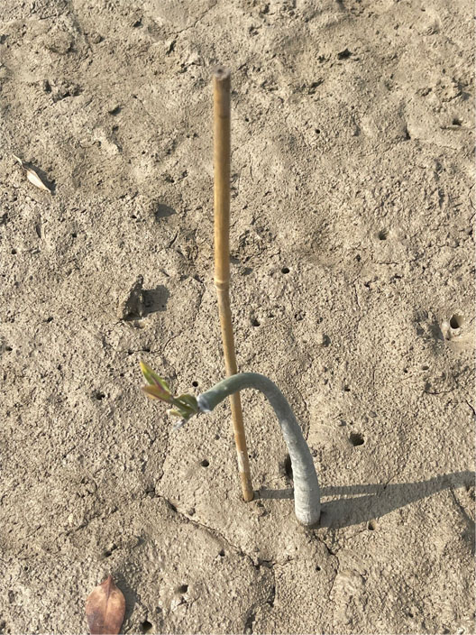

4.6 Keti Bundar Mangroves

4.6.1 Site Description
Keti Bundar in Thatta District was visited in November 2023. A short boat trip was made from the town to a mature mixed species mangrove plantation of A. marina and R. mucronata, plus a small number of C. tagal trees. A nearby island (Tippun Island) was also visited. The plantation site (location Tangey Wari) features a large, elevated walkway constructed on cement pillars for public access (figure 14). The SFD has plans to further develop this site as an ecotourism centre for visitors to Keti Bundar. There is abundant birdlife associated with the mangroves and mud flats, as well as a network of creeks at this location, which makes it very suitable for mangrove boat trips and bird watching for visitors (figure 15).
Figure 15: Mangrove creek habitat near Keti Bundar suitable for ecotourism activities. Q Don Macintosh

Figure 14: Mangrove plantation site and walkway near Keti Bundar. Q Don Macintosh

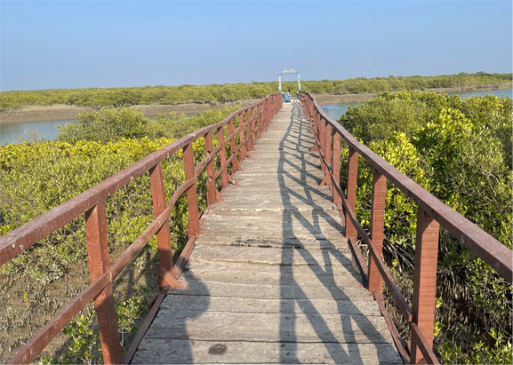
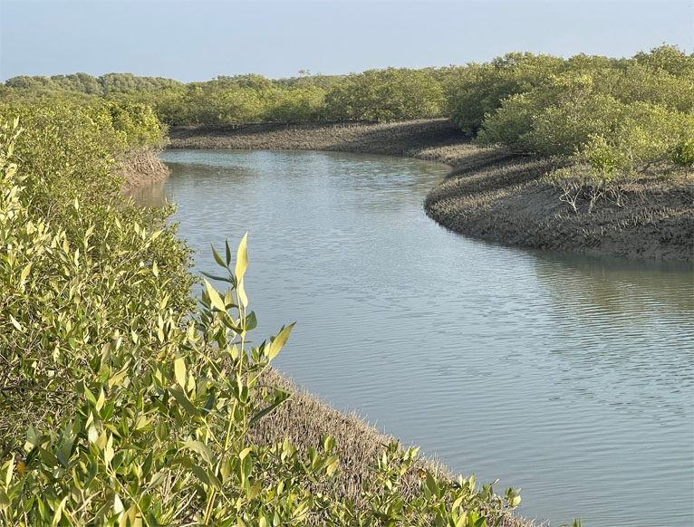
However, while accretion is taking place along some of the creeks, severe erosion is occurring, elsewhere, especially near Tippun Island because of tidal scouring (see section 6.6.3 coastal erosion), which is probably being made worse by the wash from passing boats.

4.6.2 Mangrove Forest Assessment
In the short time available, the mangrove plantation (6-7 years old) could only be assessed from the walkway. The trees were healthy with a stout, branching growth form and an average height of 2.0-2.2 m (R. mucronata) and 1.60-1.80 m (A. marina). The Rhizophora trees had well-developed prop roots and many of them had produced flower buds and propagules. There were numerous naturally-recruited Avicennia seedlings among the planted trees.
Ecological functioning at the ecosystem level was evident in the form of active bioturbation (turnover of the soil by the feeding and burrowing activities of crabs and other fauna), particularly around the roots of the trees (figure 16). Mangrove leaf fall and tidal dispersal of leaves were also noted, indicating that the mangroves are contributing well to the coastal food web that supports the fishery-based livelihoods of the local community. The water salinity in the creek was moderate (31.4 ppt) indicating some dilution by freshwater.
Figure 16: Bioturbation by crabs: an indicator of ecological function in mangrove plantations. Q Don Macintosh

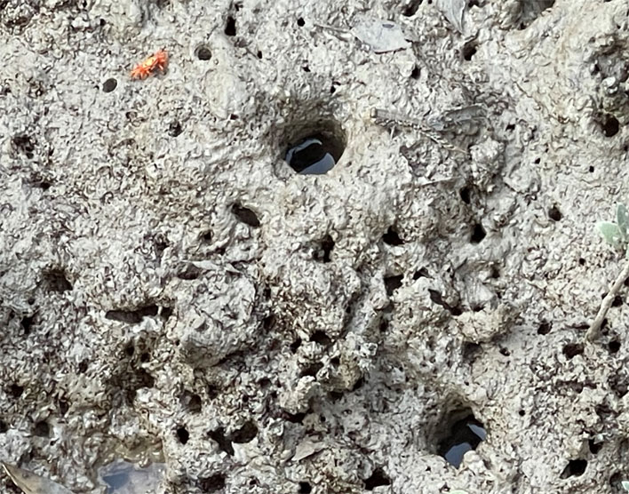
At a Forest Department mangrove nursery and plantation site near Keti Bundar (figure 17), a young fisherman catching mud crabs explained that there were no crabs at this site before the mangrove plantation was established.
Figure 17: Mud crab fisherman at a SFD mangrove nursery and plantation site near Keti Bundar. Q Don Macintosh

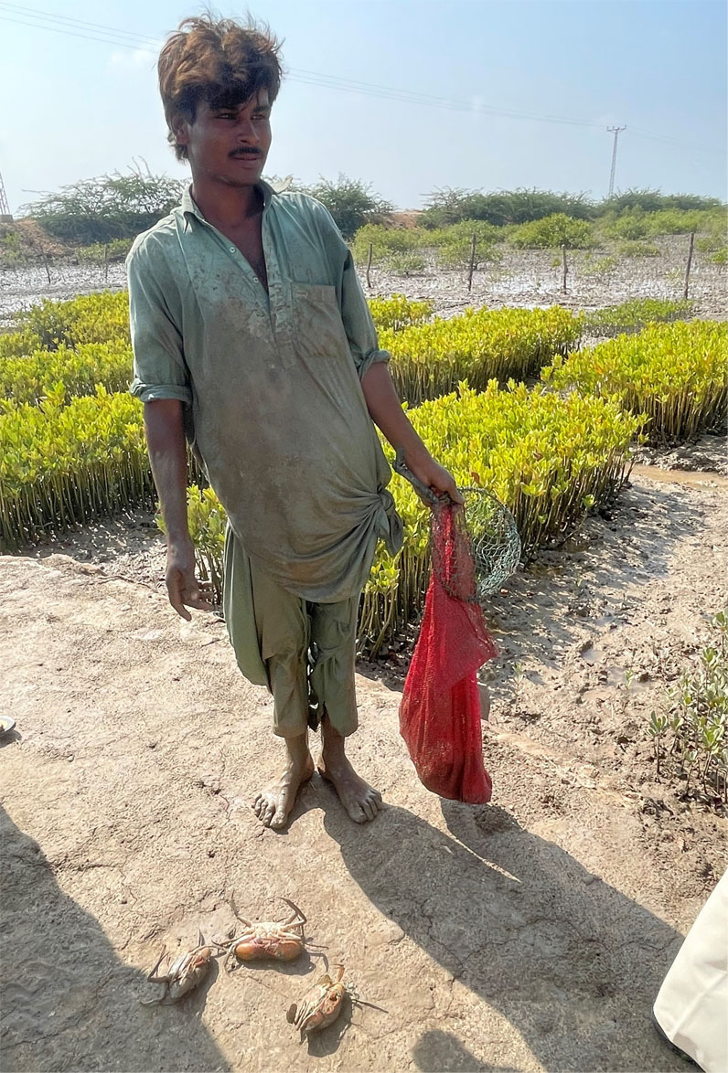

4.7 Eastern Indus Delta
Although the district of Badin was not visited during the assessment, discussions with SFD confirmed that this eastern coastal region of Sindh, which extends to the border with India at Sir Creek, is extremely arid and largely barren of vegetation (figure 18). This makes it much more challenging for mangroves to survive. It is doubtful that afforestation efforts are justifiable given the low probability of mangrove survival in such an extreme environment, whereas planting A. marina in areas that still have mangroves, or are known to have had mangroves previously, is likely to be more successful.
Figure 18: Avicennia marina showing extreme environmental stress at Sir Creek, Badin District. Q Shezad Sadiq Gill

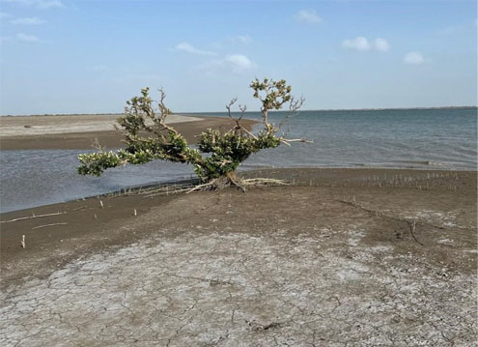
However, where mangroves are planted in Badin, it will be particularly valuable to monitor the climate, soil and water temperatures and salinity in relation to mangrove survival and growth. The data recorded can be used to help identify the extreme environmental tolerance limits for mangroves in the delta.

5. Current Status of Mangrove Ecosystems: Balochistan

5.1 Introduction
In contrast to the extensive mangroves in the Indus Delta and around Karachi in Sindh Province, the mangroves in Balochistan Province have a very restricted distribution because of the narrow sandy and rocky nature of most of the coastline. For many years mangroves were reported to occur in only three main locations in Balochistan: two coastal lagoons, Miani Hor and Kalmat Khor, and a wetland area in Jiwani Bay. However, there are several other locations where small patches of mainly planted mangroves now exist, namely Shadi Khor, Sawar Khor and Shabi and Ankra creeks.

5.2 Mangrove Legal Status and Area Change
Saifullah et al. (1999) citing Mirza, et al. (1988) estimated the mangrove cover in Balochistan to be 7,425 ha, but this seems to be a significant overestimate. A figure of 4,662 ha based on 2008-09 data was reported by Abbas et al. (2013). The Balochistan Forest and Wildlife Department (BFWD) provided time series data showing the change in mangrove area from only 1,939 ha in 1990 to 5,485.6 ha in 2020, a 283% increase (Table 5). The mangrove area estimates for Balochistan include both natural mangroves (mainly in Miani Hor) and planted mangroves (mostly Avicennia marina, with some Rhizophora mucronata).
The total mangrove area in Balochistan of 5,485.6 ha was notified as Protected Forests by BFWD in 2022.

Table 5: Mangrove forest areas (in hectares) in Balochistan, 1990-2020.
Location | 1990 | 1995 | 2000 | 2005 | 2010 | 2015 | 2020
Miani Khor | 1,480 | 2,766 | 3,241 | 3,556 | 3,615 | 4,030 | 4,280
Kalmat Khor | 378 | 277 | 361 | 575 | 662 | 668 | 933
Shadi Khor |  |  |  |  |  | 8 | 20
Sawar Khor |  |  |  |  |  | 0.3 | 1.6
Jiwani Bay | 81 | 83 | 96 | 194 | 193 | 199 | 223
Shabi-Ankra Creek |  |  |  |  | 10 | 11 | 28
Total: | 1,939 | 3,126 | 3,698 | 4,325 | 4,480 | 4,963.3 | 5,485.6
Source: Balochistan Forest and Wildlife Department, 2023.

5.3 Miani Hor

5.3.1 Introduction
Miani Hor (25º 31’N, 66º 20’E) is the largest coastal lagoon in Pakistan and contains more than three-quarters of the total mangrove forest area in Balochistan. Miani Hor has further significance because it is the only location where the three mangrove species, Avicennia marina, Rhizophora mucronata and Ceriops tagal, occur naturally together. Avicennia marina is the only naturally-occurring species elsewhere in Balochistan and there is no record of any of the original R. mucronata and C. tagal trees in the Indus Delta surviving beyond the 1990s. Thus, the absence of naturally-occurring C. tagal and R. mucronata in adjacent areas of Kalmat Khor and the Jiwani Wetland in Gwatar Bay, as well as in the Indus Delta, makes Miani Hor “a unique and curious case when it comes to mangrove biodiversity” (Saifullah and Rasool, 2002).
Because of its importance, both nationally and in the context of mangroves in Balochistan, the lagoon environment and the history of mangrove exploitation and management in Miani Hor are described in detail in the sections that follow.

5.3.2 Site Description
Miani Hor is approximately 60 kms long and 7 kms wide, with 83,846 ha of water surface and mangroves, mud flats and bare areas (Abbas et al., 2013). The lagoon is connected to the Arabian Sea by a single mouth at its southeast corner. Miani Hor is unusual for a large lagoon with only a single connection to the sea, because the lagoon mouth is about 4 km wide, thereby allowing good water exchange with the open sea. In this respect it is not a “choked” lagoon, which is the term used to describe many other lagoons with a single mouth in the classification of Kjerfve (1994).
Mukhtar and Hannan (2012) describe Miani Hor as a subtropical arid zone with less than 200 mm of rainfall annually. Miani Hor receives freshwater from two main rivers: the Porali River, which discharges into the north-central part of the lagoon, and the Windor River in the eastern part. However, river water only enters Miani Hor during the monsoon flood season and is highly variable year to year due to an erratic pattern of precipitation. Based on annual rainfall data for Lasbela District over 34 years from 1982 to 2016, there were 10 years with less than 100 mm of rain and in five of these years the rainfall was less than 50 mm; while the annual extremes of rainfall ranged from 0 to 475 mm (Muhammad et al., 2022).
The physical and climatic characteristics of Miani Hor mean that salinity in the lagoon is high and uniform. The salinity measured in September and December 1993 was 39-41 ppt in surface water and 40-42 ppt in pore water (Saifullah and Rasool, 2002). The surface water salinity measured in January 2024 during the present assessment was 48 ppt, indicating that there has been a significant increase in salinity over the past 30 years due to climate change.
Salinity profiles of surface and soil pore water across Miani Hor are needed to confirm this conclusion. Because of the variable climate, it will be important to monitor both dry and wet season salinities over several years to understand the average and extreme salinity ranges that the lagoon’s mangroves are being exposed to.
A study of the sedimentation dynamics in the lagoon is also needed. The reduced inflow of freshwater from the Porali and Windor rivers suggests that there is also less fine sediment being deposited. Fine alluvial sediment is very important for mangrove development, particularly for Rhizophora mucronata and Ceriops tagal, whereas the dominant sedimentation process in the lagoon now seems to be sand deposition, which is leading to the formation of extensive, barren sand banks. Even thirty years ago it was reported that wind-blown sand was being deposited in Miani Hor (Saifullah and Rasool, 2002) and this seems to be on an increasing trend.
Compared to muddy or mixed mud-sand sediments, sandy areas are much less suitable for mangroves because sand-dominated sediments are more porous with poor water retention capacity; they are commonly also deficient in nutrients.

5.3.3 Mangrove Biodiversity, Distribution and Exploitation
Mangroves in Miani Hor are present naturally only on the intertidal mudflat areas at Gut, Bargashi and Damb. The past history of Miani Hor records that mangroves were heavily exploited for animal fodder, fuelwood and timber, including removal of whole trees. Due to their location, the mangroves on the northeast (mainland) coastline and on Bargashi Island in the lagoon were the most susceptible to over-exploitation This led to mangrove degradation and deforestation in the form of blank patches.
Because of its high tannin content, the bark of Rhizophora trees was also used previously to dye and preserve fishing nets (Saifullah and Rasool, 2002). Unsurprisingly, stands of Rhizophora trees survived only in Gut, which was much less accessible to local people.
In addition to direct human over-exploitation, the mangroves in Miani Hor have been impacted by a decrease in average rainfall in coastal Balochistan in recent decades. As described by Saifullah and Rasool (2002) quoting Hussain (1998), this caused the main sources of fresh water from the Porali and Windar rivers to decline to such an extent that they became a ‘river of sand’ depositing huge quantities of sand and silt into Miani Hor.
As a result, the lagoon’s mangroves are under extreme stress from high salinity and this is having the greatest impact on newly planted mangrove propagules and young seedlings.

5.3.4 Mangrove Management in Miani Hor
Mangrove rehabilitation/afforestation increased the mangrove forest cover in Miani Hor from only 1,480 ha in 1990 to 4,280 ha in 2020 (Table 5), representing an almost 300% increase. WWF (2005) reported higher estimates of 2,546 ha in 1989 and 3,716 ha in 2001, but as in the Indus Delta, this may be explained by differences in the methods of assessment between the two studies.
The first nurseries for large-scale mangrove seedling production were established in Miani Hor in 1995 by WWF-Pakistan in collaboration with the BFWD (Rasool and Saifullah, 2000, 2002). Thus, 1995 represents a landmark year as the beginning of much-needed nursery propagation of Rhizophora mucronata and Ceriops tagal in Pakistan beyond an experimental level. In the preceding years, large quantities of propagules of these species had been collected from Miani Hor for reforestation in the Indus Delta, and for export to the Middle East. This practice seriously impacted on the seed supply and reproductive potential of mangroves in the lagoon (Saifullah and Rasool, 2002).
Today there are four mangrove nurseries at Miani Hor (figure 19), one of which has been allocated to women. Mangrove planting is done by both men and women, for which they are paid directly PKR 1,000-3,000 per day according to how difficult access to the planting sites is; and also the availability of funding, which is mainly project-supported. Because mangrove planting provides only a few days of work per person in April-May each year, the income is minor. However, the nursery and planting work has contributed well to the local community’s understanding of the ecological benefits of mangroves.
An elderly fisherman interviewed at Damb in January 2024 recounted that previously they considered mangroves to be useful only as animal fodder “like grass” he said; whereas now they know that the mangroves protect them from storms. And, notably, women have informed IUCN that they would like to know more about the impact of climate change on mangroves and the lagoon environment (Babar Hussain: pers. comm.).
Figure 19: A community-managed mangrove nursery in Miani Hor. Q Babar Hussain

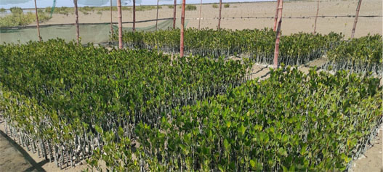
In 2022, BFWD declared 10,576.209 acres (4,280.133 ha) of mangroves in Miani Hor as Protected Forests (Notification No.SO (Dev-1) 6-5/ Forest-2022/4125-37) under the Balochistan Forest Act 2022. This act specifies that the Government can permit “inhabitants and right holders to take trees, timbers, fuel wood or other forest-produce from [protected] forest for their own use.” However, large-scale removal or commercial use of such produce is prohibited or regulated. In practice, BFWD is encouraging local people to take only dead or fallen mangrove wood.

5.3.4 Mangrove Forest and Plantation Assessment
A one-day rapid assessment of mangrove afforestation activities at three sites in Miani Hor in January 2024 revealed variable results regarding propagule survival and growth. Rhizophora mucronata planted within the vicinity of natural Avicennia marina vegetation were growing well (figures 20 and 21), whereas propagules planted on higher barren sandy banks, or near salt marsh vegetation (mainly Arthrocnemun indicum), showed severe signs of salinity stress/water deficit and probably also a lack of nutrients (figure 22).

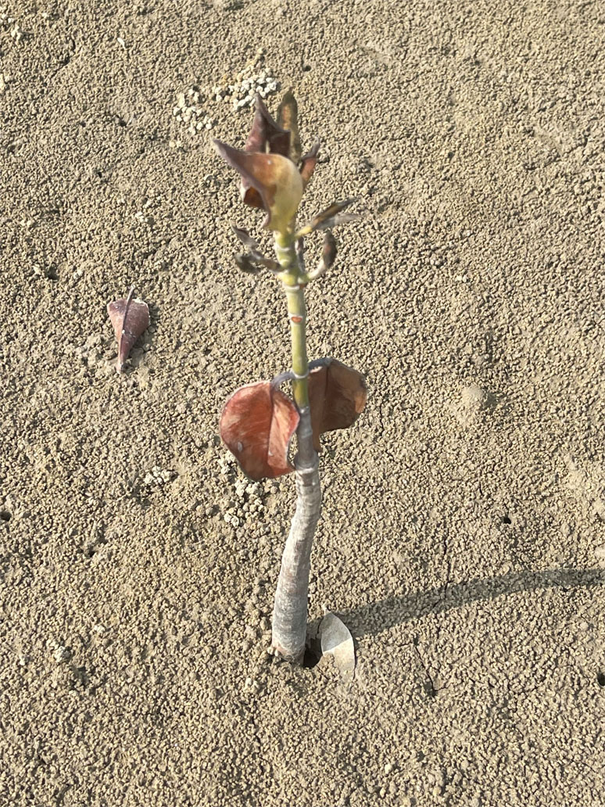
Figure 22: A young Rhizophora seedling showing acute environmental stress on sandy soil in Miani Hor.
Q Don Macintosh

Figure 21: Healthy Rhizophora seedlings growing among Avicennia pneumatophores in Miani Hor.
Q Don Macintosh

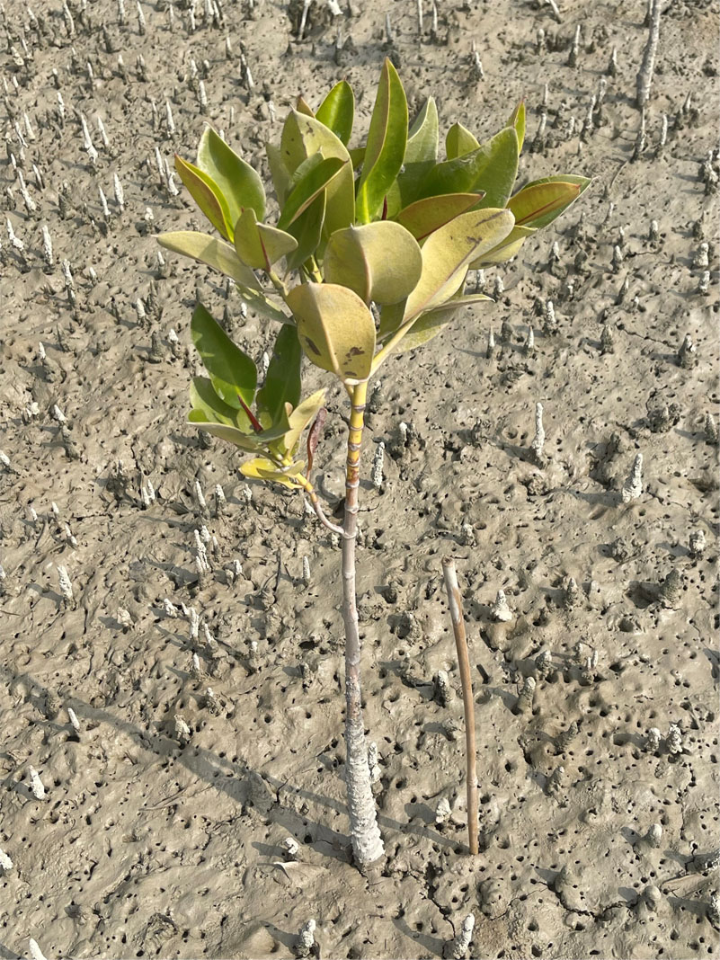
Figure 20: Rhizophora mucronata planted in 2020 at Groo Cheila in Miani Hor;
note the presence of natural Avicennia mangroves. Q Babar Hussain

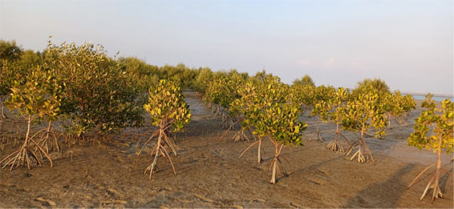
Because of the observed low survival of planted R. mucronata in sand-dominated or very high intertidal locations, it is recommended that R. mucronata should only be planted where it can grow in close association with natural or planted A. marina. This can include all areas where the spreading cable roots and pneumatophores of A. marina have reached: these can extend many metres from the actual trees and indicate more suitable conditions for survival of Rhizophora than completely barren sandy areas. Mixed sediments of muddy-sand or sandy-mud are also much more favourable for the survival and growth of R. mucronata and C. tagal.

5.3.5 Miani Hor Fisheries
Over 90% of the households living around Miani Hor depend on fisheries for their livelihood. Fishing is done both within Miani Hor and outside the lagoon in the coastal waters of Sonmiani Bay. However, fish catches have declined significantly over recent decades and some previously abundant fish species are now locally extinct.
Even in earlier years, WWF-Pakistan found that the catches of some species were already reduced and the overall quantity of catches had increased only slightly, despite greater fishing effort due to an increasing fisher population (Burki, 2006). Already at that time about 70% of the landings in Miani Hor by volume consisted of low value trash fish due to depletion of the more valuable species by over-fishing (Saher et al. (2018).
More recently, a similar predominance of sardines, anchovies and other small pelagic species was reported in Sonmiani Bay by Baloch et al. (2023). They recorded only 91 species, showing that biodiversity has also declined. Four species dominate in the fishery: Liza subviridis (25%), Sardinella longicep (16%), Silago sihama (9%) and Acanthopagrus berda (8%). Of these dominant species, only L. viridis is associated with mangroves.
As in other coastal regions of Pakistan, many of the Miani Hor fishermen take loans to cover the cost of fishing trips. In return, they are bonded to sell their catches to the loan giver at a price set by the latter. Loan givers are often agents or middlemen of seafood processors as this financing system helps to ensure a reliable supply of raw materials for the processing plants.
In the face of declining catches, and because the fishers (loan takers) are bonded and indebted to the loan givers, it is particularly difficult to introduce fisheries conservation measures in Miani Hor and other coastal fishery centres. Moreover, during the September to April fishing season, migrant workers come from all over Pakistan to work in the lagoon fishery; this influx of labour adds to the problem of overfishing and the use of harmful fishing methods.
The annual economic value of fish habitat services provided by the Miani Hor mangroves was calculated to be USD 651-1,291 per hectare (Baig and Iftikhar, 2010). However, because of overfishing in Sonmiani Bay and Miani Hor, the role of mangroves in providing vital habitat for many fish and crustacean species (especially food and shelter for their juvenile life stages) in the lagoon is not being given time to support the rebuilding of the fishery stocks. Moreover, the widespread use of fine fishing nets that catch juvenile fishes and crustaceans (termed growth or juvenile overfishing) is highly detrimental to the fishery. The removal of large numbers of juveniles impacts negatively on stock recruitment and future catches (e.g. Waghmare et al., 2022).
One way to demonstrate the mangrove-fishery relationship would be to monitor and manage the population of mud crabs (Scylla olivacea, and possibly other Scylla species?) in Miani Hor. It is well-established that the life cycle of S. olivacea is intimately associated with mangroves (figure 23). Therefore, monitoring mud crab catches could help to demonstrate the ecological support role that mangroves in Miani Hor provide to coastal fishery stocks.
Mud crab fisheries are among the easiest to manage because basic regulations can be introduced to impose a minimum legal crab size, or to require the release of female crabs during the breeding season. Another sustainable management measure involves identifying small areas of mangrove that provide important nursery habitats for juvenile mud crabs and designating these as non-fishable (no take) areas. This enables many more juvenile crabs to grow to a larger and more valuable size before they can be caught outside the no-take areas.
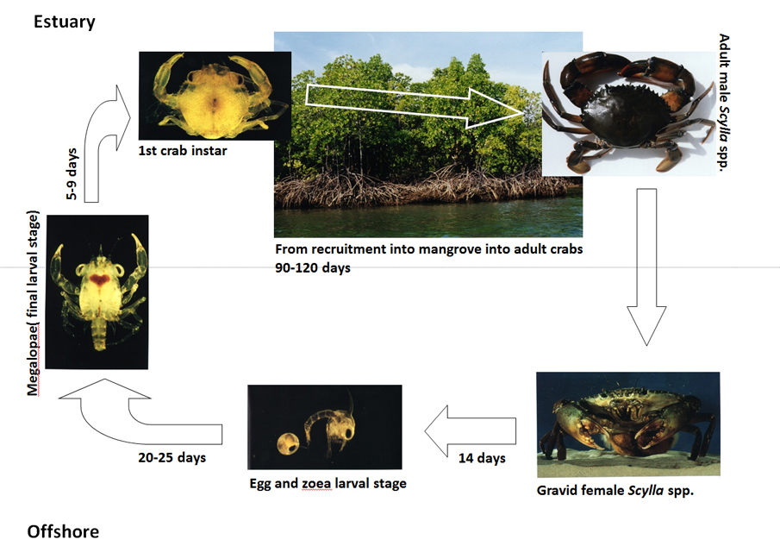
Figure 23: Mangrove-associated life cycle diagram of the mud crab Scylla olivacea.

There is also good potential to introduce simple crab farming methods in Miani Hor. Two of the most common fish species caught in the lagoon, Liza viridis and Acanthopagrus berda, also have aquaculture potential.

5.4 Kalmat Khor
This large lagoon is connected to the Arabian Sea by a single, centrally located 2 km wide channel. It has a reported surface area of 10,216 ha (Mukhtar and Hannan, 2012). Unlike Miani Hor, there is no direct inflow of freshwater; the nearest river is the Basol River 15 kms east of Kalmat Khor. The climate is arid with only slight seasonal rainfall; as a result the lagoon is hypersaline year-round. Avicennia marina is the only naturally-occurring mangrove species in this lagoon.

The natural Avicennia mangroves in Kalmat Khor were described as dwarf by Rasool and Saifullah (1996), with an average tree height in 1994 of only 2m, indicating suppression of growth due to the lagoon’s high salinity environment. They also observed that the mangroves were exploited heavily by the local communities for fuelwood and fodder for their camels and cattle.
There are still remnants of the original mangrove forest in the lagoon and grazing lines caused by camels can be seen clearly on the trees (figure 24).
Figure 24: A kharai camel among natural Avicennia marina mangroves in Kalmat Khor. Q Abdul Rahim

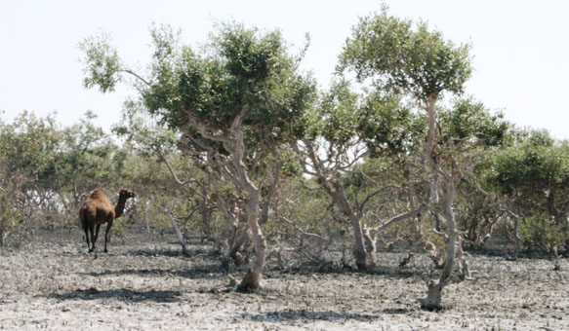
The area of mangroves in Kalmat Khor reached a low point in the 1990’s of only 277 ha (Table 5). Due to reforestation/afforestation of mudflats bordering Kalmat Khor by donor projects and BFWD, the mangrove area has increased significantly since the 1990s, reaching 662 ha in 2010 and 933 ha in 2020 (Table 5). A further 1,000 ha approximately have been created more recently by planting 1.2 million seeds/seedlings of A. marina (BFWD, unpublished data).
In 2022, 551.762 acres (223.295 ha) of mangrove forest in Kalmat Khor was declared Protected Forests by BFWD Notification No.SO (Dev-1) 6-5/ Forest-2022/4138-50 under the Balochistan Forest Act 2022. As in Miani Hor, this act allows local inhabitants to take mangrove wood and other forest produce for their own use only. Large-scale removal or commercial use of such produce is prohibited.

5.5 Jiwani Coastal Wetlands (Gwatar Bay)
The Jiwani wetlands in Gwatar Bay are a large complex of inland and coastal wetland habitats covering more than 26,000 ha (Stedman-Edwards, 2000) in western Balochistan near the border with Iran. The coastal wetland component, which includes mangroves and other salt-tolerant shrubs, covering an area of about 4,600 ha, was declared a Ramsar site (25°05'N, 61°48'E) in 2001. The Jiwani Ramsar site is contiguous with the Govater Bay and Hur-e-Bahu Ramsar site in Iran covering 75,000 ha, which also includes mangroves.
The Jiwani wetlands are protected on the seaward side by a wide beach front running parallel to the coastline, with a deltaic and lagoon-like formation of mangroves and mudflats behind it. The mangroves receive freshwater from the Dasht River, the largest river in Balochistan. However, the river’s inflow does not bring large quantities of sediment into the habitats where the mangroves are found (Qureshi et al., 2001). Thus, sediment availability may represent a restriction on increasing the mangrove cover by rehabilitation or afforestation.
The history of mangrove exploitation and rehabilitation in Jiwani is similar to that described in Kalmat Khor. Due to past cutting for wood and fodder, the mangrove area was only 83 ha in 1995, but rehabilitation/afforestation activities increased the mangrove cover to 193 ha by 2010 and to 223 ha by 2020 (Table 5).
In 2022, 551.762 acres (223.295 ha) of mangrove forest were declared Protected Forest by BFWDP (Notification No.SO (Dev-1) 6-5/ Forest-2022/4191-4203) under the Balochistan Forest Act 2022. This notification applies the same restrictions on mangrove exploitation as in Miani Hor and Kalmat Khor; namely, that local inhabitants may take wood or other forest produce, but only for their own use.
The Jiwani coastal and inland wetland habitats are important as staging or wintering grounds for many species of waterbirds, most of which are migrants that arrive in Jiwani in August-September and leave by the end of April (Pandrani, et al., 2005). The Jiwani Ramsar site is also critically important for green turtles (a species classified by IUCN as Endangered) and Olive Ridley turtles (classified as Vulnerable). Females of these two species come onshore to nest on four sandy beaches on the eastern side of the Ramsar site near Jiwani Town.

5.6 Shabi Khor-Ankra Creek and Shadi and Sawar khors
These mangrove sites are small, but they are significant because they have added to the recorded range of distribution of mangroves in Balochistan (see Table 5). Despite an acute shortage of freshwater at these locations, plantations of Avicennia marina and Rhizophora mucronata were developed successfully by IUCN and handed over to the BFWD (figures 25 and 26).
Figure 25: Avicennia marina planted in Shabi Khor. Q IUCN Pakistan

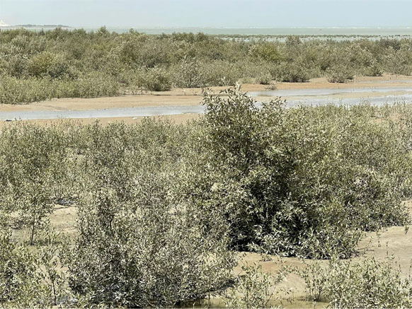
Due to their arid climates, compounded by a lack of freshwater and fine sediment reaching these sites, the environmental conditions can be considered close to the tolerance limits of R. mucronata. Thus, it will be valuable to monitor the long-term survival, growth and reproduction of R. mucronata in these plantations in relation to climate change impacts on the local environment, especially environmental temperature and salinity.
Figure 26: Rhizophora mucronata planted in Shabi Khor. Q IUCN Pakistan

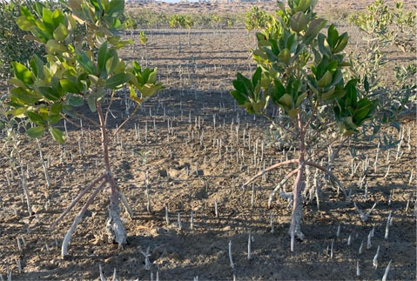

6. Current Threats to Mangroves
in Pakistan

6.1 Introduction
The recent causes of mangrove degradation and loss have been similar in the four South Asia countries of Pakistan, India, Bangladesh and Sri Lanka (Giri et al., 2015). They include over-harvesting of wood, animal fodder and fishery resources; reduction in the supply of freshwater and silt; coastal erosion; pollution; storm and tsunami impacts; and conversion to other land uses.
This section of the assessment examines each of these threats to mangroves in Pakistan, including the estimated scale of their impacts and the likely trend: whether they are expected to be a decreasing or increasing threat to mangroves in the future.

6.2 Wood and Fodder Exploitation

6.2.1 Domestic Wood and Fodder Use
The early literature on Pakistan’s mangrove forests records that mangroves were exploited heavily for fuelwood, timber and animal fodder, resulting in degradation of many of the original forest areas. This was certainly the case in the Indus Delta (e.g. Saifullah, 1997), while over-exploitation of mangroves for timber and camel fodder has also been blamed for areas of deforestation in Miani Hor (Muhammad et al., 2022).
Mangrove felling for wood extraction increased in scale during the 20th century, in part because of population growth, while alternative sources of fuel were either not available, or were more expensive than mangrove wood. One study of household fuel use in the late 1990’s showed that 46% of 125 households surveyed in the Indus Delta, and 22% of 73 households in Balochistan, were still using mangrove wood (Stedman-Edwards, 2000). Not surprisingly, therefore, between 1990 and 1998 the country’s total area of mangrove forests declined qualitatively from dense to normal and/or sparse vegetation (Mukhtar and Hannan, 2012), with wood and fodder extraction being the main cause.
The impact of wood and fodder exploitation on mangroves is rather different today, certainly in Miani Hor in Balochistan, where other fuel sources are now readily available, especially cylinder gas and mesquite wood (Prosopis juliflora). Nonetheless, mangrove fuelwood and timber extraction are still identified as drivers of deforestation in the Participatory Forest Management Plan 2022-2031 for Miani Hor, including some timber harvesting for boat-building and tool-making (Muhammad et al., 2022). Although the large resident population of fisher households living in Miani Hor do have the right to collect dead, dry and fallen mangrove wood, tree-cutting for fuelwood and fodder is difficult to control, unless this is done by the communities themselves.
Some communities in the Indus Delta still depend heavily on mangroves for fodder, fuel wood and timber for hut-making. Findings from a recent project in Keti Bundar and Kharo Chan implemented by WWF-Pakistan, “Sustainable Management of Mangroves Ecosystem and Enhance Resilience of Coastal Communities in the Indus Delta" (2019-2022), associated mangrove degradation with householders' dependency on mangroves for fuelwood, timber, grazing, and fodder for livestock. This project found that "The use of mangroves for livestock is largely unmanaged and unregulated." It also concluded that the resulting loss of essential mangroves-based ecosystem services included a decline in fishing activities.
Much has been written about the impact of fodder collection and livestock grazing on mangroves, especially the harm to mangrove growth and regeneration attributed to camels (Stedman-Edwards, 2000). While the impact of camels on mangroves has not been quantified, camel grazing is regarded as a localised rather than widespread problem. For example, camel grazing still impacts some mangroves in landward areas of Miani Hor (an informant advised that there are only 8-10 camels kept at Miani Hor, but 80-90 others are brought from elsewhere to graze there). As a partial offset measure, local people in Miani Hor are permitted to harvest young mangrove branches and leaves as fodder for camels and other livestock.
Camels still pose a significant threat to mangroves in parts of the Indus Delta (figure 27). This was a major local issue mentioned by community respondents interviewed in Keti Bundar during the present assessment. Similarly, Abbas et al. (2013) described camel grazing as a major threat to the delta’s mangroves causing sparseness of the forest canopy. They concluded that tree cutting and camel grazing are the main causes of mudflat erosion, or the presence of sand deposited by wave action, in the absence of mangroves.
Figure 27: A large camel herd at Dadiwari Creek near Port Qasim, Indus Delta. Q M.K. Jamali

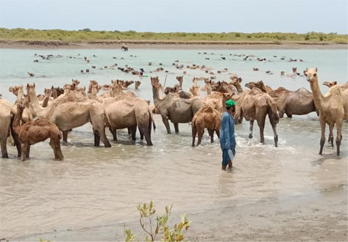

Thirty percent of the 1.1 million camels in Pakistan are found in Sindh and the coastal mangroves of Thatta, Badin and Karachi are one of the four ecological zones that support camels in the country (Faraz, 2020). The kharai camels of Pakistan are good swimmers and previously were taken to the islands in the delta in summer to graze on the mangroves. However, subsequent mangrove loss and the lack of freshwater reaching the islands has forced the camel herders to confine their animals mainly to the mainland where the grazing pressure is now locally more concentrated.
Grazing and trampling by camels and cattle is particularly harmful to planted mangrove seedlings and saplings. Camels like to eat the tender foliage of young mangrove plants, which are also easily trampled on, making new mangrove plantations highly vulnerable.
There has been a decrease in camel ownership in Pakistan over recent years, but other forms of livestock are on a significant rising trend. FAO (2009) estimated that Pakistan’s mangroves provided forage for around 8,000 camels, compared with up to 16,000 camels reported to graze on mangroves in the Indus Delta in the early 1990s (Qureshi, 1993). The swimming kharai camel is now considered to be on the verge of extinction (Guriro, 2017), although other camel breeds are still plentiful
Professional herders, each managing hundreds of camels, cause the greatest impact but they are difficult to control. However, some success has been achieved by the Sindh Forest Department through a combination of the Watch and Ward system and agreement with the camel herders to use allocated grazing areas on a rotational basis.

6.2.1 Illegal Commercial Logging of Mangroves
Commercial logging of large mangrove trees is prevalent along the Karachi coast. Recently, the scale of this illegal practice in the Port Quasim area has been highlighted by WWF-Pakistan. Mangrove loggers generally prefer mature trees 5-15 cms in diameter which they can fell selectively within dense forest areas to avoid detection (figure 28). The cut trees are left for about one week to dry before being transported by boat and then by road to the local market (figures 29 and 30).
Figure 28: Sindh Forest Department staff investigating the selective felling of trees in
mangrove forest on the Karachi coast: the stumps of cut trees are clearly visible. Q M.K. Jamali

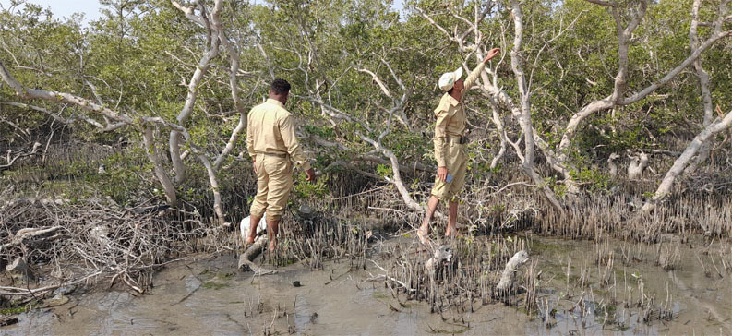
According to WWF (2024) this illegal commercial logging of mangroves is much greater than the domestic consumption of more than 100 tonnes per day of mangrove wood used by households living along the Karachi Coast. Commercially logged mangrove wood is sold to fish meal producers and other businesses. The demand for mangrove fuelwood has considered to have increased because of the current high price of cooking gas.
Figure 30: Onward transportation of felled mangrove wood near Ibrahim Hyderi Village,
Malir District, Karachi: saw and axe cuts in the wood are clearly visible. Q Babar Hussain

Figure 29: Boat transportation of mangrove trees felled illegally near Port Qasim. Q M.K. Jamali

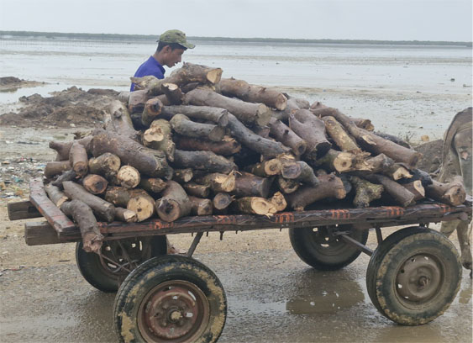
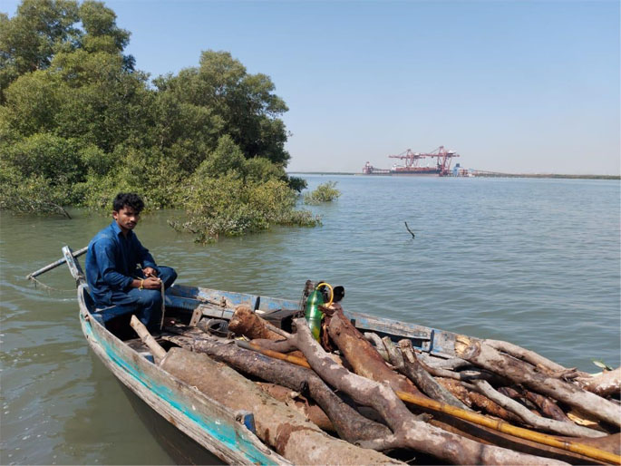
Unless there is stronger enforcement of the rules pertaining to mangroves as Protected Forests, which prohibits inter alia “cutting, sawing and removal of reserved trees and timber;” commercial logging will continue and is likely spread to other coastal areas. However, it is easy for violators to exploit a provision in the law on Protected Forests that allows communities to use dead or fallen mangrove wood.

6.3 Freshwater Deficiency
The entire coastal belt of Pakistan is suffering from an acute shortage of freshwater, which is affecting coastal communities, agriculture, fisheries and mangroves. The historic cause has been the damming and channelization of the Indus River for irrigation and flood control purposes. Lack of freshwater has been a major driver of mangrove ecosystem degradation and species loss (see section 2.3.2). Climate change, in the form of less precipitation and shorter wet seasons, is also contributing increasingly to the deficiency of freshwater, especially in Balochistan.
Over a period of about 100 years, the volume of freshwater supplied to the Indus Delta has decreased steadily from a natural flow of 185,000 million cubic metres annually from the Indus River to just 7% of this amount (Table 6). The acute shortage of freshwater reaching the delta has impacted both the mangrove ecosystem and the many species associated with mangroves. It has also greatly affected the livelihoods and well-being of coastal communities. Guriro (2017) quoted local people as saying that “all the creeks, deltaic islands, channels and empty river beds, where once there was thick mangrove forest, are now completely barren”. IUCN Pakistan has estimated that an average freshwater flow of 1 cusec (about 28 litres per second) is needed per 40 ha of forest for healthy growth of mangroves (IUCN, 2016).

Table 6. Decrease in freshwater reaching the Indus Delta in Sindh Province 1890s to 1990s.
Year | Annual Indus water volume supplied to Sindh Province (million cubic metres) | Intervention
1892 | 185,000 | Unrestricted natural river inflow
1932 | 105,000 | Sukkur Barrage constructed (in 1932)
1960 | 79,581 | Kotri Barrage constructed (in 1955)
1970 | 43,000 | Indus Water Treaty (in 1960)
1990s | 12,300 | Pakistan Water Apportionment Accord among provinces (in 1991)
Modified from Bux Mallah (2013).

The consequence of the extreme decrease in freshwater flow to the lower delta is that the coastal water salinity has increased significantly, from 15-20 ppt about 50 years ago, to 45-50 ppt in recent years (Rafique, 2018). While this may be an overestimate, the current dry season salinity in coastal waters is certainly in the range 40-45 ppt.
The effect of increased coastal salinity is clearly evident in the form of suppressed growth of planted mangroves. The now hypersaline environment is also impacting on aquatic biodiversity and the productivity of coastal fishery stocks. The most obvious indicator of this is the decline is the once rich coastal prawn fisheries and stocks of estuarine fish species.

6.4 Reduced or Excessive Sediment Supply
Due to the diversion of freshwater for irrigation, and loss of the high silt load carried previously by the Indus River system, the rate of sediment aggregation in the delta is now only 1 mm per year. This is less than the rate of subsidence of around 1.3 mm per year. In contrast, the annual sediment aggregation rate early in the 20th century was 8 mm (Syvtiksi et al., 2009), which created highly suitable soft substrata in the form of mud banks and mud flats for mangrove colonisation and growth.
Because mangroves are sediment-dependent, the great reduction in the riverine (alluvial) sediment supply has contributed significantly to the loss and degradation of mangroves, especially mangroves on the islands and along creeks in the southern part of the Indus Delta. Fine alluvial sediments have been replaced by courser sandy marine sediments, which are much less suitable for mangroves because the latter are less stable, as well as being lower in nutrients compared to muddy sediments originating from the land.
In extreme cases, an oversupply of sediment can physically smother mangroves by blocking the aerial breathing roots (pneumatophores). This can occur during severe floods if excessive amounts of sediment are carried into mangrove areas by flood water. It has been reported as a cause of death of A. marina trees along the Red Sea coast (Suda, 2013), but flood-borne sediment is unlikely to be a significant risk to mangroves in Pakistan.
More commonly, however, sediment smothering of mangroves occurs as the result of coastal construction work and the release of large quantities of soil or sediments during excavation activities. For example, dredging of bottom sediment in order to deepen the shipping lane at Port Qasim, and its disposal via a pipeline into natural A. marina forest, resulted in the death of trees due to sediment smothering of their pneumatophores (Suda, 2013).
It has been estimated that the dumping of solid sediment waste can be harmful to mangroves if it exceeds a rate of about 5 mm of sedimentation per year (Vaiphasa et al., 2007). However, mangrove seedlings planted in waste sludge from aquaculture ponds can grow well provided the sediment is allowed to settle in sedimentation ponds or other suitable set-aside locations before planting (Macintosh, 1996). This rapidly oxidises the sulphides in the sludge that could be toxic to mangrove seedlings and aquatic life (Frederiksen et al., 1998).

6.5 Coastal Pollution
Much has been written about pollution as a threat to mangroves, However, it is important to identify the types of pollutants involved rather than to generalise that all pollutants are harmful. Mangroves actually tolerate high nutrient levels very well, to the extent that they are advocated as natural biofilters for nutrient-rich waste water. Whereas, in contrast, oil pollution can be highly toxic to mangroves (Lacerda et al., 2001).

6.5.1 Status of Coastal Pollution in Pakistan
Coastal pollution is not widespread in Pakistan, but it has been a serious concern for many years in the Lyari River outfall and Karachi Harbour areas (e.g. Khan and Saleem, 1988). Today, pollution may represent a significant threat to the mangrove ecosystem of the northwest Indus Delta region because of the huge quantities of effluent and other wastes emanating from the Karachi metropolitan area, the cattle colony (where livestock are slaughtered) and surrounding industrial sites, which include steel and textile industries. However, pollutants emanating from the greater Karachi area are more likely to impact on the aquatic organisms in the coastal ecosystem, rather than on the mangrove vegetation; these pollutants also represent a significant risk to human health.
Pollution is not yet a threat to mangroves in Balochistan, but there is concern that pollutants from Karachi discharged via the Lyari River mouth and Karachi Harbour could eventually reach Miani Hor in eastern Balochistan. The new deep-water port and associated large scale industrial and urban development at Gwadar present a future potential pollution risk to the coastal ecosystems in western Balochistan.
There is already a current risk of pollution in the form of cross-border smuggling of diesel and petrol (at a rate of 1.2 million litres per day) from Iran into Gwadar, which usually takes place via the Jiwani creek system (Moazzam et al., 2021). Not only the mangroves, but also the Daran turtle nesting beach, have been impacted by this illicit practice. Without further action by the authorities to halt the smuggling of petroleum products from Iran, the Jiwani wetlands will undoubtedly become exposed increasingly to pollution risks from oil spills and seepage.

6.5.2 Types of Coastal Pollution and their effect on Mangroves
Coastal pollution along the Karachi coast stems from a combination of household, municipal and industrial wastes, and from oil spills or discharges from ships (figure 31). Mangrove-fringed waterways such as Rehdri Creek near Port Qasim have been polluted heavily for many years with TSS, BOD, COD readings, and heavy metal concentrations, well above the National Environmental Quality Standards, as well as containing high levels of phosphate and nitrogen compounds (Shahzad et al., 2009).
Figure 31: Pollutants discharging into mangroves from Rehdri Creek, Karachi. Q Waqar Ahmed

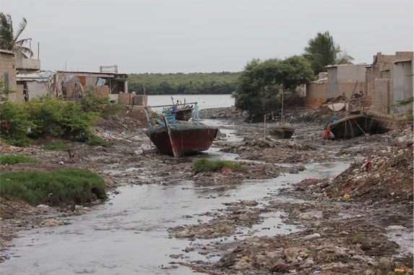
More than 75% of the municipal and industrial waste from Karachi and adjacent industrial areas discharges via the Lyari River estuary into the sea through or near Karachi Harbour. Karachi generates 472 million gallons per day (MGD) of wastewater and sewage, whereas sewage treatment was reported to be only 55 MGD; the remainder (88%) flows untreated into the Arabian Sea (Tahir, 2017).
Water samples taken from the Lyari River and Karachi Harbour area by Nergis, et al. (2021) showed high BOD and COD values above the Sindh Province Environmental Quality Standards (SEQS). Nickel was also significantly above the SEQS limit because of its presence in waste released by the electroplating industries, while the concentrations of other heavy metals including cadmium and lead were also high.
Heavy metals like cadmium, lead and nickel entering coastal food chains pose a significant risk to human health. Mangrove trees can retain high concentrations of heavy metals at the level of their root systems within sediments, thereby preventing or greatly reducing heavy metal release into the aquatic environment (Lacerda et al., 2001).
Mangroves can also serve as a barrier to leaching of heavy metals into the sea, for example from landfill sites for solid wastes. Although mangroves can contribute to reducing heavy metal pollution in these ways, mangrove growth and ecosystem health can be affected severely by excessive levels of heavy metals in the environment.
In contrast to the harmful impact of heavy metals, mangrove trees are quite tolerant of eutrophic water containing high concentrations of the nutrients typically present in wastewater from domestic, agricultural and aquacultural sources.
Mangroves are actually considered suitable as natural biofilters to treat the waste water from prawn farms, which often contains high levels of nitrogen and phosphorous from prawn waste and uneaten food (Robertson and Phillips, 1995). The high economic value assigned to the mangroves in Korangi-Phitti Creek as biofilters of the wastewater from Karachi is shown in Table 11 (section 11.2.3).
In contrast, the aquatic organisms associated with mangrove ecosystems are much more susceptible to organic pollutants, eutrophication and high BOD levels (especially plankton, prawns and some fish species). Consequently, it is the aquatic biota in the mangrove ecosystem that is most affected, rather than the mangroves trees themselves. A recent study has also reported high concentrations of micro plastics in the surface water and in estuarine and coastal fish species on the Karachi coast (Arshad et al., 2023)
Unlike most other organic pollutants, oil can be very harmful to mangrove vegetation as well as to the associated mangrove biota. Because of its thick and adhesive properties, oil from spills or dumping can accumulate on the soil surface and roots and pneumatophores of mangroves, which usually kills any epifauna present and causes the trees to defoliate and eventually die. Oil pollution can also cause major lethal or sub-lethal impacts on mangrove-associated macrofauna: these include physical smothering, impairment of physiological and behaviour functions, and off-flavours in fishes, prawns and crabs (e.g. Yuewen and Adzigbl, 2018).
Natural mangrove regeneration and ecosystem recovery can be very slow after an oil spill and planted seedlings may not survive (Lacerda et al., 2001). Interestingly, Avicennia propagules and trees seem to be more susceptible to oil exposure than Rhizophora mangroves (Getter et al., 1985; Naidoo, 2016). One explanation is that the salt exclusion mechanism of Rhizophora roots may help to reduce the uptake of toxic derivatives from oil, whereas Avicennia roots do not have this mechanism.
Because Pakistan’s legislation on pollution control is not being enforced to an effective level, the contamination of coastal waters by pollutants, especially in Karachi Harbour and adjacent areas, will continue. There is a significant risk that pollution will increase due to further population growth, accompanied by municipal and industrial expansion, unless there is stronger control of pollution through enforcement.
In conclusion, it is misleading to regard all forms of pollution as being harmful to mangroves, although some pollutants clearly are. Wastewater and sediments high in nutrients may actually benefit mangrove growth, as evidenced by the luxuriant mangroves growing in the Phitti Creek area near Karachi, whereas heavy metals and especially oil pollution are highly toxic to mangroves.

6.6 Climate Change
Pakistan was ranked fifth by Germanwatch in the global list of the countries that were most vulnerable to climate-related shock events (e.g. from storms, flooding, heatwaves) during the 20-year period from 1999 to 2018 (Eckstein et al., 2021), a ranking that does not include impacts from the severe flooding event in Pakistan in 2022. In relation to national efforts to combat climate change, Germanwatch has scored Pakistan low in the Climate Policy category, very low on Renewable Energy, and high in GHG Emissions and Energy Use (Burck et al., 2023).

6.6.1 Sea-level rise
Sea-level rise (SLR) is a major consequence of climate change and shallow coastlines and islands are the first to be impacted. SLR is caused by a combination of thermal expansion of the oceans as they become warmer and an increase in water entering the oceans from the melting of continental glaciers. SLR is severely impacting Pakistan’s coastal zone and its natural resources, especially in Sindh Province.
The Indus Delta is the world’s fifth largest delta and ranks as the third most vulnerable to climate change (Aeman et al., 2023). The coastal zone of Sindh is highly vulnerable to SLR because it has a flat topography and the coastal city of Karachi contains a large population with a high concentration of surrounding coastal industries. In area, 475,000 ha of the delta is less than 2 m above sea level (Syvtiksi et al., 2009).
From 1856 to 2000, the estimated SLR along the coast of Karachi was only 1.1 mm per year and therefore historically sedimentation in the delta exceeded SLR, enabling mangroves to flourish on the deposited soft sediments. However, coupled with the decrease in the amount of sedimentation, the rate of SLR has increased rapidly in recent years.
According to IPCC (2023), global mean sea level rose by 1.3 mm yr⁻¹ between 1901 and 1971; by 1.9 mm yr⁻¹ between 1971 and 2006; and by 3.7 mm yr⁻¹ between 2006 and 2018 (IPCC, 2023). The median projection for SLR in South Asia to 2100 is 0.7 m; and for Karachi SLR is expected to be 0.20 m to 2050, 0.33 m to 2070 and 0.60 m to 2100.
The coastal zone of Balochistan is less vulnerable to SLR because the coast is uplifting by 1-2 mm/year due to tectonic activity (Chaudhry, 2017). Moreover, sediment deposition rather than erosion is occurring in Miani Hor where the province’s main concentration of mangroves is located. However, the coastal cities of Pasni and Jiwani in Balochistan are experiencing significantly hotter weather and fewer rainfall days per year (Abbas et al., 2017). Thus, other climate change-driven trends, in the form of higher temperatures, less rainfall and increasing salinity in Balochistan’s coastal waters, will become increasingly detrimental to local communities, fishery stocks and mangroves.

6.6.2 Storms and Flooding
Climate change is causing more frequent and severe tropical cyclones in some regions of the world, including Pakistan. In the period 1982 to 2019, the frequency, intensity and duration of cyclonic storms showed a significant increasing trend over the Arabian Sea, including a more than 50% increase in cyclone frequency in the most recent years 2001 to 2019 (Deshpande et al., 2021). The maximum intensity and duration of cyclonic storms also increased significantly during this period compared to 1982-2000.
Low-lying coastal zones like the Indus Delta are particularly vulnerable to cyclonic storms, which cause not only wind damage, but also bring major flooding events due to sea surges. In addition, the extreme precipitation associated with cyclones increases the risk of land-based flooding from flash floods or river spill-over.
Coastal villagers in the Indus Delta are ill-prepared for the shock events caused by storms. When Cyclone Yemyin struck Keti Bundar in 2007 more than 22,000 people were affected and 1,800 houses and 200 fishing boats were destroyed or damaged (WWF, 2007). A more severe cyclone made landfall at Shah Bundar in 1999, killing 6,200 people, while an even deadlier cyclone struck Karachi in 1965 killing an estimated 10,000 people.
Based on recent cyclone research, there is relatively high confidence that climate change is increasing the precipitation produced by tropical cyclones and intensifying their wind speed. There is also high confidence that storm surge-driven flood risks are increasing due to sea-level rise (Sobel et al., 2021). Thus, cyclones are an increasing threat to Pakistan’s coastal belt, especially in Sindh Province.
Mangroves are a vital natural defence against cyclonic storm impacts because they can absorb a considerable amount of the wind and water forces generated by a cyclone (e.g. Kella, 1999). For this reason, mangroves can reduce the vulnerability of coastal communities. Thus, the role of mangroves in protecting lives, property and livelihoods from cyclone impacts in Pakistan deserves to be given greater recognition and promoted as one of the important co-benefits provided by large-scale mangrove rehabilitation/afforestation programs.

6.6.3 Coastal Erosion
Sea currents and wave action are the main physical drivers that determine coastal land erosion or accretion dynamics. Sediment aggregation and mangrove vegetation (especially their root systems) can slow the rate of shore erosion, or assist shore accretion, but mangroves cannot reverse erosion without a sufficient supply of sediment. On the contrary, the great reduction in river-borne sediment reaching the main part of the Indus Delta, coupled with land subsidence and mangrove loss, has accelerated seawater intrusion, leading to severe erosion and salinization of coastal land and waterways (figure 32).
Figure 32: Severe erosion in a mangrove-fringed creek near Keti Bundar. Q Don Macintosh

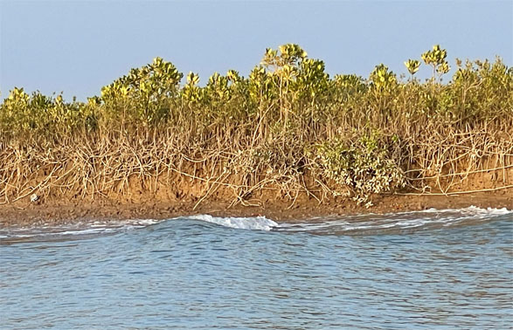

Coastal erosion also has a climate change element because sea-level rise (SLR) and more frequent storm surges act additively to accelerate erosion processes. A study by WWF-Pakistan of erosion versus accretion at Keti Bundar and Kharo Chann showed that 9,065 ha of coastal land were eroded from 1962 and 2011, whereas only 1,347 ha of land were gained by accretion (cited by Chaudry, 2017). The same study found that Ghoro Creek had the highest rate of erosion, with 425 m of land lost to the sea from 2006 to 2009, or 176 m per year. Other high erosion areas included Hajamaro, Kanhir and Kahhar creeks with loss rates of 31 m per year or more.
Another study of erosion along the Sindh coast covering the period from 1989 to 2018 reported widespread erosion along the entire coastline, but in general the erosion rate is increasing from west to east across the Indus Delta region. The Karachi coastline actually experienced an annual net gain of land (erosion 2.43 ± 0.45 m; accretion 8.34 ± 0.45 m), whereas the right and left banks of the Indus River showed an annual average net loss from erosion of 12.5 ± 0.55 m and 19.96 ± 0.65 m, respectively (Kanwal, et al., 2020).
Coastal erosion is likely to become increasingly severe in the main part of the Indus Delta as SLR and more frequent storm surges have increasing impact on the coastline.
Coastal erosion is difficult to control, but soft engineering solutions have been developed that can halt erosion and rebuild eroded coastlines in some locations. They involve a combination of wooden fencing and planted mangroves. The fencing serves to reduce the velocity of tidal and current water flow, allowing soft sediments to settle behind the fence. This creates more favourable conditions for mangroves planted behind the fence to grow and stabilise the accumulated sediment.
This method has been applied successfully in several Southeast Asian countries, but it is costly and location specific as to its suitability. Examples include erosion control projects in Vietnam (Schmitt et al., 2013; Thornton and Johnstone, 2015) and the inner Gulf of Thailand. Winterwerp et al. (2020) provide a general assessment of the use of fences and other semi-permeable structures together with mangroves to control erosion on muddy coasts.

Encroachment and Land Conversion
Loss of mangrove habitat caused by encroachment, mangrove conversion or unauthorised land allocations for urban or industrial expansion is a severe problem in the coastal areas near Karachi (WWF-Pakistan, 2024). This has included a rapid loss of mangrove cover on land under the jurisdiction of the Karachi Port Trust and Port Qasim Authority, despite the mangroves still having the status of Protected Forests.
Encroachment is a widespread problem affecting mangroves near large urban areas in many countries. It usually starts gradually with increasing levels of mangrove degradation, followed by deforestation and finally complete land conversion e.g. to illegal housing, as in Karachi (figure 33).
Strict control measures are required to halt encroachment and unauthorised conversion of the Karachi mangroves otherwise this cause of mangrove loss is likely to increase over time. As reported by WWF (2024) mangrove deforestation can be monitored precisely by satellite remote sensing and GIS. However effective enforcement of the laws on forest protection requires coordinated action by the relevant authorities, including significant penalties for those encroaching into mangrove forests or converting them illegally for other uses of the land.
Figure 33: Encroachment and land conversion of mangroves in Karachi. Q Google Earth Image

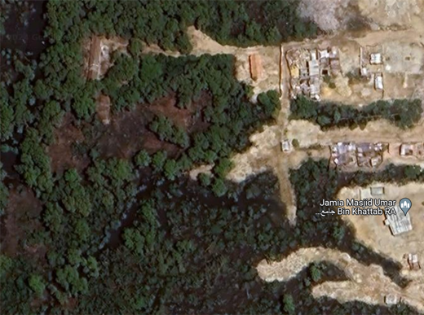

7. Biodiversity of Pakistan’s
Mangrove Ecosystems

7.1 Introduction
Although there are little more than 70 species of true mangroves worldwide, mangrove ecosystems support many other associated plant species, a huge diversity of aquatic, intertidal, terrestrial and avian animal species, and countless meiofaunal and microbial organisms.
The main focus of this section is to review the mangrove tree species in Pakistan, both past and present. It also assesses some of the important mangrove-associated macrofauna, especially birds and large mammals due to their ecotourism value, and in some cases threatened status. Mangrove-associated fishery species are also reviewed because of their socio-economic importance to Pakistan’s coastal communities.

7.2 True Mangrove Species in Pakistan Past
and Present
There is considerable interest and importance attached to the mangrove species that have been reported previously in Pakistan, but which are now absent and presumed to be locally extinct.
From historical plant collections, Stewart (1972) listed eight mangrove species: Avicennia marina, Rhizophora mucronata, Ceriops tagal, Aegiceras corniculatum, Sonneratia caseolaris, R. apiculata, Bruguiera gymnorhiza and C. decandra. Saifullah (1982) also reviewed the early accounts of mangrove species in the country from studies dating from 1872 to 1973 and included their reported locations (Table 7). Saifullah’s list of eight mangrove species is also quoted frequently in more recent publications on mangroves in Pakistan (e.g. Wagan, 2018).

Table 7. Mangrove species in Pakistan based on Saifullah (1982) with additions from Stewart (1972).
Species | Synonyms | Recorded Locations | Author/source
Bruguiera conjugata | Rhizophora conjugata  B. gymnorhiza | Sindh: Indus Delta  Karachi and Indus Delta; estuary of Indus | Kogo et al. (1980) in Saifullah (1982)  Stewart (1972)
Ceriops tagal* | R. tagal  C. candolleana | Sindh: Keti Bunder; Balochistan: Miani Hor  Karachi and coast of Sindh; mouths of Indus and ''saltwater creeks" | S.M. Saifullah in 1977 (Saifullah, 1982)  M. Kogo in 1981; (Saifullah, 1982)  Stewart (1972)
C. roxburghiana | R. decandra | Sindh  Sindh in the tidal zone | Saifullah (1982)  Stewart (1972)
Rhizophora apiculata | R. conjugata | Balochistan: Lasbela, Miani Hor  Tidal marshes at the mouths of the Indus; Miani Hor, Las Bela | Saifullah (1982)  Stewart (1972)
Rhizophora mucronata* |  | Balochistan: Lasbela, Miani Hor, Makran coast  Mouths of the Indus on muddy shores and tidal creeks | S.M. Saifullah in 1977 (Saifullah, 1982)  Stewart (1972)
Aegiceras corniculata* | R. corniculata  A. majus | Sindh: Indus Delta, in Chinna Creek, Karachi  Mangrove swamps at mouth of the Indus; Karachi; Miani Hor | Jafri (1966) cited in Saifullah (1982)  Stewart (1972)
Avicennia marina* | A. officinalis  A. officinalis var. alba  A. alba | Sindh: all along the coastline; Balochistan: Miani Hor, Kalmat Hor  Tidal mangrove swamps of Sindh and Balochistan; Sandspit, Chinna Creek, etc. | Saifullah (1982)  Stewart (1972)
Sonneratia caseolaris | R. caseolaris  S. acida | Sindh: Indus Delta  Mouths of the Indus and tidal zones; mangrove swamps; very common | Saifullah (1982)  Stewart (1972)
* The mangrove species still present in Pakistan.

Unfortunately, the historical record is rather confusing because different generic and species names have been used in some of the early records and not all the species identifications can be verified. The most puzzling among these is Bruguiera gymnorhiza, which has not been reported in Pakistan since the 1970s (Kogo, et al., 1980). The identifications of B. gymnorhiza and C. decandra in Pakistan have even been doubted (Hogarth, 2001).
There are two main questions to consider: a) what were the reasons for the historical loss of four mangrove species from Pakistan; and b) can any/all of these species be reintroduced, propagated and planted for rehabilitation purposes to increase mangrove diversity?

7.2.1 Mangrove Species Assessment
This section summarises the status of each of the eight mangrove species listed in Table 7 from Saifullah (1982). The known salinity tolerance limits of each species are summarised in Table 8.
They are described below in the order: abundant, common, rare, locally extinct:
Avicennia marina: this is the most widely distributed mangrove species worldwide because it has the greatest tolerance to extreme environmental conditions, especially high salinity. This explains its widespread and abundant presence in both Balochistan and Sindh provinces. It is also the only widely distributed mangrove species in Iran, where the arid coastal environment is similar to that of Balochistan.
The remarkable tolerance of A. marina to hypersaline conditions is explained by its ability to tolerate a higher concentration of sodium and chloride ions in its tissues compared to other mangrove species. Avicennia mangroves are also able to secrete excess salt through special salt glands in the leaves.
In northwest Australia, which also has an arid coastal environment with high temperature and salinity conditions comparable to those in Pakistan, transpiration rates of Avicennia were high (daily maxima 32-91 mg dm⁻² min^{-I}) despite high soil salinity (65-85 ppt). Avicennia also displayed consistently higher stomatal conductance and lower mid-day xylem pressure potential than Ceriops when exposed to the same environmental conditions (Gordon, 1993). These findings show that, compared to other salt-tolerant mangrove species. Avicennia is able to maintain a higher transpiration rate even in extreme salinity conditions.
Rhizophora mucronata: this species occurs naturally in Miani Hor and is also present in one coastal region of Iran. It is presumed that R. mucronata was previously widespread in the Indus Delta in the form of tall forests, but was overexploited for its valuable wood. Since being transplanted from Miani Hor back into the Indus Delta from the 1990s, rehabilitation/afforestation of R. mucronata has been an outstanding success.
Rhizophora mucronata is quite tolerant of high salinity because it can partially exclude salt from entering through its roots. However, unlike Avicennia species, it does not have salt secreting glands in its leaves. Titah et al. (2019) reported that the leaves of R. mucronata seedlings turned brown when plants were grown in 50 ppt salinity and cells in the roots showed extensive damage, suggesting that planted propagules or seedlings would not survive in salinities of 50 ppt or above.
Ceriops tagal: like R. mucronata, which is in the same plant family (Rhizophoraceae) C. tagal occurs naturally in Miani Hor and has been transplanted back into the Indus Delta. In nature, C. tagal is usually found among or behind the main forest zone of Rhizophora trees and this would have been the case in the delta. Ceriops tagal is described as almost as salt tolerant as A. marina, but is less able to cope with a sudden change in salinity (Aziz and Khan, 2001). It does not have salt secreting glands, but like R. mucronata, C. tagal is able to partially exclude salt from entering its roots.
Aegiceras corniculatum: this small mangrove tree is seldom a major component of mixed mangrove forests, but it has value for biodiversity and livelihood support because its flowers are insect-pollinated and the nectar can produce excellent honey. This species has been misunderstood in Pakistan to be a "freshwater" mangrove. However, this is incorrect: A. corniculatum is actually quite tolerant of saltwater and its presence naturally in Pakistan demonstrates this. However, as with other mangrove species, it grows faster in more moderate salinities.
Sonneratia caseolaris: this species is less tolerant of saltwater compared to mangroves in the other genera reported from Pakistan: Rhizophora, Ceriops, Bruguiera and Aegiceras (e.g. Bunt et al., 1982). Although S. caseolaris can occur in seawater, it is found more typically in deep muddy soil bordering river estuaries where salinities are low due to significant dilution by freshwater. From earlier reports, Stewart (1972) recorded S. caseolaris in Sindh as follows: “mouths of the Indus and tidal zones; mangrove swamps; very common”. These conditions could only have occurred in the lower Indus Delta before freshwater flows to the coast were diverted for irrigation purposes.
Although it has also been suggested that Sonneratia caseolaris disappeared from the delta due to anthropogenic actions (Kogo et al., 1986), it would have been the species most susceptible to increasing salinity levels and decreasing fine sediment supply resulting from the construction of irrigation structure on the Indus River. It is notable that S. caseolaris is also not present in Gujarat, which has a similar arid environment to that of the Indus Delta.
Ceriops decandra: this species was reported previously from the Indus Delta, but there are no recent records to suggest that it has survived in Pakistan. However, Ceriops decandra is a salt tolerant mangrove species and grows in highly saline conditions in Gujarat. It is reported to have an extreme salinity tolerance of 67 ppt in Australia (Duke, 1992). Experimentally, growth of C. roxburghiana (=decandra) seedlings was found to increase with salinity up to a concentration of 17.5 ppt and seedlings could survive in 35 ppt (Elayaraj et al., 2018).
Bruguiera gymnorhiza: although there have been no reports of this species in Pakistan since the 1970s, the Indus Delta is still included within the geographical distribution of B. gymnorhiza in the IUCN Red List of Threatened Species. It was also reported previously from the Red Sea coast (Kalil, 2015), but B. gymnorhiza is now considered to be locally extinct there.
Bruguiera gymnorhiza is instantly recognizable because the flower buds are surrounded by calyces that are typically bright red (figure 34), making this species highly visible and easy to identify. It is also quite salt tolerant so its long absence from the delta is somewhat surprising.
Rhizophora apiculata: there is little information about the former presence of this species in Pakistan. It is reported in Stewart (1972) from earlier accounts that R. apiculata occurred as follows: “Sindh: tidal marshes at the mouths of the Indus; Miani Hor, Las Bela”. This species is not in Iran and is rare in Gujarat, if still present there? It was not found in Gujarat during a relatively recent (2018) botanical survey of the state’s mangroves (Saroj et al., 2018).

Rhizophora apiculata is less salt tolerant than the three common species in Pakistan, A. marina, R. mucronata and C. tagal. In seedling growth experiments, R. apiculata grew best in 0 ppt, whereas the other three species showed highest growth in 15-17ppt (de Silva and Amarasinghe, 2021).
Figure 34: The mangrove species Bruguiera gymnorhiza with distinctive
red calyses and cigar-like propagules. Q Don Macintosh

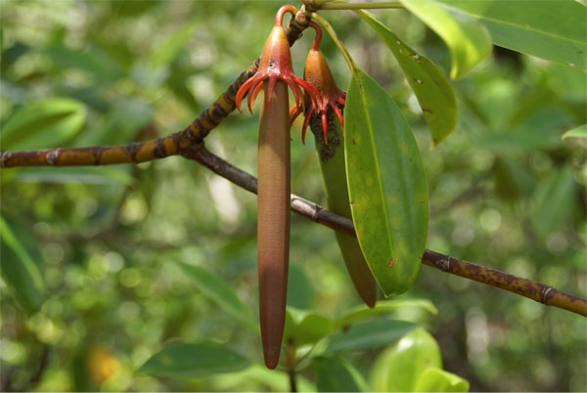
Another reason to doubt R. apiculata as a candidate species for reintroduction to Pakistan is the tendency for its flowers to have a high rate of abortion and hence this species can have poor self-recruitment (UNDP/UNESCO, 1991).

7.2.2 Species Selection for Reintroduction
A number of mangrove species from Malaysia, Singapore and Thailand were trialled on an experimental basis in the Indus Delta in the 1980s. They included both locally sourced and imported propagules of A. marina, R. mucronata and C. tagal, plus imported propagules of the four species no longer found in Pakistan (R. apiculata, C. decandra, B. gymnorhiza and S. caseolaris), as well as exotic species (other species of Avicennia, Bruguiera and Sonneratia, plus two Xylocarpus species and the mangrove-associated palm Nypa fruticans).
The propagule germination success was high for both the locally sourced and imported A. marina, R. mucronata and C. tagal propagules. Germination of the other species from Southeast Asia was variable, being 90% and above for B. gymnorhiza and C. decandra, compared to 60-70% for S. caseolaris, and as low as zero for some of the other exotic species. Beyond propagule germination, the exotic species trialled did not survive the more extreme conditions of the Indus Delta (Qureshi, 1990).
Although these trials had a number of limitations, including variation in the number and viability of propagules tested per species, the results support the conclusion from the present study that B. gymnorhiza and C. decandra are the two species most suitable for potential reintroduction to Pakistan. Whereas, Rhizophora apiculata, and especially S. caseolaris, are considered less suitable candidates for reintroduction.
In order to trial the reintroduction of B. gymnorhiza and C. decandra, it is recommended that propagules of these two species are sourced from Bangladesh via the Bangladesh Forest Department with the assistance of IUCN. However, importation from other countries may also be considered.
It is recommended that imported propagules of B. gymnorhiza and C. decandra should be raised in optimum salinity and temperature conditions to an advanced seedling stage before they are trialled in situ in the delta. This is a necessary step because the salinity tolerance capabilities of B. gymnorhiza and C. decandra depend on the seedlings having a well-developed root system. It is their roots that possess the salt-restricting mechanism used by these species to cope with high salinity.
Table 8. Salinity tolerance of current and former mangrove tree species in Pakistan.
Mangrove species | Salinity tolerance limit (ppt) | Optimum salinity for growth (ppt) | Source
Current species in Pakistan
Avicennia marina | 90* | 22 | Khan and Aziz (2001)
Rhizophora mucronata | 55*  ≤50** | 8-18  22 | Hoppe-Speer et al. (2011)  Khan and Aziz (2001)
Ceriops tagal | 60** | 22 | Khan and Aziz (2001)  Ayyaz et al. (2023)
Aegiceras corniculatum |  | 11 | Ayyaz et al. (2023)
Former species now extinct in Pakistan
Rhizophora apiculata | 30* | 5 (seedlings) | Basyuni et al. (2021)
Bruguiera gymnorhiza | ≥30 | 12 (seedlings) | Zhu et al. (2012)
Ceriops decandra | 67*** | 17.5 | Elayaraj et al. (2018)
Sonneratia caseolaris | ≤ 35* | very low (0-5)
* Source: Harrison et al. (1994) citing Chapman (1976).
** Titah et al. (2019) experimental testing of Rhizophora mucronata seedlings.
*** Roberson and Alongi (1992).

7.3 Mangrove-Associated Macrofauna
An early assessment of the macrofauna associated with mangrove ecosystems in Asia reported the following species numbers: insects/arachnids 500, fishes 286, crustaceans 229, molluscs 211, birds 177, reptiles 22 and mammals 36 (Saenger et al., 1983). Similarly, although Pakistan’s mangroves are dominated by a single tree species, Avicennia marina, the country’s mangrove ecosystems provide habitat for a great diversity of birds, fishes, crustaceans and molluscs. For example, 114 bird species have been recorded in the Sandspit/Hawks Bay coastal wetlands (Durranee, et al., 2008), while Rafique (2018) lists 129 fish species and at least 30 species of prawns and crabs having some degree of dependency on mangroves.
Mangrove-associated creeks and mudflats are important habitats for both resident birds and migrant species, especially as resting and feeding areas during winter migrations of the latter. More than 50,000 wading and water birds, including pelicans, flamingos, egrets, herons, gulls and terns, are observed in these habitats in Pakistan during the mid-winter season (Abbas et al., 2013).
Several dolphin and porpoise species are associated with Pakistan’s mangrove waterways. They include the Indus River dolphin, Platanista minor, which is found only in Pakistan and is classified in the IUCN Red List of Threatened Species as Endangered (EN). And the Indo-Pacific Bottlenose dolphin, Tursiops aduncus, which is classified as Near Threatened (NT); and the Indo-Pacific Finless porpoise, Neophocaena phocaenoides, which is classified as Vulnerable (VU).
Other more common dolphin species associated with mangroves in Pakistan include the Indo-Pacific Hump-backed dolphin, Sousa chinensis, the Spinner dolphin, Stenella longirostris, and the Common dolphin, Delphinus capensis.
Whatever their conservation status, all the dolphin species in Pakistan are at risk because of mangrove habitat loss, depleted water bodies, pollution and entanglement in fishing nets. However, efforts over many years to conserve the Indus River dolphin have led to a significant increase in their numbers, although their population is still only about 2,000 animals (Saving the Indus River Dolphins | WWF (wwfpak.org)).
The extremely rare mangrove-associated fishing cat, Pronailurus viverrinus, is classified as Endangered (EN) by IUCN and is a protected species in Pakistan. It has been reported previously from Sindh Province and may still occur in the Indus Delta mangroves (Zubairi and Naidu, 2016).
One consequence of the intrusion of seawater into Pakistan’s mangrove creeks and lagoons is that venomous sea snakes (Family Elapidae, sub-family Hydrophinidae) are now seen commonly in mangrove areas in both Balochistan and Sindh (Rafique, 2018).
In relation to the diversity of mangrove-associated fish and crustacean species that support coastal fisheries in Pakistan, the composition of fishery stocks has changed negatively because of a) overfishing, and b) ecological changes caused by the increase in water salinity in creeks and lagoons. Previously, the Indus Delta creeks were estuarine due to the inflows of freshwater and the fisheries consisted of fish and prawn species adapted to brackishwater.
There were also anadromous species (migrating from the sea to rivers to breed) and catadromous species (migrating to the sea to breed). Among the anadromous fishes, the once valuable hilsa shad (Tenualosa Ilisha) fishery declined following the diversion of freshwater away from the lower delta, which resulted in severe reduction of the hilsa’s riverine spawning grounds (Ahmed, 1999).
The once highly productive coastal prawn fisheries (previously described as the ‘backbone’ of Pakistan’s marine fisheries) have been most affected by the loss of estuarine mangrove habitat. Highly valued penaeid prawn species like Black tiger prawn (P. monodon), White prawn (Penaeus indicus) and Banana prawn (P. merguiensis) spawn at sea, but their larvae drift back inshore where they develop as post-larvae. They then migrate in huge numbers into mangrove-fringed estuaries as juvenile prawns before migrating seawards again as sub-adults in preparation for breeding offshore as adults (described by Vance and Rothlisberg, 2020).
Post-larvae and juveniles of these penaeid species are not tolerant of high salinities and prefer brackishwater conditions (P. indicus: 5-25 ppt; P. monodon 10-35 ppt). Salinization of Pakistan’s creeks and lagoons, and the degradation of mangroves, have impacted severely on the estuarine prawn stocks. Thus, it can be concluded that their decline in abundance has been due largely to environmental change.
The above conclusion is supported by the prawn fisheries catch data, which show that landings of Penaeus species (known commercially as jaira or White prawn) decreased from about 10,000 tons in 1971 to only around 4,000 tons by 2009, despite a more than four-fold increase in the number of trawlers operating during this same period (Shah et al., 2019).
While the increased areas of healthy mangrove forest created by rehabilitation/afforestation will benefit Pakistan’s coastal fish stocks, it must be expected that the fisheries will remain dominated by small, low value species like sardines and anchovies. The high salinity coastal environment will continue to suppress the populations of penaeid prawns and mangrove-associated estuarine fish species like seabass and mullets because they prefer more brackishwater conditions.
In contrast, the mud crab (Scylla olivacea), which has a similar life cycle to that of penaeid prawns, is much more tolerant of high salinities up to 40 ppt. Thus, populations of this commercially important crab species are likely to recover and expand as a result of mangrove rehabilitation/afforestation, even in hyper saline areas (see details section 5.3.5).

TABLE 9: Mammals recorded in the Indus Delta (Delta Blue Carbon Project area).
Order | Family | Scientific Name | Common Name | Status*
Artiodactyla | Delphinidae | Sousa plumbea | Indian Ocean Humpback dolphin | EN
Artiodactyla | Delphinidae | Tursiops sp. | Bottlenose dolphin | LC
Artiodactyla | Suidae | Sus scrofa | Wild boar | LC
Carnivora | Canidae | Canis aureus | Golden jackal | LC
Carnivora | Felidae | Prionailurus viverrinus | Fishing cat | VU
Chiroptera | Pteropodidae | Pteropus giganteus | Fruit bat | LC
Eulipotyphla | Erinaceidae | Hemiechinus auritus | Long-eared hedgehog | LC
Feliformia | Herpestidae | Herpestes edwardsii | Indian grey mongoose | LC
Lagomorpha | Leporidae | Lepus tibetanus | Desert hare | LC
Rodentia | Hystricidae | Hystrix indica | Indian crested porcupine | LC
Rodentia | Sciuridae | Funambulus palmarum | Indian palm squirrel | LC
Source: Mammals of DBC-1 Project Area – Delta Blue Carbon – Mangrove Restoration In Sindh
EN = Endangered; VU = Vulnerable; LC = Least Concern (Red List of Threatened Species, IUCN, 2024).

8. Stakeholder Analysis and Mapping
This section summarises the involvement of the main mangrove stakeholders in Pakistan regarding their responsibilities and interests in mangrove ecosystems.

8.1 Institutional Stakeholders

8.1.1 Federal Authorities and other National Bodies
Ministry of Climate Change and Environmental Coordination (MoCC): although forestry is a provincial responsibility in Pakistan, as a party to international agreements and conventions on climate change mitigation, Pakistan has various commitments and obligations related to forests which require national-level actions by MoCC and cooperation by all the country’s provinces and territories. These include multi-lateral financing mechanisms under the United Nations Framework Convention on Climate Change (UNFCCC): Reducing Emissions from Deforestation and Forest Degradation (REDD+) and the Green Climate Fund (GCF), as well as regional and bilateral funding. Moreover, forest carbon accounting must be done at the national level to ensure that Pakistan follows the international standards mandated for carbon trading.
The National Forest Policy 2015 developed by MoCC recognized the urgent need for the Federal Government to implement a long-term mass afforestation programme as a climate change mitigation measure and to meet domestic demands for wood. This national priority is being realized via the TBTTP/Upscaling Green Pakistan Programme.
Ministry of Maritime Affairs (MoMA): the former Ministry of Ports and Shipping was restructured and renamed the Ministry of Maritime Affairs in 2017. MoMA is responsible for licensing and developing Pakistan’s national ports and coastal areas; strengthening maritime trade and utilization of marine resources; and ensuring the security and safety of maritime trade. MoMA has a National Centre for Maritime Policy Research (NCMPR) in Islamabad and an equivalent centre in Karachi. The Gwadar Port Authority, Karachi Port Trust and Port Qasim Authority also come under MoMA.
Pakistan Poverty Alleviation Fund (PPAF): this fund seeks to alleviate poverty and empower the rural and urban poor by providing them with access to resources and services. PPAF has five project components: a) micro-credit; b) small scale community infrastructure sub-projects to improve the quality of life of the poor; c) capacity development of partner organizations to improve their poverty alleviation programs; d) capacity building within PPAF; e) a financial equity provision, with the interest earned being used to support PPAF's core institutional costs. In response to the 2022 floods, PPAF initiated an Emergency Flood Relief Programme to address the immediate needs of flood-affected communities; facilitate their early recovery and rehabilitation, and build their resilience to climate-induced disasters.
Pakistan Navy and Naval Headquarters, Islamabad: the primary role of the Pakistan Navy is to guard the country’s territorial waters and ensure maritime security and safety. This includes defence of the coastline and coastal assets. For this reason, the Navy must be consulted on all matters relating to coastal protection and management. The Navy is also involved directly in mangrove conservation and rehabilitation, including becoming a member of the National Coordinating Body (NCB) established by the Mangroves for the Future (MFF) initiative in Pakistan in 2009. To date, the Navy has supported the planting of 8.2 million propagules in Shah Bundar and Keti Bundar.
National Institute of Oceanography (NIO): the NIO was established in 1981 by the Ministry of Science and Technology. NIO has its Head Office in Karachi and three sub-stations at Sonmiani, Gwadar and Ghora Bari. NOI’s main research focus is on oceanic and atmospheric processes in the north Arabian Sea extending from the coastal regions to the deep ocean floor and below. Research activities include studies on the monsoons and climate change; the Indus Delta and sedimentation; and ocean upwelling and circulation.
Fisheries Development Board (FDB): the FDB is an autonomous body under the Ministry of National Food Security and Research tasked with promoting sustainable fisheries and aquaculture practices. FDB has its head office in Islamabad, a regional office in Karachi and two field locations in Punjab and Damb. A diverse group of stakeholders are members of FDB, including fish farmers, fish dealers and exporters and representatives of government and research organizations. The work program and projects of FDB are implemented directly, or in collaboration with provincial fisheries departments.
FDB is a key stakeholder in terms of mangrove ecosystems because mangroves provide habitat and feeding grounds for many coastal fishery and aquaculture species. Conversely, unsound aquaculture development can impact negatively on mangroves, as the history of coastal prawn farming in many other countries has demonstrated. FDB has prepared a National Small-Scale Fisheries and Aquaculture Development Strategy and Action Plan of Pakistan (2023-2030) that recognizes the importance of mangroves as nursery habitat for the early life stages of economically important finfish and shellfish species.

8.1.2 Provincial Authorities and other Organisations located in Balochistan
Balochistan Forest & Wildlife Department (BFWD): headquartered in Quetta, BFWD oversees the conservation and management of forests, National Parks, Wildlife Sanctuaries, Ramsar sites and other protected areas in Balochistan. They include two coastal Ramsar sites with mangroves: Miani Hor, which has the largest area of mangroves in the province, and Jiwani Coastal Wetland, another important mangrove area. Astola Island off the coast of central Balochistan was notified by BFWD as Pakistan’s first Marine Protected Area in 2017.
BFWD is the main custodian of mangrove forests in Balochistan and all the mangroves in the province were surveyed and notified by BFWD as Protected Forests in 2022. BFWD is also mandated to implement and enforce the Balochistan Wildlife Protection Preservation Conservation and Management Act 2014, which provides the legal framework for the province’s protected areas and their wildlife.
Balochistan Coastal Development Authority (BCDA): this provincial authority has jurisdiction along Balochistan’s entire coastal belt from the high tide line to 30 kms inland, excluding Federal Government installations, the Gaddani ship breaking yard and townships. BCDA is responsible for coastal master planning, including fishing ports and ecotourism sites, as well as tourism infrastructure development (such as highway rest areas and beach parks). BCDA also has a project to plant Salicornia in Damb (Miani Hor) and Jiwani.
Balochistan Fisheries and Coastal Development Department (BFCDD): the fisheries sector provides the main source of livelihood for an estimated 300,000 people living in Balochistan’s coastal belt. Recognizing the great potential in the marine fisheries sector, but also the many challenges associated with illegal, unreported and unregulated (IUU) fishing, and inadequate on-shore facilities for landing and processing catches, the BFCDD is preparing a new Fisheries Policy for Balochistan with the assistance of FAO.
Gwadar Development Authority (GDA): this authority is responsible for implementing and regulating the Gwadar Master Plan. The GDA’s functions include attracting private investment, issuing No Objection Certificates for construction projects, and monitoring development and utility services. There is a GDA Horticulture Department involved in tree-planting.
Gwadar Port Authority (GPA): this is the government body established to oversee all aspects of the development and operations of Gwadar Deep Water Port. The port is expected to serve as a national and regional economic hub, thereby bringing significant benefits to Pakistan’s economy. However, the port’s massive infrastructure has had significant impact on the coastal ecosystem of the Gwadar area. Various issues have been raised including negative impacts on biodiversity; loss of fisheries resources and fishing grounds for local fishermen; changes in coastal current and sediment flows, and aquatic pollution. GPA is working on environmental sustainability, which includes tree-planting by its Plantation Section.
Provincial Disaster Management Authorities (PDMAs): these provincial authorities were established by the National Disaster Management Act 2010 in response to the massive floods in that year. The PDMAs are responsible for implementing provincial policies and plans for disaster management and risk reduction, with the aim of reducing vulnerabilities, enhancing the resilience of communities and improving disaster preparedness and response. The coastal regions of Balochistan and Sindh are most at risk from cyclones, floods or droughts exacerbated by environmental degradation. Thus, mangrove rehabilitation/afforestation is highly relevant as a natural coastal disaster risk reduction strategy in both coastal provinces.
Coastal Association for Research and Development (CARD): CARD is a community-based, non-governmental and non-profit organization working in Balochistan’s two coastal districts of Lasbela and Gwadar. CARD’s goal is to uplift the socio-economic condition of coastal communities by helping them to manage environmental resources more sustainably and by introducing alternative livelihood opportunities. CARD works in close collaboration with government bodies, larger NGOs and donor organisations, with a focus on sustainable community development through women’s empowerment, resources advocacy, participatory research, information dissemination, capacity development and other participatory processes. CARD is actively involved in mangrove planting and protection in Miani Hor; and also community preparedness against climate change and natural hazards like cyclones, storm surges, and flooding.

8.1.3 Provincial Authorities and other Organisations located in Sindh
Sindh Forest Department (SFD): almost 10% of Sindh’s land area has forest cover under the jurisdiction of SFD. Four forest types are recognized, the largest being mangrove forests (4.3%), followed by Rangelands (3.2%), Riverine forests (1.7%) and Irrigated plantations (0.6%). Pioneering work on mangrove nursery propagation and experimental planting in the Indus Delta by SFD in the 1980s led to large-scale rehabilitation and afforestation from the 1990s. Supported by IUCN, World Bank, ADB, other donors and government programs, SFD has achieved a more than 270% increase in the delta’s mangrove cover over the past 30 years.
Most notably, in partnership with IUCN, SFD achieved three Guinness World Records for planting the most mangroves in a single day in 2009 (at Keti Bundar), 2013 (Kharo Chaan) and 2018 (Keti Bundar). SFD is also implementing the world’s largest mangrove carbon project, which is expected to rehabilitate and protect up to 350,000 ha of mangrove forests and associated creeks, channels and islands in the Indus Delta. Known as the Delta Blue Carbon Project, it will contribute significantly to climate change adaptation and mitigation, including removal of an estimated 142 million tonnes of CO₂e emissions.
Sindh Environment, Climate Change and Coastal Development Department (SECC&CDD): this department was established in 2016. It includes the Sindh Environment Protection Agency (SEPA), Sindh Environment Protection Tribunal (SEPT), Sindh Coastal Development Authority (SCDA) and Climate Change. The SECC&CDD is involved in the implementation and monitoring of different development activities, and the issues of climate change and pollution in Sindh, with the objective of achieving a cleaner, greener and sustainable environment.
As part of SECC&CDD, the SCDA is responsible for coastal planning for the overall development, improvement, beautification and coordination of the coastal areas of Sindh. In this role, the agency has a wide range of functions, including coordination of coastal physical developments, provision of technical services, training and research on development planning, and monitoring of development activities.
Sindh Directorate of Fisheries (Marine): this directorate within the Department of Livestock and Fisheries Sindh is responsible for the management, conservation and surveillance of marine and coastal fisheries resources. The directorate’s main functions include licencing of fishing vessels; enforcement of fisheries legislation within the marine and coastal sector; development of modern and less harmful fishing methods; post-harvest infrastructure; and aquaculture development.
National Institute of Maritime Affairs (NIMA): NIMA is a semi-autonomous organization at Bahria University, which serves as a focal point for multidisciplinary maritime research, analysis, and policy advice on maritime affairs, which cover Security, Economy and Trade, Infrastructure, Ports and Shipping, the Marine Environment, Conservation and Ocean Resources, Laws, Policies, and Awareness-building. The set up includes the National Centre for Maritime Policy Research (NCMPR) which serves as a think-tank for analysis and study of maritime affairs. NCMPR aims to provide important guidelines and solutions for national stakeholders to help them address challenges in the maritime sector.
Port Qasim Authority (PQA): located in Phitti Creek near Karachi, Port Qasim has been operational as a deep-water port since 1980. It is the largest industrial complex in Pakistan occupying an area of 6,267 ha with 400 operating industrial and commercial units dealing with oil, gas, chemicals, fertilizers, grain and other commodities. More than 50% of the country’s total sea trade passes through this port.
To make development of a large port complex in the Indus Delta possible, SFD leased 64,405 ha of mangrove forest land to PQA in 1973, but on the basis that it would remain as Protected Forests. Thus, PQA is a key direct mangrove stakeholder responsible for numerous private sector industries operating in the coastal environment. Recognizing this important responsibility, together with other partners, PQA established a Business and Biodiversity Platform in 2017 to focus on nature conservation through the collective support of the private sector. This initiative includes tree planting for afforestation of the port complex, solid waste management and effluent treatment systems.
Karachi Port Trust (KPT): Karachi Port is the oldest port in Pakistan and has operated as a major container terminal since 1973. KPT overseas three container terminals, three oil piers and wharfs with over 30 berths for ships. Because of sedimentation, the channel must be dredged constantly to maintain a sufficient depth for large container ships. KPT operates a fleet of dredgers for this purpose. A Marine Pollution Control Department was created by KPT in 1996 to combat marine pollution in Karachi harbour, which receives large amounts of both land-based and marine-based pollutants, including around 400 million gallons (1,818 million litres) per day of untreated industrial and municipal waste from Karachi, as well as wastes from fishing boats and ships using the port area.
Defence Housing Authority (DHA): this authority was established with the aim of providing a good standard of accommodation for retired armed forces officers. Managed by the Pakistan Army, it has grown into a major urban development authority, which owns and manages more than 8,700 acres of land with housing and amenities for armed forces staff, their descendants, and other civilians. Mangroves fringe parts of the DHA’s extensive land area.
DHA is an important stakeholder in the Karachi area because of the impact that urban centres can have on mangroves via encroachment, land conversion or risks from pollution.

8.1.4 Civil Society Organisations
Indus Earth Trust (IET): IET a not-for-profit sustainable development organization established in 2000. From its inception, IET’s aim has been to improve the lives of coastal communities in Pakistan by understanding their problems and needs, then addressing the main issues underlying their poverty and hardship: livelihood employment, water supply, alternative energy, housing, food security, drought mitigation and adaptation. IET works in almost 400 villages in six southern districts, including Lasbela, Thatta and Sujawal, where this organisation's programmes include water supply, alternative energy and livelihood diversification to offset the decline in the villagers’ traditional fisheries income due to fish stock depletion.
CRAB: the Conservation Restoration Alliance for Biodiversity is an outcome of the Mangroves for the Future (MFF) initiative and continues to focus on the key objectives of MFF though its efforts to safeguard ecosystem health and biodiversity. CRAB plays a significant role in coastal areas of Pakistan, providing nature-based solutions for the rehabilitation of compromised and degraded ecosystems, especially mangroves and other wetlands. Mainly operating from Karachi, CRAB maintains a small core team, but harnesses the expertise of a wide range of professionals from diverse fields, which gives this NGO a strong outreach capability. Among its achievements, CRAB provided the independent monitoring and adjudication for Pakistan’s Guinness World Record for planting the most mangroves in one day.
Engro Foundation: located in Karachi, the foundation's mission is to include the under-privileged in Engro's product value chains, especially in the agriculture and dairy sectors. This is achieved by applying an inclusive business model. Project interventions are designed to involve all stakeholders in a community and to achieve permanent positive change. The Engro Foundation works with financial partners like USAID and KFW, and implementation partners including IUCN and WWF, to support strategic projects on education, health access, livelihood opportunities and infrastructure. In collaboration with WWF-Pakistan, one of the foundation's projects is on the protection, conservation and management of the Indus River dolphin. The selected project area and adjoining wetlands support 90% of the of the Indus River dolphin population, as well as freshwater turtles, smooth-coated otters, fishing cats, hog deer and migratory birds.
Shehri-Citizens for a Better Environment (SHEHRI): is a registered non-governmental organization in Karachi. It provides a participatory platform for concerned citizens to have an effective voice on environmental issues, particularly the built environment in Karachi, and to seek solutions to make Karachi a healthier and more sustainable city through e.g. effective governance, environmental protection, water management and climate efficient urban mobility. SHEHRI has implemented previous projects on turtle conservation through habitat protection and management (funded by UNDP); and GIS mapping of the Karachi coast (funded by WWF).
IUCN: the IUCN Asia Region, which includes Pakistan, has five programme areas, all of which are relevant to mangrove ecosystem management: Species and Biodiversity, Water and Wetlands, Coastal and Marine Ecosystems, Protected and Conserved Areas, Forest and Agricultural Landscapes. IUCN Pakistan has a Country Office in Islamabad and a Project office in Karachi. The programmatic focus is on biodiversity conservation, particularly in the country’s coastal and forest areas, and on addressing challenges to conserving ecosystems and biodiversity, especially in the face of climate change.
IUCN Pakistan has extensive experience of mangrove rehabilitation and management, including the Mangroves for the Future (MFF) initiative and projects in Miani Hor. Moreover, IUCN is the Lead Partner in the 3rd Party M&E Consortium of the TBTTP/Upscaling Green Pakistan Programme.
World Wide Fund for Nature (WWF): headquartered in Lahor, the mission of WWF-Pakistan is to conserve nature and ecological processes by: preserving genetic, species, and ecosystem diversity; ensuring that renewable natural resources are used sustainably; and promoting action to reduce pollution and the wasteful exploitation and consumption of resources and energy. WWF-Pakistan has many years of experience on mangrove rehabilitation, coastal fisheries management and working with coastal communities to improve their livelihoods and reduce their vulnerability to climate change. WWF-Pakistan is a partner in the 3rd Party M&E Consortium of the TBTTP/Upscaling Green Pakistan Programme.

8.1.5 Academic Institutions
University of Karachi: is the oldest university in Pakistan and has a long history of involvement in mangrove research, beginning with the pioneering studies on mangroves in the 1980s and 1990s by S. M. Saifullah in the Botany Department. Currently, research is being conducted on a wide range of topics related to mangroves and other coastal resources by faculty members in several departments, centres and institutes: Department of Botany, Centre of Excellence in Marine Biology, Institute of Environmental Studies, Institute of Marine Science, International Centre for Chemical and Biological Sciences (includes the H.E.J. Research Institute of Chemistry). There is also a Marine Reference Collection and Resource Centre, which is the oldest marine biodiversity research centre in Pakistan.
University of Gwadar: this new university became operational from October 2021. In keeping with its coastal location in Gwadar District, and the importance to Pakistan of the Gwadar Deep Water Port and associated coastal infrastructure, the university plans to offer courses on Maritime Affairs, Marine Science and Oceanography. It has a Chemistry Department and a Centre for Maritime and Marine Sciences for inter-disciplinary teaching and research on geological, physical, chemical and biological aspects of the oceans.
Lasbela University of Agriculture, Water and Marine Sciences (LUAWMS): the university was established in 2005 and provides education and applied research on subjects of high importance to coastal development in Balochistan. LUAWMS has faculties dealing with agriculture and natural resources management: Agriculture, Veterinary and Animal Sciences, Marine Sciences and Engineering Science and Technology (which includes a Department of Water Resources). A Department of Coastal and Environmental Sciences was established by the Faculty of Marine Sciences in 2015. Staff of this faculty are active in mangroves research, fisheries research and marine chemistry. A Mangrove Research Centre is in the planning stage and a Department of Tourism has been proposed.

8.1.6 Donor Organisations
The Food and Agricultural Organization of the United Nations (FAO): FAO’s priorities in Pakistan for 2023-2027 are to partner with the government to support Basic Services, Climate Change and the Environment, and Sustainable Inclusive Economic Growth and Decent Work. FAO is involved in actions to improve and rehabilitate forest and rangeland ecosystems, and is a partner with IUCN and WWF in the 3rd Party M&E Consortium of the TBTTP/Upscaling Green Pakistan Programme. Fisheries is another important sector for FAO in Pakistan. FAO is collaborating with the Balochistan Fisheries and Coastal Development Department (BFCDD) on a Livelihood Support Project Phase 2 in Gwadar and Lasbela, and on a new fisheries policy for Balochistan, also with BFCDD).
United Nations Development Programme (UNDP): in addition to providing broad support towards achieving the Sustainable Development Goals (SDGs) to 2030, climate change is a priority for UNDP in Pakistan because it is one of the most climate-vulnerable countries globally. Strategically, UNDP is promoting the integration of environmentally sustainable and climate resilient policies into Pakistan’s development planning and programmes.
UNDP also has a long history of supporting mangrove research and management projects in South and Southeast Asia, including two UNDP/UNESCO projects (Training Pilot Programme on Mangrove Ecosystems in Asia and the Pacific (RAS/79/002) and Research and its Application to Mangrove Ecosystems Management in Asia and the Pacific ((RAS/86/120). Pakistan’s participation in these projects resulted in the first experimental propagation and rehabilitation of mangroves in the Indus Delta. UNDP was also co-chair with IUCN of the Mangroves for the Future regional initiative implemented after the 2004 Asian Tsunami, which Pakistan joined in 2010. Current UNDP programmes in Pakistan most relevant to mangroves include a climate change policy for Balochistan, protected area management, green skills development, post-flood recovery and ecotourism.

8.2 Coastal Community Stakeholders

8.2.1 Introduction
Community stakeholders are defined here as village communities and individual households who are dependent directly on mangrove provisioning services: mainly timber, fuelwood and animal fodder; and those who benefit indirectly from other mangrove services, including many households whose livelihoods are dependent on mangrove-associated fisheries, and/or the protection that mangroves provide from coastal storms and flooding.
Some communities are also benefitting from direct seasonal employment in the form of work paid by the Sindh and Balochistan Forest Departments or NGOs to collect and plant mangrove propagules. There is also work in mangrove nurseries to produce seedlings, as well as payments to local people who help to protect mangrove plantations from illegal tree-cutting and livestock grazing.
This section summarises the socio-economic status and environmental challenges facing communities living in or near the main mangrove forest areas in Sindh (lower Indus Delta) and Balochistan (Miani Hor). The information provided below is based mainly on published information, supplemented by interviews with community focal groups in Keti Bundar and Damb.

8.2.2 Indus Delta
The lower Indus Delta is sparsely populated with small villages associated with the delta’s creek system. Fishing is the dominant source of income, with some villagers also able to grow rain-fed crops and raise livestock (mainly camels and buffaloes). A study of fifty village household respondents in the Port Kasim to East Karachi region of the delta reported that 70% were directly employed in the fisheries sector and 40% had livestock (Muhammad and Ahmed, 2008).
The financial return from fishing was variable, whereas livestock-raising was considered profitable because mangrove fodder was available at no cost. However, the respondents expressed concern about the impact of livestock grazing/fodder collection on mangroves.
Only 8% of the respondents depended exclusively on mangrove wood for domestic fuel. The great majority used Acacia nilotica, Prosopis juliflora and other wood sources as well as mangroves. Ninety-four percent of the respondents considered mangroves to be most important for the provision of fish habitat, secondly as habitat for other animals, and thirdly for village protection.
A socio-economic and environmental study by WWF (Zaheer et al., 2012) found that nearly 50% of sampled households in Kharo Chan and 40% in Keti Bundar were living below Pakistan’s poverty line. They faced severe environmental, socio-economic and climate change related difficulties, including unpredictable rainfall, more frequent and intense weather events, seawater intrusion, land erosion, and an acute shortage of freshwater. The latter affected crop production and pasture for livestock grazing, as well as causing human health issues, which were compounded by a lack of health facilities.
Moreover, because of environmental degradation and overfishing, the fish stocks had declined and therefore the income of fisher households had fallen. In response, the fishers were facing greater danger by spending more time at sea fishing to offset their lower catches; by fishing in deeper waters, or by using less selective fishing nets. Not surprisingly, at that time the sampled households were cutting mangroves for domestic fuelwood, leading to further habitat degradation.
A more recent assessment of the communities living in 60 villages in the lower delta regions of Thatta, Sujawal and Badin was conducted by the Delta Blue Carbon phase one project (DBC-1) based on participatory rural appraisal (PRA) and household surveys (Indus Delta Capital et al., 2021). The total population recorded by DBC-1 was 42,483 people living in 4,911 households. The DBC-1 findings indicate that the socio-economic and environmental conditions for these households have declined further since the WWF study in 2012: the households are facing two related problems a) growing poverty, and b) increasing environmental degradation.
The majority of the households depend on fishing as there are few alternative sources of employment or other income opportunities. As a result, more than 70% of the population are living below the poverty line on a subsistence basis. Physical infrastructure and the organisational capacity of the coastal village communities to improve their living conditions are poor; while the level of literacy is extremely low.
Poverty is exacerbated by a lack of formal credit facilities, so that fishermen have become indebted to money lender who charge very high interest rates. They are then forced to fish for longer and to use more efficient, but illegal fishing gears such as fine gill nets. These nets are extremely harmful to fish stocks as they catch juvenile fishes and prawns (= juvenile overfishing) that cannot then recruit into the adult populations and reproduce to maintain the stocks.
The environmental problems faced by these village communities include an acute lack of freshwater and salinization of former agricultural land. Their general health is poor because of a lack of clean drinking water and very poor hygiene and sanitation conditions. Infectious viral and bacterial diseases like hepatitis, cholera and dysentery are reported to be widespread among the households. Many householders must travel long distances to obtain drinking water and their access to health services is extremely limited. Not surprisingly, therefore, there has been a trend of families migrating from the delta to the cities of Karachi or Hyderabad in search of work.
The main positive developments for these vulnerable coastal communities are the environmental and socio-economic improvements resulting from mangrove rehabilitation/afforestation activities in the lower Indus Delta. DBC-1 and other mangrove planting projects are slowly improving the coastal environment and providing some income support in the form of payments for mangrove propagule collecting, nursery work, planting and mangrove forest protection.
Although mangrove propagule collecting and nursery and planting work are seasonal activities, the introduction of Mangrove Stewardship Agreements (MSAs) covering the conservation, restoration and sustainable management of planted mangroves in the DBC-1 project area is now providing regular and long-term renumeration to community representatives, who are termed Mangrove Stewards.
In this way, MSAs have formalised and strengthened the traditional “Watch and Ward” system of protection by local communities. Under Watch and Ward, and now as Mangrove Stewards, designated household members in the communities are responsible for controlling the grazing/pasturing of livestock in planted or regenerating mangrove forest areas, illegal cutting or clearing of mangroves, and any other illegal activities, including illegal hunting and fishing, as defined by the environmental laws of Sindh Province.
The MSAs explain in a detailed and transparent manner the monthly renumeration arrangements and the responsibilities of both the Mangrove Stewards and the Sindh Forest Department (see Annex 5).

8.2.3 Miani Hor
The resident population around Miani Hor lives in three main villages: Damb, Sonmiani and Bera. As reported by Muhammad et al., (2022), there are more than 19,500 people residing in 1,110 households. This represents a significant increase in population from 4,000 reported in 1988 and 11,678 in 2005 (Shah and Jusoff, 2007). Moreover, many more migrant workers come to the lagoon during the fishing season each year. As many as 10,000 to 15,000 seasonal migrants were reported to arrive in Damb to labour on fishing boats (Baig and Iftikhar, 2010).
The local economy is based heavily on fishing, which occurs seasonally from August to May. A livelihood assessment of households in Damb village showed that their economy is almost completely dependent on the mangroves, both directly from fishing within the lagoon and indirectly from the habitat use of the lagoon by fish caught offshore in Sonmiani Bay (Baig and Iftikhar, 2010). The offseason period for fishing is particularly difficult economically for the poorest households because they are the group most dependent on income as workers on fishing boats.
Although many of the households at Miani Hor face similar livelihood issues to those in the lower Indus Delta as a consequence of overfishing and negative environmental change, the resident Miani Hor populations are much less isolated physically and benefit from better housing, infrastructure and facilities, including access to healthcare, as well as stronger community organisation. However, there is a wide range in incomes from poor to wealthy households.
Baig and Iftikhar (2010) divided the Damb community into five socio-economic groups: the poorest and the poor, who work chiefly as fishing boat labourers; the lower middle- and middle-income groups, who are small boat owners; and the wealthy who own large boats for offshore fishing. At the time of their study, the per capita monthly average income within these five groups showed an extreme range from USD 12 in the poorest group to USD 823 in the wealthy group.
Despite the large number of both resident and temporary inhabitants in Miani Hor, exploitation of the mangroves now seems to be much less severe than previously. A major reason given for this is that cylinder gas and cheaper wood alternatives to mangroves, especially mesquite wood (Prosopis Juliana), are readily available as fuel for cooking. Awareness-raising about the wider values of mangrove, and additional livelihood opportunities including mangrove nursery and planting work, provided by BFWD and donor projects, have also contributed.
Under the BFWD Notifications 2022 declaring mangroves in Miani Hor as Protected Forests, local people can legally collect dead, dry or fallen mangrove wood. Some mangrove cutting for domestic uses of timber, fuelwood and fodder still occurs, but this is discouraged by the BFWD, which is making efforts to consult with the local communities and involve them in all mangrove-related activities as community custodians of the mangrove forests.
No evidence of destructive mangrove-cutting was seen during a rapid assessment of the mangroves in Miani Hor on 24th January 2024. However, some grazing of the more accessible mangroves by camels was evident (see section 6.2).

8.3 Stakeholder Mapping
A stakeholder map is provided in figure 35 to indicate the relative positions of the key mangrove stakeholders in relation to their interest in mangroves and their authority and/or influence to support sound mangrove ecosystem rehabilitation and management.
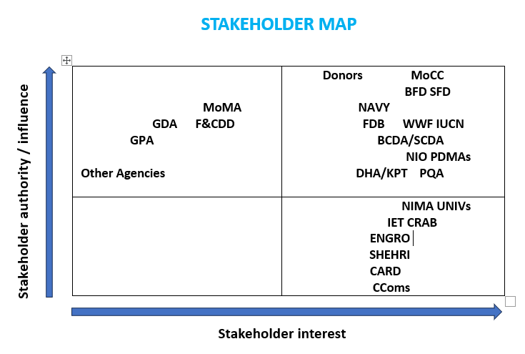
Figure 35: Figure 35: Stakeholder map illustrating the relationships between the main mangrove stakeholders in Pakistan. Abbreviations are as in section 8.1 (Institutional Stakeholders). CComs = Coastal Community Stakeholders (as in section 8.2).

For obvious reasons, stakeholder authority/influence is highest for those at national or provincial level, with the most influential being the Ministry of Climate Change and Environmental Coordination and the Navy at national level; and the Forest Departments in Sindh and Balochistan at provincial level. Universities are also recognized as having considerable influence and interest because of their prominent roles nationally and internationally in teaching and research.
Although the influence of some other stakeholders may be low nationally/provincially (e.g. local NGOs/CBOs), they are very important at the field level for educating and mobilising local communities to plant and protect mangroves.
Stakeholder maps are subjective and it is difficult to compare the influence and interests of diverse stakeholder groups (as in the case of mangroves) in this simple form. Nonetheless, figure 35 clearly indicates that there is a wide range of stakeholders who are highly relevant to mangroves in Pakistan.
The above conclusion also highlights the need for more effective coordination and implementation mechanisms between stakeholders. Thus, the National Coordination Body (NCB), which was established in 2009 to oversee Pakistan’s participation as a member country in the Mangroves for the Future (MFF) regional initiative, should continue to play an important role in further strengthening coordination among the mangrove stakeholders at national and provincial levels.

9. Mangrove Resources Use and Sustainable Livelihoods

9.1 Introduction
The communities living close to mangrove forests in Pakistan consist mainly of fisher households who have seen their livelihoods impacted severely by overfishing and negative environmental change. This section reviews opportunities for livelihood diversification. Aquaculture development and mangrove-based ecotourism have been selected because, potentially, these two sectors can provide significant alternative income opportunities via both direct and indirect employment.
However, in addition to improving livelihoods, there are three other cross-cutting needs fundamental to the well-being of coastal fisher communities in Pakistan: a) increased availability of clean drinking water; b) viable alternatives to using mangrove wood as domestic fuel; and c) improved access to health services. Thus, livelihood support activities should not be proposed in isolation from other assistance that can meet these other needs of vulnerable coastal communities.
Small grant projects under the Mangroves for the Future (MFF) initiative have proved to be an effective way to provide coastal communities with livelihood and other quality of life assistance. The MFF project facility is recommended as a best practice approach to help mangrove-dependent coastal communities. There is well-documented experience from implementing successful MFF small grant projects in Pakistan, as well as regionally (IUCN, 2012; MFF website).
The benefits of small grant projects, and the lessons learned from more than 300 MFF-supported projects implemented across South and Southeast Asia, are summarised in this section and in Annex 2.

9.2 Coastal Aquaculture
Lagoons in Balochistan, and creeks and other water bodies in the Indus Delta, have good potential for aquaculture using species that are associated with mangroves. These include finfishes (sea bass, mullets and sea catfishes), penaeid prawn species and mud crabs. Moreover, aquaculture can provide good ancillary employment opportunities in the form of on-farm work, collection of wild seed and feed to support aquaculture production, post-harvest activities including transportation to market.
Although some forms of coastal aquaculture involve significant investment costs and carry high risks (from severe weather events, stock escapes, theft or aquatic diseases), there are low-cost, lower risk options more suited to the limited financial and technical capacity of coastal householders. For example, with support from IUCN and Australian university researchers, simple cage and pond culture trials with fishes and prawns, respectively, have shown promising results in Tippun Dublo, Keti Bundar (Jarwar et al., 2024).
It is beyond the scope of this mangrove assessment to go into further details regarding the potential of coastal aquaculture in Pakistan. However, it is worth highlighting the advantages of mud crab culture in terms of its suitability for the socio-economic and environmental conditions prevailing in the country’s mangrove habitats.
Mud crab rearing involves lower investment costs and lower risks compared to other forms of coastal aquaculture. Mud crabs have a high value and are easily transported alive, even over long distances. In addition to being a low-cost and low risk form of aquaculture, crab rearing can also generate income for fishermen supplying farmers with live crabs for pond or cage stocking.
The great increase in mangrove cover achieved in Pakistan by rehabilitation and afforestation programs should ensure that there is a plentiful supply of wild juvenile crabs to support mud crab fattening or rearing

9.3 Mud Crab Rearing
The advantages of mud crab rearing are summarised below.
- Mud crabs are intimately associated with mangrove ecosystems and juvenile and young adult crabs seek out mangrove habitat, including plantation mangroves as nursery habitat. Thus, they can be caught easily as stock for aquaculture.
- Mud crabs tolerate an extremely wide range of temperature (12-35ºC) and salinity (2 to 60 ppt), whereas fish, and especially prawn, are easily stressed by extreme temperatures or salinities.
- Because mud crabs are able to breath out of water, they are also much more tolerant of water with a low dissolved oxygen concentration and/or high silt content.
- Mud crabs can be reared in low-cost facilities including cages, fenced pens or ponds. They are scavengers/carnivores, so they readily accept a diet of trash fish supplemented by molluscs or crab waste (if available?).
- Unlike fishes and prawns, mud crabs can be transported alive, even to quite distant markets, without the need to use water or ice (they only need to be kept cool). And they can be harvested and sold in small quantities, or even individually, with the value per crab ranging from about PKR 300 to 1500 according to their size.
- The simplest form of mud crab rearing involves ‘fattening’ only: crabs that have recently moulted (known as thin or “watery” crabs) are fed well for 10 - 30 days until their meat weight (and value) has increased.
Crab culture involves stocking juvenile crabs typically weighing 50 g to 100 g in small ponds (e.g. 200 m²) and allowing them to moult and grow until they reach a suitable size and weight to sell profitably (200 to 400 g), which usually takes 3-6 months. However, the larger crabs can be harvested and sold regularly during the culture period.
A women’s group at Sandspit is rearing mud crabs in this manner. Juvenile crabs costing PKR 50 each are grown for about six months using abundantly available trash fish as crab feed; the crabs can then be sold for PKR 700 to 800 each.
Mud crabs can also be stocked as a second species in fish culture ponds, or stocked in abandoned prawn or fish ponds, provided that netting is fixed around the ponds to prevent crabs from escaping. There are several helpful manuals and other guides on mud crab farming and its suitability for low-cost investment by coastal communities (e.g. Shelley and Lovatelli, 2011; Overton and Pushpakumara, 2023).

9.3 Mangrove-based Ecotourism
Mangroves feature prominently as an ecotourism attraction throughout the world. They have excellent potential for ecotourism in Pakistan because there is good land-based road access to several mangrove areas from centres of urban population. The mangroves at Sandspit, Keti Bundar and Miani Hor have these favourable conditions, being easily accessible from Karachi, while the Jiwani Wetland mangroves are close to the city of Gwadar. With careful planning and appropriate assistance, some mangrove-dependent fishing communities should be able to derive significant additional income from ecotourism.
The basic infrastructure needs to support mangrove ecotourism are a small jetty from which to operate boat trips through mangrove waterways. The creeks around Keti Bundar and the Miani lagoon are ideal environments for viewing mangroves by boat. An elevated walkway through part of the mangrove forest is also a valuable asset and visitor attraction. In addition to the mangrove trees, walkways and boat trips provide visitors with opportunities to observe wildlife, especially crabs, birds and dolphins, and also to see local fishing and, in some locations, aquaculture activities.
Another important function of mangrove ecotourism sites is to inform and educate visitors about the importance of mangroves via their multiple roles in supporting biodiversity, coastal fisheries and protecting against storms and flooding. This requires good information in the form of display boards, posters and other visual formats
Additional infrastructure can include shaded rest areas, an observation tower and, if possible, a visitor/information centre and rest rooms. A visitor/information centre, such as the one at the Sandspit Wetlands Centre, can greatly enhance the learning opportunities for visitors.
It is also important to have facilities where the local community can sell food and drink, handicrafts and other products to visitors for income generation. Local people can also be trained and employed as boatmen and mangrove guides to inform visitors about the mangroves and to answer their questions.
However, poorly planned, or commercially-dominated tourism can lead to mangrove forest loss (e.g. through unsound development or encroachment), depletion of other natural resources and increased pollution in the mangroves and surrounding areas. Therefore, a balance must be established between realising the economic benefits from tourism and the need to conserve mangrove ecosystems so that tourism development is sustainable (Ahmad and Suratman, 2021).
An example is provided of a successful community-led mangrove ecotourism site in Cambodia, where community members are custodians of the mangrove forest and protect it in return for being able to generate income from tourists. This provides financial support to the households involved, as well as paying for mangrove protection, site security and cleaning, and other community-level services (Annex 3).

9.4 Small Grant Projects for Environmental and
Livelihood Improvement
Many small grant projects were funded during the Mangroves for the Future (MFF) initiative (2006 to 2018) and some of the MFF governance and project grant mechanisms continue to be applied in Pakistan.
With oversight from a National Coordinating Body (NCB), the small grant facility (SGF) mechanism involves a well-designed and tested process involving calls for project proposals; training on project proposal writing; proposal appraisal and competitive selection of projects for funding. The selected projects are then monitored regularly during implementation, so that learning from each project be shared widely.
Collectively, the MFF SGF projects have made a substantial contribution to rehabilitating, conserving and managing coastal ecosystems; to building the capacity of both local NGOs and CBOs; to improving governance over the use of coastal resources; and to diversifying the livelihood options of people in traditional coastal communities, especially for women.
Large coastal development projects can benefit by including an SGF component so that within the project’s overall target area (e.g. district level) specific local needs (e.g. at village level) can be supported by individual SGF projects.
In the MFF SGF mechanism small grant beneficiaries have to be coastal resources-dependent communities. Eligible project contract holders are NGOs, CBOs, university departments or other research bodies. Government agencies and the private sector can be project partners, but not project holders, and project co-funding is required from private sector partners.
The MFF initiative identified the selection of capable and committed local leaders as a key factor in mobilizing community support and external assistance for SGF projects. So too was the involvement of experienced NGOs/CBOs to guide project implementation. These and other lessons learned from MFF SGF projects are summarised in Annex 2.

10. Mangrove Carbon Sequestration
and Carbon Marketing

10.1 Introduction
Based on the Paris Agreement at COP-21 in 2016, all parties to the United Nations Framework Convention on Climate Change (UNFCCC) agreed to a collective aim of preventing global temperatures from rising this century by more than 2ºC above their pre-industrial levels. Each country has defined its own contributions and targets towards achieving this shared objective in the form of a Nationally Determined Contribution (NDC). By 2030 Pakistan intends to achieve an overall 50% reduction in emissions; for example, by banning the import of coal.
Carbon marketing based on mangrove rehabilitation/afforestation and protection is highly appropriate for Pakistan in the context of the country’s current NDC targets towards reducing emissions and adapting to climate change. Large rehabilitation/afforestation projects like UGP/TBTTP and the Delta Blue Carbon Project represent an effective strategy for Pakistan to offset emissions and sell carbon credits. Trees sequester carbon dioxide and store it as carbon in their aboveground biomass, in their roots and in the soil. Mangrove ecosystems can be particularly effective as carbon sinks because up to 90% of the total ecosystem carbon is stored in the roots and soil. On average, one hectare of mangrove forest stores five times more carbon than a similar area of terrestrial forest.
Expansion of mangrove forests and improved protection of mangrove ecosystems can also contribute effectively to the climate change adaptation priorities in Pakistan’s NDC. These cover several sectors, with emphasis on reducing loss and damage: agriculture, biodiversity and ecosystems, disaster risk management, forestry, health, water and waste. While most relevant to forestry, biodiversity and ecosystems, mangroves can also serve as a natural asset in disaster risk management. And they are effective biofilters of many types of pollutants, particularly of nutrients like nitrogen and phosphorus that can cause eutrophication in creeks and coastal waters.

10.2 Mangrove Carbon Marketing
Carbon marketing is a trading system in which carbon credits can be bought and sold in much the same way that stock markets operate. Companies can use carbon marketing to compensate for activities that cause greenhouse gas emissions. They do this by purchasing carbon credits from organisations or projects that remove or reduce greenhouse gas emissions, e.g. by planting trees.
One tradable carbon credit is equivalent to one tonne of carbon dioxide sequestered or avoided (not released). The burning of one tonne of carbon in the form of oil, coal or wood, releases the equivalent of 3.67 tonnes of carbon dioxide. The other greenhouse gases are also expressed in CO₂ equivalents (usually shown as CO₂e); methane, for example, has a CO₂e of 25 (one tonne of methane is equivalent to 25 tonnes of carbon dioxide = 25tCO₂e).
The markets for carbon fall within two main categories: compliance and voluntary markets. Compliance markets are determined by national, regional and/or international policies or regulatory measures.
Clean Development Mechanism (CDM): this is an important international compliance market of long-standing, which was created under the 1997 Kyoto Protocol. The CDM enables emission-reduction projects in developing countries to generate certified emission reduction (CER) credits, where one credit equals one tonne of CO₂e. CERs can be sold to developed countries to help them meet their emission reduction targets under the Kyoto Protocol. The CDM is also a source of income for the UNFCCC’s Adaptation Fund, which was established to finance adaptation programmes and projects in developing countries that are particularly vulnerable to impacts from climate change. This trust fund was financed initially from a 2% levy on the sale of CERs, but it is now increasingly supported by voluntary contributions plus investment income generated by the trust fund itself.
Emissions Trading System (ETS): this is another compliance market based on emission or pollution allowances (permits) issued under government regulations to limit the amount of allowable emissions/pollution by industries and businesses. ETS operate at the country level within the European Union and they are also being developed in other countries and within countries. If a regulated company or country exceeds its emission/pollution cap, it must buy additional permits from entities that have permits available for sale, a system known as “cap and trade”.
Joint Crediting Mechanism (JCM): this was initiated by the Government of Japan as a bilateral greenhouse gases offset crediting mechanism. Through bilateral projects Japan transfers low carbon technologies, products and services to developing countries to assist them to reduce emissions. The results are then evaluated and credited towards Japan’s own national emission reduction targets. An ADB trust fund provides grant support and technical assistance to projects in developing member countries of ADB that have signed bilateral agreements for the JCM with Japan. To date, 29 countries have signed with Japan under the JCM, including several Southeast Asian countries, Bangladesh and Sri Lanka, but not yet Pakistan. Many of the JCM financed projects involve energy-saving to mitigate climate change.
Voluntary Carbon Market (VCM) enables buying and selling of carbon credits on a voluntary basis. Voluntary carbon credits are now available from many carbon projects, especially forest rehabilitation and afforestation projects that sequester and store large quantities of carbon. The buyers of carbon credits are typically businesses with specific corporate environmental sustainability targets that they must reach. By purchasing carbon credits they can offset some of their emissions and present a “greener” image to their shareholders and customers. Once a carbon credit is sold it is termed a carbon offset. The Delta Blue Carbon project has used the VCM successfully to sell mangrove carbon credits and it is the main market used in this way by other mangrove carbon projects.

10.3 Mangrove Carbon and Climate Change Projects
While the VCM is a specific mechanism that enables forest owners to benefit from selling carbon credits, there are several other financing mechanisms that support climate change projects. The protection and rehabilitation of mangrove ecosystems is widely recognized as a valuable nature-based solution to climate change mitigation and adaptation. Mangroves, along with seagrasses and saltmarshes are commonly referred to as ‘blue carbon’ ecosystems because they can rapidly sequester carbon dioxide into carbon and store large quantities of carbon on a unit area basis relative to terrestrial ecosystems.
Mangroves are also attractive for conservation financing because they have suffered extensive losses due to past exploitation, they remain threatened globally, but are relatively easy to rehabilitate. In addition to their ability to store carbon, mangroves provide a wide range of other ecosystem services, some of which, like carbon, can be monetarized, such as mangrove coastal protection functions, mangrove-associated fisheries and aquaculture, and mangrove-based ecotourism.
Green Climate Fund (GCF): this fund was established as a decision of COP-16 at Cancun in2010. The GCF is the largest dedicated climate fund serving developing countries. It operates as a financial mechanism of the UNFCCC and is guided by the goals of the Paris Agreement. Thus, the purpose of the GCF is “to make a significant and ambitious contribution to the global efforts toward attaining the goals set by the international community to combat climate change”.
The GCF supports both climate change mitigation and adaptation projects. The Strategic Plan for the GCF 2024-2027 includes the aim “to promote cross-cutting, multi-sectoral, inclusive interventions which address complex, interacting climate risks and deliver economic and non-economic co-benefits; encourage use of nature-based solutions or ecosystem-based approaches as critical tools to address adaptation, mitigation, biodiversity and poverty.”
The GCF aim is highly compatible with the goal of managing mangroves as ecosystems able to build resilience and provide a wide range of benefits in the face of climate change. As an example, one of the recently approved GCF projects is entitled “Improving the resilience of vulnerable coastal communities to climate change related impacts in Vietnam”.
There are four other smaller climate funds also coordinated by the UNFCCC:
Adaptation Fund (AF): this fund’s strategy is to finance adaptation programmes/projects under three strategic pillars: action, innovation, and learning and sharing. There are several cross-cutting themes including to empower and benefit the most vulnerable people and communities; advance gender equality; and encourage locally-based and locally-led adaptation. Thus, the AF is a potential source of project funding to assist the most vulnerable coastal communities in Pakistan
Global Environment Facility (GEF): this facility funds both climate change mitigation and adaptation projects. It also includes two sub funds of the GEF: the Least Developed Countries Fund (LDCF) and the Special Climate Change Fund (SCCF). Pakistan does not qualify as an LDCF, but applications to AF, GEF and SCCF for mangroves and climate change projects would be possible.
The GEF has already financed mangrove projects in other Asian countries, as well as globally, e.g. Coastal Resilience to Climate Change: Developing a Generalizable Method for Assessing Vulnerability and Adaptation of Mangroves and Associated Ecosystems (GEF ID 2092); My-Coast: Ecosystem-Based Conservation of Myanmar’s Southern Coastal Zone (GEF ID 9261).

11. Capacity Development Needs

11.1 Introduction
There is a need for capacity development about mangroves at all levels from decision-makers, to resource managers, local authorities and field staff, to village community leaders and the individual householders that live in close association with mangroves.
Moreover, because mangrove ecosystems contain distinctive trees and a rich associated diversity of wildlife, they are also valuable as a focus for environmental awareness-raising among the general public.
Table 10 summaries the capacity development needs of different mangrove stakeholder groups by topic. The topics are general and their ranking is highly subjective because each stakeholder group will have particular learning needs.
Table 10. The main capacity development needs of mangrove stakeholders.
Capacity Development Needs | Decision-Makers and Resource Managers | Local Authorities, Field Staff, NGO/CBOs | Coastal Village Leaders and Households
Coastal Zone Management (CZM) | *** | ** | *
Marine Biology | *** | ** | *
Ecological functions of mangrove ecosystems | *** | ** | *
Mangroves as a Nature-based Solution to climate change | *** | *** | ***
Ecosystem-based management | *** | ** | *
Economic valuation of goods and services from mangrove ecosystems | *** | ** | *
Carbon sequestration by mangrove forests | *** | ** | *
Mangrove carbon marketing | *** | ** | *
Indicator-based monitoring of mangrove ecosystems | *** | *** | *
The legal and policy framework governing mangrove ecosystems | *** | ** | **
Co-management of mangrove resources (shared governance) | *** | *** | ***
Empowerment of vulnerable coastal communities | ** | ** | ***
Knowledge and skills for improved community livelihoods and resilience to climate change | * | ** | ***
*** Highly relevant/essential knowledge; ** Relevant/some knowledge required; * Should be made aware.

These learning needs can be addressed through seminars for decision-makers; short courses for managers, field staff and NGOs/CBOs; and awareness-raising activities for coastal communities and the public. Study tours and exchange visits for peer-to-peer learning are also an effective way for stakeholders to gain new knowledge and experience. The MFF initiative found that community to community learning can be particularly productive; and short videos are a valuable visual format for awareness-raising.

11.2 Decision-Makers and Resource Managers

11.2.1 Overview
As the custodians of forests in Pakistan, the Forest Departments in Sindh and Balochistan recognise that their staff lack capacity for mangrove management because traditionally the focus of staff training has been on terrestrial forests. Their primary capacity development need is to learn how to manage mangroves as a coastal ecosystem in the context of coastal zone management, rather than simply as trees growing in the intertidal zone.
Short courses on marine biology would therefore be helpful for mangrove forest managers to learn about the biological and ecological connections between mangroves and the broader coastal environment. These courses would also benefit managers in the fisheries, agriculture and water resources sectors.
In addition to having a good understanding of mangrove forests in the context of coastal zone management, decision-makers and resource managers should also be well-informed about a) the scientific predictions on coastal climate change (based on the IPCC projections); b) resilience-building and the role that mangrove ecosystems can play in climate change mitigation and adaptation; and c) the impact that climate change may have on mangrove ecosystems.
It is particularly important for these stakeholders to understand why mangrove forests can sequester and store more carbon per unit area than other forest types, as this explains why mangroves can play a valuable role in climate change mitigation.
Mangrove carbon has additional importance because of the economic benefits that can be derived from mangrove carbon marketing, as in the case of the DBC-1 project. Not surprisingly, provincial level forestry staff expressed strong interest to learn more about mangrove carbon sequestration and marketing.
However, decision-makers and managers must also be aware of the co-benefits of other mangrove ecosystem functions and services, particularly regarding storm and flood control, and the supporting role that mangrove play as habitat for biodiversity and fishery stocks.
It is the fisheries support function of mangroves that is most important to the livelihoods of coastal communities in Pakistan. These communities also value the physical protection that mangrove forests provide to their villages during extreme weather events.
For these reasons, there is a pressing need to build capacity for ecosystem management and co-management (or shared governance) over mangrove forest and fisheries resources in Pakistan. These important topics are elaborated on the sections that follow.

11.2.2 Nature-based Solutions and Ecosystem-based Management
Nature-based solutions are actions to protect, sustainably manage, or restore natural ecosystems, that address societal needs, e.g. food and water security, human health and challenges e.g. climate change and disaster risk reduction, while simultaneously supporting human well-being and providing biodiversity benefits.
The achievements in large-scale mangrove rehabilitation and afforestation activities in Pakistan are de facto a nature-based solution to some of these needs and challenges.
Ecosystem-based management is an approach to managing environmental resources that considers the whole surrounding ecosystem, including resource-dependent coastal communities. This is referred to as the social-ecological system, which regards people as part of nature, rather than separate to nature.
Ecosystem-based management recognizes the need to manage the multiple processes and interactions involved, rather than focussing management on a single sector, species group or product. Having successfully planted mangroves as a nature-based solution towards restoring coastal ecosystems in Pakistan, the next step is to apply this holistic management approach to the mangrove social-ecological system.
In order to apply ecosystem-based management to mangroves, managers need to learn about the following topics:
- Ecological functions of mangrove ecosystems.
- Mangrove goods and services and their economic values.
- Restoring biotic and abiotic processes in mangrove ecosystems.
- Life cycles of key aquatic animals, especially mangrove-associated fishery species (finfishes, prawns, crabs).
- Mangrove habitat use by resident and visiting mammals and birds.
- Mangrove food chains and the mangrove-coastal waters food web.
- Climate change mitigation and adaptation benefits of mangroves.
- Impacts of climate change on mangroves.
- Mangrove carbon sequestration and storage.

Nearly all these topics are covered in information and training materials available from the 3rd party M&E Consortium of TBTTP/UGPP partners (FAO, IUCN and WWF). There are also four comprehensive teaching modules on ICM prepared by AIT and IUCN that include these topics.
In addition, the article by Alongi (2014): “Carbon sequestration in mangrove forests” https://doi.org/10.4155/cmt.12.20 is informative on the topic of mangrove carbon.

11.2.3 Economic Valuation of Mangrove Goods and Services
Decision-makers should be made aware of the full range of goods and services provided by mangrove ecosystems and have access to reliable information about their total economic value (TEV).
Baig and Ifikhar (2010) estimated the annual direct value of mangroves in Miani Hor to be USD 1,287/ha, which was mainly due to the value of the lagoon’s fisheries; the TEV was USD 1,938-2,587/ha. They also provided evidence for decision-makers that the net economic benefits derived from mangroves can exceed those that would result from mangrove conversion e.g. to aquaculture ponds.
A more recent study by the Pakistan Forest Institute (PFI, 2018) calculated the economic value of mangrove forest services at a study site in Miani Hor at USD 646/ha per annum and for the study area overall at only USD 87/ha. However, much higher economic values were estimated by PFI (2018) for another mangrove study site located in the Korangi-Phitti creek area near Karachi (Table 11). In this case the TEV for the mangrove forest services was USD 3,850/ha per annum and for the site overall USD 1,780/ha.
The value of the Korangi-Phitti Creek mangroves as a biofilter of polluted wastewater from Karachi made a very high contribution to the TEV. In fact the PFI study noted that the mangroves in this area have “...for decades been acting like a large back-up waste water cleaning facility for Karachi City and its surroundings, which has not so far been recognized.”
Table 11. Economic valuation of mangrove goods and services (from PFI, 2018).
Main ecosystem services identified* | Economic benefits analysed | Monetized value PKR | Monetized value USD**
Protection of fish and shrimp spawning sites | Fishery and fish/shrimp spawning site value | 38.78 million | 349,332
 | Fishery related other community wage labour | 4.57 million | 41,167
Coastal zone and habitat protection | Cleaning of waste water pollution with mangroves | 11.5 billion | 103.6 million
 | Cyclone & tsunami mitigation with mangroves | 136.69 million | 1.23 million
Biodiversity conservation and promotion of ecotourism | Ecotourism | 73.5 million | 662,162
 | Education and research activities in mangroves | 20,000 | 180
Carbon and other forest products | Community wood and NTFPs | 309.9 million | 2.79 million
 | Mangrove carbon sequestration | 271.2 million | 2.44 million
Shoreline stabilization and prevention of sea intrusion | Land erosion prevention | 110.55 million | 995,919
 | Land stabilization | overlaps with land erosion prevention
Total study area monetized value |  | 12.4 billion | 112.1 million
Total value per hectare of Sindh study area |  | 197,544 | 1,780
Total value of mangrove forest per hectare |  | 427,323 | 3,850
* The study area was 62,994 ha, including 29,121 ha mangrove forest plus mudflats and water bodies. ** USD to PKR exchange rate is that at the time of the study.

While the PFI study provides an excellent analysis of mangrove economic valuation to support capacity development, more extensive and up to date information on mangrove TEV in Pakistan is needed to better inform decision-makers, including from other mangrove locations in Pakistan. The great difference in the TEV estimates for the Korangi-Phitti Creek and Miani Hor sites indicates that TEV values are site-specific and therefore the use of average TEV values for mangroves could be misleading.
New economic studies should include assessment of all the indirect values of mangrove ecosystems, including mangrove protection against storms and flooding, shoreline stabilization/erosion control, water purification, carbon sequestration, and mangrove supporting services to biodiversity, ecotourism and environmental education, as well as their wood, fodder and fisheries provisioning values.

11.2.4 Indicator-based Monitoring
Because there are too many ecosystem processes and interactions to monitor directly, representative indicators are normally selected. The preferred criteria for indicators are often denoted by the acronym SMART, meaning Suitable, Measurable, Achievable, Relevant and Time-bound.
To monitor mangroves, the indicators should be capable of assessing mangrove ecosystem health and resilience (especially in relation to climate change). In the case of mangrove plantations, the indicators should provide information showing whether mangrove rehabilitation/afforestation is restoring mangrove functions at the ecosystem level?
Potential indicators for monitoring mangrove ecological function and the resilience of mangrove social-ecological systems are shown in Annex 4. However, indicators should be selected on a site-specific basis. The resources available for monitoring should also be considered carefully when designing a mangrove monitoring system.

11.3 Local Authorities, NGO/CBOs, Village Leaders and Coastal Households
At the local level mangrove stakeholder respondents expressed most concern about their declining fishery-based livelihoods and the impact of climate change on their communities, especially climate-associated threats from storms and flooding.
Based on interviews with community focal groups in Keti Bundar and Damb, it is clear that capacity development activities by IUCN, WWF and local NGOs have greatly improved awareness among community leaders and households, including women. This is reflected in their basic understanding of the importance of mangrove ecosystems to their livelihoods and general well-being.
It will be beneficial to provide these coastal community stakeholders with more information about coastal climate change. In particular, the concept of resilience to climate change, and how they can make their communities more resilient, should be a key aspect of capacity development to enable them to better withstand the impacts of climate change.
Because the great majority of mangrove-associated communities and local business entities depend on fisheries for their main sources of income, the importance of mangroves as nursery habitat for many coastal fish, prawn and crab species should also be explained clearly. This can give them a better understanding of why illegal fishing with very fine nets is so damaging to the recruitment of juvenile fishes, prawns and crabs into the fisheries (juvenile overfishing), and therefore to their livelihoods in the medium to longer term.
Capacity development for these stakeholder groups should also focus on empowerment and opportunities for alternative sources of livelihood to improve household incomes and the local economy. Empowerment is needed so that coastal communities are better able to take responsibility as partners (joint-custodians) together with the Forest Departments and other government stakeholders in the co-management of mangrove resources, as explained in the next section.
Capacity development to assist vulnerable coastal households to improve their livelihoods should involve helping them to diversify their income away from almost sole dependency on fishing. This requires a holistic approach usually involving skills training, the provision of tools and raw materials (at least initially) for product-making, and assistance with product marketing.
For example, women in some fisher households at Miani Hor have been provided with sewing machines so that they can produce embroidery for sale. Similarly, in Thailand, many fisher communities have been assisted to increase their income from traditionally-made products. This was achieved by helping them to improve product quality and by providing marketing support so that they could produce and sell value-added handicrafts and food products like model boats and shrimp paste.
As explained in section 9.4, small grant projects using the project governance and implementation mechanisms developed by Mangroves for the Future (MFF) are recommended as an effective way to provide capacity-building through new and improved skills development, and other assistance needed to improve the livelihoods of vulnerable coastal communities.

11.4 Co-management
Mangrove protection is the primary responsibility of the Sindh and Balochistan Forest Departments. However, they do not necessarily have sufficient staff or the financial resources to do this in an effective way, especially where there are travel difficulties involved to reach the more remote coastal areas.
The solution is to involve the households whose livelihoods depends on the use of mangrove resources and develop in them a shared sense of ownership with the Forest Departments to ensure that sustainable use of mangrove resources and effective mangrove protection can be achieved. This can be realized through co-management, which is a form of shared governance over natural resources.
Mangrove co-management has the aim of achieving sustainable use of mangrove resources for the benefit of the local communities, while at the same time maintaining the protection functions of the mangrove forest.
It has already been shown via cost-benefit analysis of the Miani Hor mangroves that co-management of mangroves through sharing the responsibilities and authority for managing mangrove habitats between the government and local stakeholders is a viable alternative management strategy (Adhikari et al., 2010).
The Forest Departments of Sindh and Balochistan have already taken some steps towards developing mangrove co-management via the Watch and Ward system. This has been formalised in the Indus Delta via Mangrove Stewardship Agreements under the DBC-1 project (see Annex 5).
Capacity development for other decision-makers and resource managers, particularly those in the fisheries, aquaculture, agriculture, water management and tourism sectors, should also include a good understanding of the advantages of co-management as a shared governance/management mechanism. They should also become familiar with the steps necessary to implement co-management in practice, as summarised below.

11.4.1 Definition and Application of Co-management
Co-management, or shared governance is a type of management/governance in which decision-making power, responsibility and accountability are shared between governmental agencies and other stakeholders, in particular the indigenous peoples and local communities, who depend on the natural resources culturally and/or for their livelihoods (Borrini-Feyerabend, et al., 2013).
Management is about what to do, whereas Governance is about who decides what to do. The principle of co-management is shared governance (or collaborative governance). That is, it involves joint decision-making about what to do.
Co-management in the context of mangrove ecosystem protection and sustainable use of mangrove natural resources is a partnership agreement in which a resource user group receives the right to sustainably use natural resources within a defined area of Protected Forest while being responsible for the sustainable management and protection of its resources. All stakeholders share the responsibility and authority for the management of a given area and a defined set of natural resources. Resource users and local authorities jointly negotiate a formal agreement on their respective management roles, responsibilities and rights.
Awareness raising about environmental issues, as well as clear and effective communication between stakeholders, are important prerequisites for the successful implementation of co-management activities. Under a co-management agreement, mangrove protection and sustainable resources use must also be monitored to ensure compliance. If compliance issues, are identified from monitoring, then adjustments to the responsibilities and accountability of the co-management partners may be necessary via adaptive management.
In summary: co-management is achieved through a process of negotiation where representatives of government, communities and other stakeholders (e.g. an NGO/CBO) meet together, exchange views, reach agreement about their aims and solutions, and develop a formal co-management agreement about sharing decision-making authority, their responsibilities and accountability regarding a specified mangrove area and its natural resources.

12. Conclusions and Recommendations

12.1 Mangroves in Pakistan since 1980
- Historically, severe overexploitation of mangroves for timber, fuelwood and fodder was the primary driver of mangrove degradation and loss in Pakistan. Subsequently, environmental changes stemming from a drastic reduction in the supply of freshwater and sediments to the lower Indus Delta led to extreme degradation of the mangrove ecosystem and local extinction of four mangrove species previously recorded there.
- From extensive mangrove cover of about 345,000 ha in 1980, around 75% of the mangroves by area were lost in little more than 20 years, with less than 90,000 ha remaining at the start of the present century.
- Only one mangrove species, Avicennia marina, was able to regenerate naturally in the Indus Delta’s now hypersaline and sediment-deficient environment. Remarkably, however, Rhizophora mucronata and Ceriops tagal also survived in Miani Hor during this period of extremely high mangrove exploitation.
- Beginning from the first mangrove rehabilitation efforts in the 1990s, well-established procedures have been developed for mangrove propagule collection, nursery production of seedlings and planting in mangrove rehabilitation and afforestation sites.
- A positive feature of these rehabilitation activities is that they include paid work for coastal communities, including women. Although the work for coastal households is mainly seasonal, as well as providing income, it has also increased their understanding of the importance of mangroves and the need for mangrove conservation.
- Led by the Forest Departments of Sindh and Balochistan, and with international donor financial support and technical assistance, large-scale mangrove rehabilitation and afforestation efforts have led to a remarkable increase in mangrove cover by about 300% in both Sindh and Balochistan provinces.
- The 2022 mangrove area estimates for Pakistan indicate at least 285,000 ha currently, with a projected total by 2027-2030 of about 342, 000 ha.
- Another positive feature is that the Watch and Ward system of mangrove protection has been formalised in the form of Mangrove Stewardship Agreements in the Delta Blue Carbon (DBC phase-1) project area in the Indus Delta.
- Further expansion of mangrove stewardship/custodianship agreements with local communities is strongly recommended in order to bring more mangrove forest areas in Pakistan under transparent co-management arrangements.

12.2 Mangrove Rehabilitation/Afforestation and Conservation
- Mangrove rehabilitation/afforestation involves planting mainly A. marina and R. mucronata. The plantation work is being done well technically and there is no shortage of propagules and nursery-produced seedlings available for planting.
- However, it would be advantageous to increase mangrove diversity by planting more Ceriops tagal and Aegiceras corniculatum. To promote biodiversity, mixed species planting should be done where there are suitable habitat areas for this.
- Because of the observed low survival of planted R. mucronata in sand-dominated, or very high intertidal locations, it is recommended that R. mucronata should only be planted where it can grow in association with naturally-occurring or planted A. marina.
- The presence of A. marina indicates more suitable conditions for survival of Rhizophora than completely barren sandy areas. This includes all areas reached by the long horizontal roots of A. marina, which can extend many metres beyond the actual trees, as indicated by the spread of their pneumatophores.
- The mat-forming perennial grass Aeluropus lagopoides, also known as mangrove grass, has a wide distribution in saline areas, including intertidal mudbanks. Here it provides suitable habitat for planting R. mucronata. However, Aeluropus is ecologically important because it produces rhizomes, or spreading subsurface roots, that bind sediment and generate a thick mat of vegetation. Therefore, intertidal Aeluropus vegetation should not be replaced entirely by planted mangroves.
- Conversely, the presence of the halophytic shrub Arthrocnemum, which is typical of high intertidal areas, indicates habitat that is generally unsuitable for mangrove planting except for A. marina.
- Where R. mucronata or C. tagal are proposed for planting in sandy/high intertidal areas only marginally suitable for them, they should be planted as seedlings, not as propagules. This is recommended because the root systems of their seedlings have a salt exclusion mechanism that Rhizophora and Ceriops mangroves depend on for survival in highly saline environments. Whereas their propagules lack this mechanism until they are able to develop side roots.
- Barren sandy areas may be suitable for planting with A. marina provided there are at least some scattered natural Avicennia bushes in the vicinity to indicate habitat suitability; or there is evidence that a particular location did support mangroves previously. However, shore levels that are out with the normal intertidal range of mangroves should not be planted.
- An important principle of mangrove forest conservation is that near-natural and mature patches of mangrove forest should be preserved as a priority because they are most likely to provide vital ecosystem functions, especially biodiversity support, as well as providing a valuable potential source of propagules for mangrove rehabilitation in other areas.
- This principle should be applied especially to the mature mangroves in Miani Hor, to protect the naturally-occurring Rhizophora and Ceriops forests there. It should also be applied to the mature mangroves in the Karangi-Phitti Creek area near Karachi, which are providing the additional functions of sediment trapping and biofiltering of polluted wastewater.
- The marketing of carbon credits based on the very high carbon sequestration and storage capacity of mangroves has become a main focus for mangrove rehabilitation/afforestation and conservation in Pakistan. The DBC Phase 1 project, with a target of restoring/protecting 350,000 ha, is the world’s largest mangrove carbon project.
- However, the co-benefits from mangrove carbon projects should be given more attention as these are also significant. They include other climate change mitigation benefits (storm and flood protection, shore stabilization/erosion control) and adaptation benefits (fisheries and biodiversity support), as well as income for local communities from mangrove planting and protection.
- These other ecosystem services are more relevant to coastal communities than mangrove carbon sequestration because local people can relate them directly to their own situation in terms of their livelihoods, well-being and safety from extreme weather events.
- Substantial improvements are required in the management of coastal protected areas. There are very significant mangrove habitats in three of the 19 Ramsar sites in Pakistan: Jiwani Coastal Wetland (Ramsar site area 4,600 ha); Miani Hor (55,000 ha); Indus Delta (472,800 ha). However, these Ramsar sites have no visible presence or obvious activities related to the mission of the Ramsar Convention.
- Smaller core areas of the mangrove ecosystems in Miani Hor and the Indus Delta should be identified for active conservation based on their biodiversity and ecological importance. These should be designated as Marine Protected Areas (MPAs) core zones, with a high level of management protection. The larger areas of habitat around the MPA core areas can be designated as MPA buffer zones, in which a reasonable level of resource use can be permitted.
- The small, but well-managed WWF Sandspit Wetland Centre near Karachi is a good example of how mangroves can be conserved and managed to support not only livelihoods of the local community, but also public education and research.

12.3 Threats to Mangrove Ecosystems
- The traditional exploitation of mangroves for wood has decreased in some areas due to the availability of other wood sources (e.g. mesquite). However, there are still significant mangrove loss from tree-cutting, especially large-scale illegal commercial felling of mature mangrove trees on the Karachi coast. This malpractice can only be stopped through effective legal action to prosecute violators.
- Loss of mangrove habitat caused by encroachment and land conversion for urban or industrial expansion, is another severe problem in the coastal areas near Karachi. It can only be controlled if the remaining mangroves are given strict conservation status, backed up by enforcement and legal prosecution for encroachment or unsanctioned land developments.
- Mangrove grazing by camels is a concern expressed by community respondents, who ranked it highly among the problems they identified when asked about local issues affecting mangrove conservation. Local community agreements with the camel herders need to be widened and strengthened e.g. on allocating jointly-agreed camel grazing areas on a rotational basis.
- Because of over-fishing and illegal fishing using very fine mesh nets, the role of mangroves in providing vital habitat for many fish and crustacean species (especially food and shelter for their juvenile life stages) is not being given time to support the rebuilding of fishery stocks. This issue of juvenile overfishing is the greatest impediment to the sustainable use of mangrove ecosystem resources.
- Effective control of these harmful fishing practices must be implemented so that coastal fishery stocks can recover. This measure will improve the livelihoods of the great majority of coastal dwellers in the medium to longer term. However, in the short term they will need alternative sources of income to offset their loss from fishing.
- The prevailing hyper salinity environment in Pakistan’s creeks and lagoons will continue to suppress mangrove-associated estuarine fish species like seabass, mullets and penaeid prawns. Without an increased supply of freshwater to lower coastal salinity, low value fish species like sardines and anchovies will continue to dominate in the fish catches from mangrove areas.
- The one notable exception is the mangrove-associated mud crab (Scylla olivacea), which is euryhaline and tolerates salinities up to 40 ppt. There is some indication that populations of this valuable crab species are increasing in Pakistan because of mangrove rehabilitation/afforestation, but this should be confirmed from crab population studies (see research needs).
- Pakistan’s legislation on pollution control is not being enforced adequately and pollution levels in the coastal waters adjacent to Karachi already exceed national and provincial water quality standards. Without effective control, pollution will likely increase with further population growth, plus municipal and industrial expansion. Mangroves are tolerant of high nutrient levels, but heavy metals and oil-based pollutants are very harmful to the growth and survival of mangroves.
- In the specific case of the illegal import of oil products from Iran into Gwadar, this harmful practice must be controlled to safeguard mangroves in the Jiwani Coastal Wetland, as well as other vulnerable species and habitats, including marine turtles and their nesting beaches.
- Climate change-driven trends, in the form of higher temperatures, less rainfall and increasing salinity in coastal waters, creeks and lagoons will become increasingly detrimental to local communities, fishery stocks and mangroves. It is clear, however, that many of the solutions to mitigate climate change impacts and build social-ecological resilience lie beyond the responsibilities of the Forest Departments and the affected communities.
- An integrated, multi-stakeholder approach is needed that will blend forestry, fisheries, agriculture and water resources management with community empowerment, socio-economic development and resilience-building against climate change. This need for this holistic approach is foremost among the future priorities listed below.

Future Management Priorities
- Having re-established a significant mangrove forest stock, priority should now be given to forest conservation and sustainable use of mangrove ecosystem services. Mangroves should be managed at three levels: a) mangrove plantations; b) mangrove ecosystems; and c) mangrove social-ecological systems.
- Mangrove plantations: these should be monitored for i) rate of survival, tree growth, flowering and propagule production; ii) signs of stress: e.g. change from normal leaf colour, excessive leaf fall, infestation by barnacles, oysters, algae or insect pests; iii) human and livestock damage to trees (beyond allowable wood and fodder use) and other illegal activities, especially commercial tree-felling.
- Mangrove ecosystems: monitor the coastal ecological functions provided by mangroves at the ecosystem level: i) mangrove natural regeneration; ii) sediment retention and shoreline stabilization/erosion reduction; iii) bioturbation by crabs; iv) biodiversity supporting function (presence of intertidal fauna, insects, birds and marine mammals); v) diversity and productivity of fishery species.
- Natural regeneration by planted mangroves is a key indicator of plantation and ecosystem function. However, over-competition of planted Rhizophora, Ceriops and Aegiceras mangroves by Avicennia should be monitored carefully because this is likely to increase with climate change. Thinning of Avicennia overgrowth may be necessary to protect these other species, especially in their early growth stage.
- Mangrove social-ecological systems: in projects/programs designed to help mangrove-dependent communities include monitoring indicators for livelihood improvement, building empowerment and strengthening resilience to climate change.
- Mangrove-associated communities are benefitting from income they receive from the Forest Departments for collecting propagules, providing their labour for nursery and planting work, and for mangrove protection. However, faced with declining income from fishing as their main source of livelihood, these communities also need more holistic support that meets their broader needs.
- Project/program assistance should focus on skills training for alternative/improved livelihoods; resilience-building against climate change impacts and disaster preparedness; providing better access to freshwater and health services; and co-management arrangements (shared governance) between government, NGO/CBO and community stakeholders to achieve sustainable mangrove resources use.
- However, it must be recognised that managing mangrove ecosystem goods and services sustainably is very challenging in the Pakistan context, particularly regarding mangrove-associated fishery stocks, which have been heavily overfished and impacted severely by overfishing and illegal fishing methods.
- Although there is no easy solution to these fisheries issues, co-management is a proven mechanism to improve fisheries governance while safeguarding the livelihoods of poor fishers. Co-management also offers opportunities to reduce local conflicts in coastal fishing areas.
- Mangroves are a vital natural defence against extreme weather events because they can absorb a considerable amount of the wind and water forces generated by cyclonic storms and hold back flood water. Mangroves also stabilise coastal soils and slow erosion processes. In these roles, mangroves offer significant disaster risk reduction benefits to vulnerable coastal communities.
- The value of mangroves in protecting lives, property and livelihoods from cyclone impacts in Pakistan deserves to be given greater recognition as a key benefit that large-scale mangrove rehabilitation and afforestation programs can provide.
- The importance of mangroves in this context can be expected to increase because of climate change. Consequently, mangrove rehabilitation/afforestation and conservation should be promoted strongly as a nature-based solution to coastal climate change.

Mangrove Data Reporting and Information
Management
- Mangrove rehabilitation activities have not been well-documented by most past projects. The location of the rehabilitation site(s) and the area or number of propagules planted are usually mentioned, whereas other details are often lacking. This is a general weakness in the reporting by mangrove rehabilitation projects, especially by smaller projects with a short life-span.
- In future, mangrove projects in Pakistan should be required to provide the following information: location(s), together with GPS coordinates; satellite remote sensing imagery (if available?); the mangrove species planted and the planting system (plantation and/or assisted natural regeneration); number and spacing of propagules/seedlings/wildlings; overall survival before and after any gap-filling; expenditure (e.g. plantation development costs per hectare). The longer-term results of the project (environmental and socio-economic benefits) should also be reported, if known?
- To improve reporting and data management, it is recommended that the Forest Departments in Sindh and Balochistan should establish repositories for the above information about current and future mangrove rehabilitation projects (and past projects if available?). By including at least GPS coordinates delineating the planted site(s), it will be possible for the Forest Departments to easily monitor mangrove plantations using GIS remote sensing technology.

Research Needs
- The success of mangrove rehabilitation involving Rhizophora mucronata, Ceriops tagal and Aegiceras corniculatum indicates that these species have adapted to the arid, highly saline conditions of Pakistan’s coastal zone. However, environmental salinities are already near or beyond the upper salinity tolerance ranges reported for these mangrove species in other countries. Further testing of the salinity tolerance range of these species in Pakistan is recommended, including comparison of the salinity tolerance of propagules and seedlings.
- Salinity in Miani Hor seems to have increased significantly from the range 39-42 ppt recorded in the 1990s. Salinity profiles of surface and soil pore water across Miani Hor should be measured during the dry and wet seasons annually to study how climate change is affecting salinity and to assess what impact this is having on the lagoon’s three mangrove species?
- A study of the sedimentation dynamics in Miani Hor is also recommended. The reduced inflow of freshwater from the Porali and Windor rivers indicates that there is less fine sediment being deposited. The dominant sedimentation process in the lagoon now seems to be sand deposition, which is leading to the formation of extensive, barren sand banks unsuitable for mangroves. Use of alternative vegetation to stabilise sand deposits should be trialled.
- Research projects to test the viability and effectiveness of different potential mud crab stock conservation management measures is strongly recommended. These should be undertaken by university staff and students in collaboration with the Fisheries Departments and local fishermen. Research methods for mud crabs are well-documented in the scientific literature. They should be adapted and applied to the mud crab populations in Miani Hor and the Indus Delta creek system.
- The research on mud crabs should be used to demonstrate to fishermen the positive role that mangroves play in providing habitat and food for this economically important fishery species. As a single, highly recognisable aquatic species, conservation measures for mud crabs are more implementable compared to those needed to conserve other fishery stocks.
- New estimates should be made of the current total economic value (TEV) of mangrove goods and services. Previous economic studies of mangroves in Pakistan have considered mainly the value of products derived directly from mangrove ecosystems by local householders, principally fishery products, together with the minor value of mangrove wood and fodder.
- It is now appreciated that the TEV of mangrove ecosystems should include many other values including indirect values, especially those relating to climate change mitigation, including shoreline stabilization, storm and flood suppression, and carbon sequestration.
- The biodiversity supporting functions of mangroves also have an indirect value because of the potential to generate economic benefits from mangrove-based ecotourism, which relies heavily on the attraction to visitors of seeing birds and other mangrove-associated wildlife.
- Reliable, up to date mangrove TEV estimates are essential for sound coastal development planning. They are also needed to justify further investment in mangrove rehabilitation and conservation activities, as well as in projects to improve the livelihoods and resilience of mangrove-dependent communities.

Species Reintroductions
- In addition to the four mangrove species currently present in Pakistan, there are earlier records of four other mangrove species: Bruguiera gymnorhiza, Ceriops decandra, Rhizophora apiculata and Sonneratia caseolaris. These now locally extinct species were recorded in the Indus Delta up to the 1970s or later. Rhizophora apiculata was also reported from Miani Hor in Balochistan.
- Based on experimental studies on the salinity tolerance of the above species, and the typical habitats they occupy in other countries, it is recommended that B. gymnorhiza and C. decandra be considered for reintroduction to Pakistan.
- The upper salinity tolerance limit of C. decandra (67 ppt) is higher than that of both C. tagal (60 ppt) and R. mucronata (55 ppt), while the optimum salinity for growth is comparable in these three species. Bruguiera gymnorhiza is less tolerant of high salinity (≥30 ppt), but this species is widely distributed in relatively dry, high intertidal areas in other countries.
- Rhizophora apiculata, and especially Sonneratia caseolaris, are less tolerant of high salinity and are considered less suitable for reintroduction. However, because of the previously reported presence of R. apiculata in Miani Hor, careful investigations should be made of the mature Rhizophora trees in this lagoon to determine whether R. apiculata may still be present there? Moreover, natural hybrids of R. mucronata and R. apiculata are known to occur (these hybrids are referred to as R. x annamalayana).
- Trials to reintroduce B. gymnorhiza and C. decandra are recommended using propagules of these two species sourced from Bangladesh, although other countries may also be considered. The imported propagules should be raised initially in near optimum salinity and temperature conditions to an advanced seedling stage before being trialled in situ. This is a necessary step because B. gymnorhiza and C. decandra seedlings should have well-developed root systems before being planted out. It is their roots that possess the salt-restricting mechanism used by these species to cope with high salinity.

Capacity Development
- Capacity development is the key cross-cutting theme needed to support improvements in mangrove rehabilitation, conservation and the sustainable use of mangrove ecosystems goods and services. However, it must be recognised that educating people requires much thought, perseverance and time, including consideration for the learning capabilities and interests of the target stakeholder groups.
- Capacity development must also be inclusive; in the context of mangrove ecosystem management and sustainable livelihoods in Pakistan; it should include targeted capacity development activities for women.
- The priority capacity development needs of the Forest Departments and other government agencies in Sindh and Balochistan are a) to gain knowledge on how to manage mangroves as an ecosystem; and b) how to build resilience to climate change using mangroves as a nature-based solution.
- Recognising that mangrove forests are very different to terrestrial forests because they are a component of coastal ecosystems, training for Forest Department and other government mangrove stakeholders should include coastal zone management, plus topics on marine biology and ecology most relevant to mangrove ecosystem management.
- Decision-makers and resource managers should be made aware of a) the scientific predictions on coastal climate change; b) the role that mangrove ecosystems can play in climate change mitigation and adaptation; and c) the impact that climate change may have on mangrove ecosystems.
- These stakeholders should also be well-informed about the total economic value (TEV) of mangrove ecosystems, including the value of mangrove forests for carbon sequestration and carbon marketing. However, as already noted, new up to date studies of mangrove TEV in Pakistan are needed to support sound decision-making.
- Coastal communities require knowledge and skills to improve their livelihood opportunities, especially capacity to diversify their income away from almost sole dependency on fishing. They should also learn about the concept of resilience to climate change, and how they can make their communities more resilient.
- Capacity development for coastal community leaders and households should include activities that build empowerment. This will help these stakeholders to become effective partners with government and NGO/CBOs in co-management arrangements to achieve sustainable use management of mangrove ecosystem resources, especially mangrove-associated fish stocks.

13. References
Abbas, S., Qamer, F.M., Ali, G., Tripathi, N.K., et al. (2013). An assessment of status and distribution of mangrove forest cover in Pakistan. Journal of Biodiversity and Environmental Sciences 3: 64-78.
Adhikari, B., Baig, S.P. and Iftikar, U.A. (2010). The use and management of mangrove ecosystems in Pakistan. The Journal of Environment Development 19: 446-467.
Aeman, H., Shu, H., Abbas, S., Aisha, H. and Usman, M. (2023). Sinking delta: Quantifying the impacts of saltwater intrusion in the Indus Delta of Pakistan. Science of the Total Environment 880, 163356.
Auditor-General Pakistan (2018). Environmental Audit Report on Mangroves Devastation and their critical role on Environment. Government of Sindh Audit Year 2017-18. 22 pp.
Ahmad, Y. and Suratman, M.N. (2021). The Roles of Mangroves in Sustainable Tourism Development. In: Rastogi, R.P., Phulwaria, M. and Gupta, D.K. (eds.) Mangroves: Ecology, Biodiversity and Management. Springer, Singapore. Pp. 401-417.
Ahmed, M. (1999). Animal and plant communities in the present and former Indus Delta. In Meadows, A., and Meadows, P.A. (eds.) The Indus River: Biodiversity, Resources and Humankind. Oxford University Press, Karachi, Pakistan. Pp 12-30.
Amjad, M. and Khan, N. (1983). The State of Forestry in Pakistan. Pakistan Forest Institute, Peshawar, Pakistan. 10 pp.
Ayyaz, M., Wasiq, J., Muhammad, F., Ahmed, W., et al. (2023). Salinity Tolerance of Aegiceras corniculatum and Ceriops tagal in the coastal area of Karachi, Pakistan. Journal of Bioresources and Environmental Sciences 2: 100-108.
Baig, S.P. and Ifikhar, U.A. (2010). Are the Mangroves for the Future? Empirical evidence of the value of Miani Hor mangrove ecosystem as the basis for investments. IUCN Pakistan. 33 pp.
Baloch, N. , Narejo, N.T., Narejo, H., Hasan, M.F., et al. (2023). Assessment of Fish Biodiversity in Sonmiani Bay, Balochistan, Pakistan (North Arabian Sea). Sarhad Journal of Agriculture 39: 641-646.
Basyuni, M., Keliat, D.A. and Amelia, R. (2021). Effect of different salt concentrations on the growth and biomass of Rhizophora apiculata seedlings. IOP Conference Series: Earth and Environmental Science 782: 032024. doi:10.1088/1755-1315/782/3/032024.
Borrini-Feyerabend, G., et al. (2013). Governance of Protected Areas: From understanding to action. Best Practice Protected Area Guidelines Series No. 20. IUCN, Gland, Switzerland. 124 pp.
Bunt, J.S., Williams, W.T. and Clay, H.J. (1982). River Water Salinity and the Distribution of Mangrove Species Along Several Rivers in North Queensland. Australian. Journal of Botany 30: 401-412.
Burck, J., Uhlich, T., Höhne, N., Nascimento, L. and Bals, C. (2023). The Climate Change Performance Index 2024: Results. Germanwatch e36 pp.
Burki, W.K. (2006). Fish Marketing Chain and Economic Analysis of Indebtedness of Fisher-Folk of Sonmiani. WWF Pakistan. 70 pp.
Bux Mallah, H.B. (2013). Social Inequality and Environmental Threats in Indus Delta Villages: Pakistan. Bielefeld: COMCAD, 2009 Working Papers–Centre on Migration, Citizenship and Development 118. 29 pp.
Champion, H.G., Seth, S.K. and Khattak, G.M. (1965). Forest Types of Pakistan. Pakistan Forest Institute Peshawar, Pakistan. Pp. 87-95.
Chandio, N.H., Anwar, M.M. and Chandio, A.A. (2014). Degradation of Indus Delta, removal of mangroves forest and its causes: a case study of Indus River Delta. 11 pp. https://www.researchgate.net/publication/261711833
Chaudry, Q.U.Z. (2017). Climate Change Profile of Pakistan. Asian Development Bank, Metro Manila, Philippines. 116 pp. http://dx.doi.org/10.22617/TCS178761
Clift, P.D. (2002). A brief history of the Indus River. Geological Society London Special Publications 195: 237-258.
Deshpande, M., Singh, V.K., Ganadhi, M.K. et al. Changing status of tropical cyclones over the north Indian Ocean. Climate Dynamics 57: 3545–3567.
De Silva, W. and Amarasinghe, M. (2021). Response of mangrove plant species to a saline gradient: Implications for ecological restoration. Acta Botanica Brasilica 35: 151-160.
Dewey, C. (2014). Steamboats on the Indus: the limits of western technological superiority in South Asia. Oxford University Press, New Delhi, India. 297 pp.
Duke, N. C. (1992). Mangrove Floristics and Biogeography. In: Robertson, A.I. and Alongi, D. M. (eds.) Tropical Mangrove Ecosystems. Coastal and Estuarine Studies 41: 63-100.
Duke, N.C. and Lee, S.K. (2024). The diversity of mangroves. Towards an authoritative list of the world’s mangrove plants. In: Leal, M. and Spalding, M.D. (eds.) The State of the World’s Mangroves 2024. Global Mangrove Alliance. DOI: https://doi.org/10.5479/10088/11986
Durranee, J., Hasnain, S.A. and Ahmad, E. (2008). Observations on the Birds of Sandspit/Hawkesbay Coastal Wetland Complex, Karachi Coast. Pakistan Journal of Zoology 40: 229-237.
Ekstein, D., Kunzel, V. and Schafer, L. (2021). Global Climate Risk Index. Germanwatch. 48 pp.
Elayaraj, B., Selvaraju, M. and Dhanam, S. (2015). Physiological and biochemical responses of Ceriops roxburghiana Arn. seedling under salt stress conditions. Journal of Aridland Agriculture 1: 20-30.
FAO (2005). Thematic Study on Mangroves: Pakistan Country Profile. Global Forest Resources Assessment. Food and Agriculture Organization of the United Nations, Rome. 7 pp.
FAO (2007a). Mangroves of Asia 1980-2005: Country Reports: Pakistan. Forest Resources Assessment Programme Working Paper 137: 81-83. Forestry Department, Food and Agriculture Organization of the United Nations, Rome.
FAO (2007b). The world’s mangroves 1980-2005. FAO Forestry Paper 153. Food and Agriculture Organization of the United Nations, Rome. 77pp.
FAO (2014). Global Forest Resources Assessment 2015: Country Report Pakistan. 83 pp.
FAO/UNEP (1981). Tropical Forest Resources Assessment Project: Forest Resources of Tropical Asia. UN 32/6.1301-78-04, Technical Report 3. Food and Agriculture Organization of the United Nations and United Nations Environment Programme. 475 pp.
Faraz, A. (2020). Portrayal of Camel Production in The Desert Ecosystem of Pakistan. Journal of Zoological Research 2: 15-20.
FDB (2023). National Small-Scale Fisheries and Aquaculture Development Strategy and Action Plan of Pakistan 2023-2030. Fisheries Development Board, Ministry of National Food Security and Research. 26 pp.
Frederiksen, T.M., Sorensen, K.B., Finster, K. and Macintosh, D.J. (1998). Implications of shrimp pond waste production in marine environments. Aquaculture Asia Vol. 3, April-June: 8-11.
Gan, B.K. (1995). A Working Plan for the Matang Mangrove Forest Reserve, Perak (Fourth Revision). The State Government of Perak Darul Ridzuan, Malaysia. 214 pp.
Getter, C.D., Ballou, T.G. and Koons, C.B. (1985). Effects of dispersed oil in mangroves: synthesis of a seven years study. Marine Pollution Bulletin 16: 318-324.
Gilani, H., Naz, H.I., Arshad, M., Nazim, K., et al. (2021). Evaluating mangrove conservation and sustainability through spatiotemporal (1990–2020) mangrove cover change analysis in Pakistan. Estuarine, Coastal and Shelf Science 249, 107128. 16 pp.
Giosan, L., Constantunescu, S., Clift, P.D., Tabrez, R., et al. (2006). Recent morphodynamics of the Indus delta shore and shelf. Continental Shelf Research 26: 1668-1684.
Giri, C., Long, J., Abbas, S., Mani Murali, R. et al. (2015). Distribution and dynamics of mangrove forests of South Asia. Journal of Environmental Management 148: 101-111.
Gordon, D.M. (1993). Diurnal water relations and salt content of two contrasting mangroves growing in hyper saline soils in tropical-arid Australia. In: Lieth, H. and Al Masoom, A. (eds.) Towards the Rational Use of High Salinity Tolerant Plants, Vol. 1. Pp. 193-216. Kluwer Academic Publishers, The Netherlands.
Guriro, A. (2017). Indus Delta’s unique ‘Kharai’ camels on verge of extinction. Daily Times 29 October, 2017. https://dailytimes.com.pk/131780/indus-deltas-unique-kharai-camels-verge-extinction/
Haig, M.R. (1887). The Indus Delta Country: A Memoir Chiefly on its Ancient Geography, History and Topography. Trubner and Company, London, England. 23 pp.
Harrison, P.J., Snedaker, S.C., Ahmed. S.I. and Azam, F. (1994). Primary producers of the arid climate mangrove ecosystem of the Indus River Delta: an overview. Tropical Ecology 35: 155-184.
Hoppe-Speer, S.C.L., Adams, J.B., Rajkaran, A. and Bailey, D. (2011) The response of the red mangrove Rhizophora mucronata Lam. to salinity and inundation in South Africa. Aquatic Botany 95: 71-76.
Hoppe-Speer, S.C.L. and Adams, J.B. (2014). Cattle browsing impacts on stunted Avicennia marina mangrove trees. Aquatic Botany 121: 9-15.
Hort, A. (2020). Translation of Theophrastus Enquiry into Plants, Vol. 1. (1916). 245 pp.
Hussain, S. (1998). The River of Sand. The Financial Post, Karachi. 03-03-1998.
Inam, A., Clift, P.D., Giosan, L., Tabrez, A.R., et al. (2008). The Geographic, Geological and Oceanographic Setting of the Indus River. In: Gupta, A. (ed.) Large Rivers: Geomorphology and Management, Chapter 16, pp. 333-346. John Wiley and Sons, Ltd.
Indus Delta Capital et al. (2021). Indus Blue Carbon-1: First Monitoring Report. Prepared by Indus Delta Capital, The Government of Sindh and Silvestrum Climate Associates. 464 pp.
IPCC (2023). In: Climate Change 2023: Synthesis Report. Contribution of Working Groups I, II and III to the Sixth Assessment Report of the Intergovernmental Panel on Climate Change [Core Writing Team, Lee, H. and Romero, J. (eds.)]. IPCC, Geneva, Switzerland. Pp. 35-115. doi:10.59327/IPCC/AR6-9789291691647
IUCN (2005). Mangrove of Pakistan - Status and Management. International Union for Conservation of Nature Pakistan. 110 pp.
IUCN (2012). Pakistan small grants programme 2011-12. IUCN Pakistan Country office, Karachi. 36 pp.
IUCN (2013). Pakistan: Sindh Coastal Community Development Project - Mangroves Raised by Coastal Forest Division Sindh Forest Department, Government of Sindh at Shah Bundar and Keti Bundar: Final Environmental Monitoring Report June 2013. 42 pp.
IUCN (2024). The IUCN Red List of Threatened Species. Version 2024-1. https://www.iucnredlist.org
Jafri, S.M.H. (1966). The flora of Karachi (Coastal W. Pakistan). The Book Corporation, Karachi. 375 pp.
Khalil, A.S.M. (2015). Mangroves of the Red Sea. In: Rasul, N. and Stewart, I. (eds.) The Red Sea. Springer Earth System Sciences. Springer, Berlin, Heidelberg. pp. 585-597. https://doi.org/10.1007/978-3-662-45201-1_33
Kanwal, S., Ding, X., Sajjad, M., and Abbas, S. (2020). Three Decades of Coastal Changes in Sindh, Pakistan (1989–2018): A Geospatial Assessment. Remote Sensing 12: 8. 24 pp.
Kella, L. (1999). Protective role of Indus Delta mangroves with particular reference to cyclone mitigation. Proceedings of the National Seminar on Mangrove Ecosystem Dynamics of the Indus Delta. Pp. 86-90.
Khan, M.A. and Aziz, I. (2001). Salinity tolerance in some mangrove species from Pakistan. Wetlands Ecology and Management 9: 219–223.
Khan, S.A. (1966). Working Plan of the Coastal Zone Afforestation Division from 1963-64 to 1982-83. Government of West Pakistan, Agriculture Department, Lahore. 134 pp.
Khan, S.H. and Saleem, A. (1988). A preliminary study of pollution in Karachi Harbour. Conference: Marine Science on Arabian Sea, Karachi, Pakistan. Pp. 539-545.
Khatoon, Z., Paperno, R. and Hussain, S.M. (2014). Spatial and temporal changes in the fish communities from a mangrove-dominated creek system near Karachi, Pakistan. Journal of Applied Ichthyology 30: 350-358.
Kjerfve, B. (1994). Coastal lagoon processes. Chapter 1 in Kjerfve, B. (ed.) Coastal Lagoon Processes. Elsevier Coastal Oceanography Series 60. Pp 1-7.
Kogo, M., Sato, K. Takatrki S. and Takashi, R (1980). An ecological survey on the mangrove forests of Persian Gulf and Pakistan. Japanese Cooperation Center for the Middle East. Publication No. 100. 96 pp.
Kogo, M.C., Miyamoto, C. and Suda, S. (1986). Report of the first consultant mission for experimental plantation for rehabilitation of mangrove forests in Pakistan. Submitted to UNDP/UNESCO Regional Mangrove Project New Delhi (RAS/79/002), by Al-Gurm Research Centre, Tokyo, Japan, 1-45.
Lacerda, L.D., et al. (2001). American Mangroves. In: Lacerda, L.D. (ed.) Mangrove Ecosystems Function and Management. Springer-Verlag, Heidelberg. Pp.1-62.
Macintosh, D.J. (1996). Mangroves and coastal aquaculture: Doing something positive for the environment. Aquaculture Asia, Vol. 1, October-December: 3-8.
Macnae, W. 1969. A general account of the fauna and flora of mangrove swamps and forests in the Indo-West-Pacific region. Advances in Marine Biology 6: 73–270.
Memon, A. (2005). Devastation of the Indus River Delta. In: Proceedings of the American Society of Civil Engineers World Water and Environmental Resources Congress 2005 “Impacts of Global Climate Change” May 15-19, 2005, Anchorage, Alaska, USA. Vol 8: pp. 4618-4629.
Meynall, P.J. (1993). A case study in sustainable management. IUCN’s Korangi Ecosystem Project and Working with Coastal Communities. In: Tirmizi, N.M. and Kasmi, Q.B. (eds.) Proceedings of the National Seminar “Study and Management in Coastal Zones of Pakistan.” BCC&T Karachi University, Karachi. Pp 209-217.
MFF Pakistan (2016). A Handbook on Pakistan's Coastal and Marine Resources. Mangroves for the Future (MFF) Pakistan, Pakistan. 78 pp.
Mirza, M.I., Hasan, M.Z., Akhtar, S. and Ali, J. (1983). Identification and area estimation of mangrove vegetation in Indus Delta using Landsat data. ESCAP Regional Workshop on Remote Sensing Applications for Vegetation Mapping. Colombo, Sri Lanka. Pp. 89-92.
Moazzam, M., Ahmad, S. and Nabi, G. (2021). Fuel smuggling: an emerging threat for green turtles at Daran Beach, Pakistan. Indian Ocean Turtle Newsletter 34: 7-10.
Mughal, O. (2009). The Indus Flotilla Company. [IRFCA] The Indus Flotilla Company
Muhammad, M.W. and Ahmed, I. (2008). Economic importance and impacts of Indus Delta mangrove forests on local communities. The Pakistan Journal of Forestry 58: 77-93.
Muhammad, S.G., Bazai, Z. and Gilani, H. (2022). Participatory Forests Management Plan (PFMP): Miani Hor, District Lasbela, Balochistan 2022-2031. Forests and Wildlife Department Balochistan. 48 pp.
Muktar, I. and Hannan, A. (2012). Constrains on mangrove forests and conservation projects in Pakistan. Journal of Coastal Conservation 16: 51-62.
Naidoo, G. (2016). Mangrove propagule size and oil contamination effects: Does size matter? Marine Pollution Bulletin 110: 362-370.
Nergis, Y., Butt, J.A. and Sharif, M. (2021). Assessment of Marine Coastal Water Pollution from Karachi Harbour Pakistan. International Journal of Economic and Environmental Geology 12: 27-31.
Overton, J.L. and Pushpakumara, R.K.U.D. (2023). Mud crab systems for small-scale aquaculture. In: Gonsalves, J., Raymundo, D., Monville Oro, E. and Rosimo, M. (eds.) Achieving Nutrition, Livelihood and Ecosystem Conservation Objectives in Coastal Areas: A Role for Small-Scale Aquaculture. International Institute of Rural Reconstruction, Silang, Cavite, Philippines. Pp. 222-230.
Pakistan Forest Institute (2004). National Forest and Rangeland Resource Assessment Study. Final Report. Peshawar, Pakistan. 65 pp.
Pakistan Forest Institute (2018). Final Report: REDD+ PES Design Document for Mangrove Ecosystem. Ministry of Climate Change, Government of Pakistan. 190 pp.
Pandrani, A., Hasnain, S.A., Ghalib, S.A. and Ahmad, E. (2005). Observations on the Waterbirds of Jiwani Wetland Complex, Makran Coast (Balochistan). Pakistan Journal of Zoology 37: 301-306.
Quamar, M.K. (2009). Mangroves of the Active Indus Delta – Changes and their Causes. Ph.D. Thesis. National College of Business Administration and Economics Lahore, Pakistan. 113 pp.
Qureshi, M.T. (1990). Experimental Plantation for Rehabilitation of Mangrove Forests in Pakistan. Mangrove Ecosystems Occasional Papers No. 4. UNDP/UNESCO Regional Mangroves Project RAS/86/120. 37 pp.
Qureshi, T. (1993). Rehabilitation and management of mangrove forests of Pakistan. In: Lieth, H. and Al Masoom, A. (eds.) Towards the rational use of Salinity Tolerant Plants Vol 1, pp. 89-95. Kluwer Academic Publishers, The Netherlands.
Qureshi, T., Kazi, J. and Jabeen, R. (2001). Information Sheet on Ramsar Wetlands: Jiwani Coastal Wetland. 2 pp.
Rafique, M. (2018). A review of the status, ecological importance, vulnerabilities, and conservation strategies for the mangrove ecosystems of Pakistan. Pakistan Journal of Botany 50: 1645-1649.
Rasool, F. and Saifullah, S.M. (1996). Mangroves of Kalmat Khor Balochistan. Pakistan Journal of Botany 28: 143-149.
Rasool, F. and Saifullah, S.M. (2000). Mangrove nurseries at Sonmiani, Balochistan. Natura 27: 23-25.
Rasool, F. and Saifullah, S.M. (2002). Establishment of field nursery for cultivation of mangroves at Miani Hor, Pakistan. In: Ahmad, R. and Malik, K.A. (eds.) Prospects for Saline Agriculture, pp. 439-446. Kluwer Academic Publishers, The Netherlands.
Robertson, A.I. and Phillips, M. (1995). Mangroves as filters of shrimp pond effluent: Predictions and biogeochemical research needs. Hydrobiologia 295: 311-321.
Saenger, P., Hegerl, E.J. and Davie, J.D.S. (1983). Global status of mangrove ecosystems. Working Group on Mangrove Ecosystems of the IUCN Commission on Ecology in cooperation with the United Nations Environment Programme and the World Wildlife Fund. The Environmentalist 3: 1-88.
Saher, N.U., Niazi, R.M. and Qureshi, N.A. (2018). Occurrence and abundance of commercially important fish species of family Clupeidae and Engraulidae in the Miani Hor, Sonmiani Bay, Balochistan. Indian Journal of Geo Marine Science 47: 702-711.
Saifullah, M. (1982). Mangrove ecosystems of Pakistan. The Third Research on Mangroves in Middle East. Publication No. 137, pp. 69-80. Japanese Cooperation Research Centre, Tokyo, Japan.
Saifullah, S.M. (1997). Management of the Indus Delta Mangroves. In: Haq, B.U., et al. (eds.) Coastal Zone Management Imperative for Developing Nations. Kluwer Academic Publishers, The Netherlands. Pp. 333-346.
Saifullah, S.M. and Rasool, F. (2002). Mangroves of Miani Hor lagoon on the north Arabian sea coast of Pakistan. Pakistan Journal of Botany 34: 303-310.
Saifullah, S.M. and Rasool, F. (2007). A unique basin mangrove stand of Indus Delta. Pakistan Journal of Oceanography, Volume 3: 35.
Saifullah, S.M., Rasool, F. and Iftikhar, I. (1999). The mangroves of Balochistan, Pakistan: an overview. Pakistan Journal of Marine Biology 5: 195-200.
Saroj, J., Jawahar, P., Joshi, A.M. and Patadiya, D.S. (2018). Status, Biodiversity and Distribution of Mangroves along Gujarat Coast: An Overview. Fishing Chimes 38: 32-35.
Schmitt, K., Albers, T., Pham, T.T. and Sinh, S.C. (2013). Site-specific and integrated adaptation to climate change in the coastal mangrove zone of Soc Trang Province, Viet Nam. Journal of Coastal Conservation 17: 545-558.
Schneider, P. (2011). The Discovery of Tropical Mangroves in Graeco-Roman Antiquity: Science and Wonder. The Journal of the Hakluyt Society. 31 pp.
Shah, A.A. and Jusoff, K. (2007). Mangrove Conservation through Community Participation in Pakistan: The Case of Sonmiani Bay. International Journal of Systems Applications, Engineering and Development 1: 75-81.
Shah, S.B.H., Mu, Y., Pavase, T.R., Abbas, G., et al. (2019). Current status of shrimp fishery in Pakistan: economic role, challenges, opportunities and strategies for aquaculture development. Indian Journal of Geo-Marine Sciences 48: 1743-1754.
Shahzad, A.S., Khan, M.A., Shaukat, S.S. and Ahmed, W. (2009). Chemical pollution profile of Rehri Creek, Karachi (Sindh). Journal of the Chemistry Society of Pakistan 31: 592-600.
Shelley, C. and Lovatelli, A. (2011). Mud crab aquaculture: A practical manual. FAO Fisheries and Aquaculture Technical Paper No. 567. 78 pp.
Siyal, A.A. (2018). Climate Change: Assessing Impact of Seawater Intrusion on Soil, Water and Environment on Indus Delta Using GIS and Remote Sensing Tools. US. Pakistan Center for Advanced Studies in Water (USPCAS-W), MUET, Jamshoro, Pakistan. 128 pp.
Sobel, A.H., Wing, A.A., Camargo, S.J., Patricola, M., et al. (2021). Tropical Cyclone Frequency. In: Earth’s Future Vol. 9. Published by Wiley Periodicals LLC on behalf of the American Geophysical Union. 24 pp.
Spalding, M.D., Blasco, F. and Field, C.D. (1997). World Mangrove Atlas. The International Society for Mangrove Ecosystems, Okinawa, Japan. 178 pp.
Stedman-Edwards, P. (2000). Pakistan: Mangroves. Chapter 12 in: Wood, A., Stedman-Edwards, P. and Mang, J. (eds.). The Root Causes of Biodiversity Loss. World Wildlife Fund and Earthscan Publications Ltd., London, UK. 27 pp.
Stewart, R.R. (1972). Flora of West Pakistan: An Annotated Catalogue of The Vascular Plants of West Pakistan and Kashmir. In: Nasir, E. and Ali, S.I. (eds.). Fakhri Printing Press, Karachi, Pakistan. 1028 pp.
Suda, S. (2013). Findings from Our Mangrove Restoration Activities over 30 Years. Global Environmental Research 17: 189-197.
SUPARCO, (2009). Mapping Mangrove Forest Resources of Indus Delta Region Using Satellite Remote Sensing and GIS Techniques. GIS Application Division, SUPARCO, Karachi, Pakistan. Cited by Wagan, R.A. (2018). Rehabilitation of Indus Delta Mangroves: A Success Story. In: Dinshaw, R.C. (ed.): Proceedings of the National Workshop on Sustainable Forest Management Best Practices in Pakistan, Naran, 6-7 September, 2018. Ministry of Climate Change, Islamabad and IUCN Pakistan. Pp. 12-21.
Syvtiksi, J.P.M., Kettner, A.J., Overeem, I., Hutton, E.W.H., et al. (2009). Sinking Delta Due to Human Activities. Nature Geoscience 2: 681– 686.
Tahir, M. (2017). Violation of Marine Pollution Laws in Karachi Harbour Became an Environmental Challenge. International Journal of Social Science Research 5: 66-75.
TBTTP/UGPP (2022). National Monitoring & Evaluation Report TBTTP/UGPP Forestry (Activities carried out in 2019-20). Project Management Unit 3rd Party M&E Consortium of IUCN, FAO and WWF. Islamabad, Pakistan. 212 pp.
TBTTP/UGPP (2024). National Monitoring & Evaluation Report TBTTP/UGPP Forestry (Period July 2020 - June 2022). Project Management Unit 3rd Party M&E Consortium of IUCN, FAO and WWF. Islamabad, Pakistan. 266 pp.
Thornton, S.R. and Johnstone, R.W. (2015). Mangrove rehabilitation in high erosion areas: Assessment using bioindicators. Estuarine, Coastal and Shelf Science 165: 176-184.
Titah, H.S., Purwanti, I.F., Pratikno, H. and Chimayati, R.L. et al. (2019). Preliminary phytotoxicity test on salinity against mangrove plants of Rhizophora mucronata. Journal of Ecological Engineering 20: 126-134.
Tomlinson, P.B. (1986). The Botany of Mangroves. Cambridge University Press, Cambridge, England. 419 pp.
UNDP/UNESCO, 1991. Research and its application to mangrove ecosystems management in Asia and the Pacific: Regional Asia and Pacific: Project findings and recommendations. UNDP/RAS/86/120/Terminal Report. 91 pp.
Vaiphasa, C., de Boer, W.F., Skidmore, A.K., Panitchart, S., et al. (2007). Impact of solid shrimp pond waste materials on mangrove growth and mortality: a case study from Pak Phanang, Thailand. Hydrobiologia 591: 47–57.
Vance, D.J. and Rothliberg, P.C. (2020). The biology and ecology of the banana prawns: Penaeus merguiensis de Man and P. indicus H. Milne Edwards. Advances in Marine Biology 86: 1-139.
Wagan, R.A. (2018). Rehabilitation of Indus Delta Mangroves: a Success Story. In: Dinshaw, R.C. (ed.): Proceedings of the National Workshop on Sustainable Forest Management Best Practices in Pakistan, Naran, 6-7 September, 2018. Ministry of Climate Change, Islamabad and IUCN Pakistan. Pp. 12-21. National Workshop on Sustainable Forest Management Practices, 6-7 September 2018, Naran, Pakistan.
Waghmare, S.D., Bunkar, K., Chavan, R. and Garg, C. K (2022). Juvenile Fishing an Emerging Global Problem: Conservation and Management for Juvenile Fishing. Just Agriculture 2: 1-5.
Watson, J.G. (1928). Mangrove Forests of the Malay Peninsula. Malayan Forest Records No. 6. Federated Malay States Government, Kuala Lumpur, Malaysia. 275 pp.
World Resources Institute (2000). A Guide to World Resources 2000–2001: People and Ecosystems: The Fraying Web of Life. World Resources Institute, Washington D.C., USA. 389 pp.
WWF-Pakistan (2005). GIS/Remote Sensing based Assessment of Mangroves Resources of selected project sites of Indus Delta and Makran Coast. GIS Laboratory, WWF Lahore. 48 pp.
WWF-Pakistan (2007). Keti Bundar Disaster, Rescue and Rehabilitation. Indus For All Programme. 4 pp.
WWF-Pakistan (2024). The Waning Guardian of Karachi: A Call to Safeguard the Miracle Trees. 7 pp.
Winterwerp, J., Albers, T., Anthony, E.J., Friess, D., Mancheño, A. G., et al. (2020). Managing erosion of mangrove-mud coasts with permeable dams - lessons learned. Ecological Engineering 158. pp.106078.
Yuewen, D. and Adzigbli, L. (2018). Assessing the Impact of Oil Spills on Marine Organisms. Journal of Oceanography and Marine Research. 6: 179. doi: 10.4172/2572- 3103.1000179
Zaheer, K., Allensworth, N., Bajwa, N. and Birwani, Z. (2012). Community Based Vulnerability Assessment: Kharo Chan, Keti Bunder and Jiwani. World Wide Fund for Nature-Pakistan. 50 pp.
Zhu, Z., Chen, J. and Zheng, H.-L. (2012). Physiological and proteomic characterization of salt tolerance in a mangrove plant, Bruguiera gymnorrhiza (L.) Lam. Tree Physiology 32: 1378–1388.
Zubairi, F. and Naidu, A. (2016). Fishing cat may not be extirpated in Pakistan: a call to survey coastal mangroves. Cat news 63: 21-22.

14. Annexes

Annex 1: Mangrove Propagation, Planting and Plantation Records by Project since 1980.
Project/Activity | Financial/  Institutional | Date(s) | Objectives/Targets | Achievements | Additional details | Source/  Reference
SINDH PROVINCE

UNDP/UNESCO Regional Project. Research and Training Programme on Mangrove Ecosystems in Asia and the Pacific. (RAS/79/002) | Japanese scientists and Sindh Forest Department | 1980s | Experimental propagation of local and imported exotic mangrove species from Southeast Asia | First experimental mangrove propagation in Pakistan | Imported propagules of exotic species showed 0-90% germination success | Kogo et al. (1986);
 |  | 1983 and 1985 | To reintroduce Rhizophora mucronata in the Indus Delta | R. mucronata from Miani Hor planted at Bin Qasim Island | Low survival and slow growth reported | Qureshi (1990)
Planting of R. mucronata in the Indus Delta | Sindh Forest Department | 1986 | To reintroduce R. mucronata in the Indus Delta | 16 ha planted in Shah Bundar | R. mucronata propagules brought from Miani Hor | Wagan (2018)
UNDP/UNESCO Regional Project RAS/86/120  Experimental Plantation for Rehabilitation of Mangroves of Pakistan | Japanese scientists and Sindh Forest Department | 1986-87 | Large-scale experimental reforestation and afforestation in the Indus Delta | 25,000 propagules of R. mucronata planted on mud flats at Shah Bundar | R. mucronata and C. tagal propagules brought from Miani Hor; Avicennia marina from Indus Delta | Qureshi (1990)
Large-scale experimental planting of A. marina, R. mucronata, Ceriops tagal in the Indus Delta | Sindh FD, IUCN Pakistan, and UNDP/UNESCO Regional Project  RAS/86/120 | Late 1980s | Reforestation and afforestation in the Indus Delta | 350 ha in Korangi and Phitti creeks; total 1,000 ha planted in the Indus Delta | Blank areas of the delta planted with A. marina (locally sourced) and R. mucronata, C. tagal (from Miani Hor) | Qureshi (1993)
Rehabilitation and Replanting of the Indus Delta Mangroves | World Bank funded | 1993-94 to 1998-99 | 17,100 ha | 17,100 ha | R. mucronata propagules (from Miani Hor) planted in the Indus Delta | Wagan (2018)
Planting of R. mucronata in the Indus Delta -Phase 1 | Sindh FD | 2000-01 to 2002-03 | 6,632 ha | 6,632 ha |  | Wagan (2018)
Replanting/regeneration of 8,000 ha in the Indus Delta: Karachi, Keti Bundar and Shah Bundar | Sindh FD | 2000-01 to 2005-06 | 8,000 ha | 8,000 ha |  | Wagan (2018)
Rehabilitation and Propagation of Drought Affected Coastal Mangroves of Thatta Dist. | Sindh FD | 2003-04 to 2007-08 | 8,000 ha | 8,000 ha |  | Wagan (2018)
Planting of R. mucronata in the Indus Delta -Phase 2 | Sindh FD | 2003-04 to  2007-08 | 10,000 ha | 10,000 ha |  | Wagan (2018)
Conservation and rehabilitation of Indus Delta mangroves for sustainable management | Federal Government  Sindh FD | 2005-06 to 2007-08 | 5,000 ha | 5,000 ha |  | Wagan (2018)
Conservation and Development of Indus Delta Mangroves | Sindh FD | 2009-10 to 2013-14 | 5,000 ha | 5,000 ha |  | Wagan (2018)
Sindh Coastal Community Development Project | Govt. of Sind and ADB  Implemented by Sindh FD and  IUCN Pakistan | 2009-09 to 2013-14 | 10,000 ha | 10,350 ha  Keti Bundar: 3,,619 ha  Shah Bundar: 6731 ha | Survival after 3-5 years  KB: 76%; SB: 74%  Species allocation:  Rhizophora 60%,  Avic. 36%, Ceriops 4% | IUCN (2013)
Development of Forestry Sector Resources for Carbon Sequestration in Sindh | Federal Government | 2008-09 to 2013-14 | 1,080 | 1,080 |  | Wagan (2018)
Conservation, Development and Management of Indus Delta Mangroves to Check Sea Intrusion, Karachi | Govt. of Sindh  Implemented by Sindh FD and  IUCN Pakistan | 2011-12 to 2017-18 | 43,704 ha @ a cost of PKR 10,334/ha | 43,000  (Sindh FD estimate) | Planting cost 43,704 x PKR 10,334/ha | Auditor General Pakistan (2018)
Natural resource-based conservation, management & community livelihood – Possible role of Mangroves in curbing sea intrusion in Indus Delta | Govt. of Sindh  Implemented by Sindh FD and  IUCN Paksiatn | 2013-14 to 2019-20 | 43,300 ha | 26,000  (Sindh FD estimate) | Planting cost 43,300 x PKR 9,445/ha | Auditor General Pakistan (2018)
TBTTP/UGPP: Rehabiliation of Mangrove Forests in Sindh | Federal Government | Plantations established 2019-2020 | PC-1 target (acres): afforestation 100,000 (= 40,470 ha); and  ANR 175,000  (= 70,822 ha) under Ward & Watch | Afforestation:  35,249 ha (87%);  ANR 70,822 ha (100%) | Species composition:  Rhizophora 79%  Avicennia 17%  Ceriops 4%  Average survival 85% (range 65-96%) | TBTTP/ UGPP (2022)
TBTTP/UGPP: Rehabiliation of Mangrove Forests in Sindh | Federal Government | Plantations established 2020-2021 2021-2022 | PC-1 target (as above 100,000 ac  (= 40,470 ha) | Afforestation:  100,000 ac  (= 40,470 ha), but 3,460 ha lost in the 2022 floods | Species composition:  Rhizophora 46%  Avicennia 54%  Average survival 89% (range 71-100%) | TBTTP/ UGPP (2024)
Sustainable Management of the Mangroves Ecosystem and Enhance Resilience of Communities in the Indus Delta | BMZ through WWF Germany | January 2019 to  March  2022 | Co-management of 14,000 ha of mangroves involving 17 villages, including 4,000 ha of intact mangroves | Co-management agreements with SFD; 2795 ha planted and 500 ha rehabilitated | Alternative fodder crops, fuel-efficient stoves, solar electricity, and livelihood activities provided | https://wwf.org.pk
Restoration of Riverine, Inland, Dry-land and Urban Ecosystems of Sindh Province | NDRMF funded;  implemented by GoS Forest & Wildlife Department | September 2021 to  September 2024 | Conservation of existing forest cover and plantations on barren lands available to Sindh FD | Mangrove afforestation and rehabilitation of  55,000 ac (22,258 ha) and protected by Watch and Ward system in the Indus Delta | 23.925 million mangroves planted  2 million fruit and fodder plants raised in nurseries managed by women and youths | https://ndrmf.pk/projects
BALOCHISTAN PROVINCE

Mangrove nurseries established in Miani Hor for Avicennia, Rhizophora and Ceriops | WWF-Pakistan and BFWD | 1995  to  2000 | First large-scale nursery propagation of mangroves in Balochistan | >400 ha of mangrove rehabilitated | Seedling growth from propagules was in the order Rhizophora > Avicennia > Ceriops; salinity 38-40 ppt | Rasool and Saifullah (2000, 2002)
Plantation and rehabitation of mangrove along the Balochistan coast | RNE funded, implementd by IUCN Pakistan | 2004 to 2012 | Mangrove plantation and rehabilitation of old mangroves areas in Balochistan | 210 ac (85 ha);  >5 million mangroves planted at creeks in the Jiwani Wetland  R.mucronta and C. tagal introduced to Jiwani | Development of a mangrove nursery at Jiwani; introduced trench method for mangrove growth in inland areas;and new planting methods like broadcasting seed | IUCN Pakistan
Plantation of mangroves at a new virgin site | RNE funded, implemented by IUCN Pakistan | 2004 to 2012 | Mangrove planting at a at new site to increase forest cover | 169 acre plantation  (69 ha) established;  >12 million mangroves planted at Shabbi and Akara creeks, West of Gwadar City. | Development of a mangrove nursery;  new planting methods introduced as at JiwaniT  A. marina, R. mucronata and C. tagal planted | IUCN Pakistan
Plantation of mangroves at a new virgin site | RNE funded, implemented by IUCN-Pakistan | 2004 to 2012 | Mangrove planting at a new site to increase forest cover | 40 ac plantation  (=16 ha);  >2 million mangroves planted at Shaddi Khor, Pasni | A. marina and R. mucronta planted; also species like mesquite for sand dune stablization | IUCN Pakistan
indicators | RNE funded, implemented by IUCN-Pakistan | 2004 to 2012 | Mangrove plantation development at a new site to increase forest cover | 5 ac (= 2 ha) plantation;  >1 million mangroves planted at west bay, Gwadar with collabration of GDA | 100x100 m square green belt urban plantation with  A. marina, R. mucronata, C. tagal | IUCN Pakistan
Plantation of mangrove at a new virgin site | RNE funded, implemented by IUCN-Pakistan in collaboration with BFWD | 2004 to 2012 | Mangrove plantation development at a new site to increase forest cover | 24 ac (=10 ha) plantation;  >6 million mangroves planted at Hingol River, Phor River with collabration of BFWD | Planted with A. marina,  R. mucronata, C. tagal | IUCN Pakistan
Plantation and rehabilitation of mangroves | RNE funded, implemented by IUCN-Pakistan  in collaboration with BFWD | 2004 to 2012 | Mangrove rehabilitation and plantation development | 96 ac (=39 ha) rehabilitation and plantation area;  >12 million mangroves planted at Miani/Sonmiani | Planted with A. marina,  R. mucronata, C. tagal | IUCN Pakistan
Plantation of mangrove | WWF-Pakistan wetlands Programme | 2010 | Mangrove plantation for community protection | 5 acre plantation >6 Million Mangorve at Kawari village creek areas | Development of Mangrove nursery and mnagrove associated aquaculutre intiatives shrimp farming | WWF Pakistan.
Plantation of Mangroves over 2,010 Acres with Sowing in Porali River Delta, Miani Hor | World Bank funded, executed by BIWRMDP, implemented by IUCN | March 2021  to  April 2024 | Project partners: Pakistan Navy, Coast Guard, Balochistan Forest and Irrigation departments, and local fisher groups, especially womens groups | Mangrove plantation of 2,010 acres  (= 813 ha)  44,220 work days created for 737 people, including 140 women.  Internships provided for 10 LUAWMS students | Propagules of R. mucronata, C. tagal and A. marina planted;  GIS maps prepared showing the situation before and after planting at the plantation sites | IUCN (2024b)
ADDITIONAL
Annual mangrove planting campaigns | Pakistan Navy | Since 2016 | Mangrove planting in Sindh and Balochistan to increase forest cover | 8.13 million mangrove propagules planted |  | Pakistan Navy and IUCN Pakistan

Annex 2: Lessons Learned from MFF Small Grant
Fund Projects
Relevance to coastal communities: Well-managed small grant fund (SGF) projects offer a proven mechanism to engage and assist vulnerable coastal communities with issues of local concern. The main strength of SGF projects is that they provide resources directly to communities in need. They are often assisted in project management by an NGO/CBO with good local knowledge.
Other funding opportunities: SGF projects can help foster a sense of official endorsement and credibility with local authorities, leading to their potential active support and involvement. They also create potential to secure co-funding from the private sector and give NGO/CBO project managers leverage to apply for funding from other sources to support post project activities, or to replicate the project in other communities.
Cultural Awareness: Understanding a project’s target community is fundamental to achieving ownership and changing behaviour positively. Thus, taking time to understand local conditions and attitudes is vital to project success, especially when dealing with traditional communities, as they may be suspicious or resistant to external influences.
Imparting learning: Educating people requires much thought, perseverance and time. Educational materials must be tailored to meet the information needs and learning capabilities of the intended audiences. Involving local religious leaders, school teachers or others respected in the community can be an effective way of promoting learning among community members.
Project ownership: Creating a sense of ownership among the intended beneficiaries is perhaps the central factor in achieving a project’s objectives. The most effective way to promote community involvement and ownership is to demonstrate tangible benefits: if people can see that the project’s innovations are both practical and valuable, they will be encouraged to participate.
Ensuring sustainability: Long-term sustainability can only be ensured if project participants are willing to take responsibility. For this reason, empowerment of the target groups is an important first step in the process.
Enhancing livelihoods: When introducing alternative livelihoods, the chances of success will be much higher if the proposed activity is in line with local knowledge, skills and traditions. Beneficiaries also need appropriate business skills such as bookkeeping and marketing. Production activities must be linked to the product market chain to ensure that they are commercially viable for the producers. Consideration of wider social and market trends may also be helpful; for example, the growing consumer preference for more naturally-produced products.
Raising expectations: One strength of the SGF projects is that they can be effective in raising expectations among poor or marginalized groups in society. Expectations, or beliefs about what is possible, are a key driver in changing attitudes and practices for the better.
Partnering with local institutions. Linking a project to existing institutions can help to mobilize local capacity and support, including the potential for endorsement and active involvement by local government authorities.
Changing behaviour: People seldom see their activities as harming the environment, so it cannot be assumed that they understand the relationship between their environment and their well-being. Changing attitudes can be difficult and time-consuming, as they may have to be persuaded to abandon or modify traditional practices, or learn and apply new ones. This is best done by demonstrating tangible benefits from the proposed changes.
Engaging young people: Understandably, involving young people in the target communities is helpful for changing behaviour, imparting learning and new skills, and planning for long term sustainability.
Building confidence: this is another important element for achieving project success. Confidence can be built by giving people the motivation and opportunity to identify their own problems, and to identify and apply their own solutions.
Encouraging local innovation: SGF projects can create opportunities for people to innovate for themselves. Local innovations should be encouraged and tested.
Sharing information: Effective information-sharing mechanisms are valuable to help project leaders and community groups learn from each other. Community to community exchange visits can be very effective mechanism for information-sharing. Information posted on websites, and social media, are also valuable and low-cost ways to share and exchange information between projects and communities.

Annex 3: Example of Successful Community-Led Mangrove Ecotourism
Background
From 2001, and with the assistance of an IDRC funded project “Participatory Management of Mangrove Resources”, the Ministry of Environment of Cambodia established Community Protected Areas (CPA) with several of the local communities living within the Peam Krasaop Wildlife Sanctuary (PKWS) in Koh Kong Province. PKWS contains a large area of mangrove forests.
One of the signed CPA agreements was with Peam Krasaop Villages 1 and 2 covering a land area of 3,146 hectares of which 1,326 ha are mangrove forest and 1,820 ha are water surface. Part of this CPA area was developed into a Mangrove Forest Ecotourism Site.
The Peam Krasaop CPA area forms part of the Community Use and Sustainable Use Zones within the overall Zoning Plan for KPWS.
The CPA agreement is renewed every five years. It is formal document signed by the Community CPA leader, Commune leader, District and Provincial Governors, the PKWS Director and the Koh Kong provincial Department of Environment.
The CPA agreement represents a form of co-management whereby the natural resources within the CPA (including coastal resources, water, fishery stocks and all wildlife) are under community management, with technical coordination provided by the Koh Kong provincial Department of Environment and the Director of PKWS.
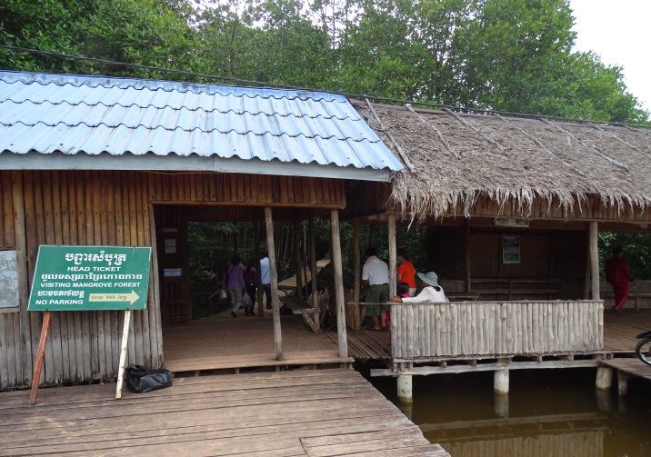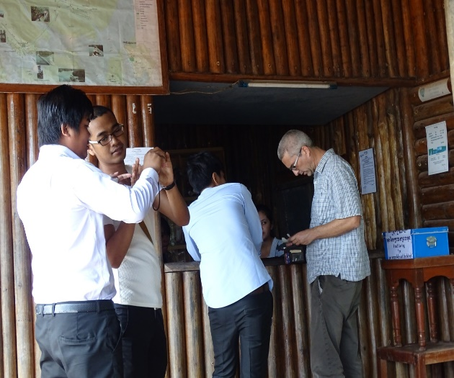
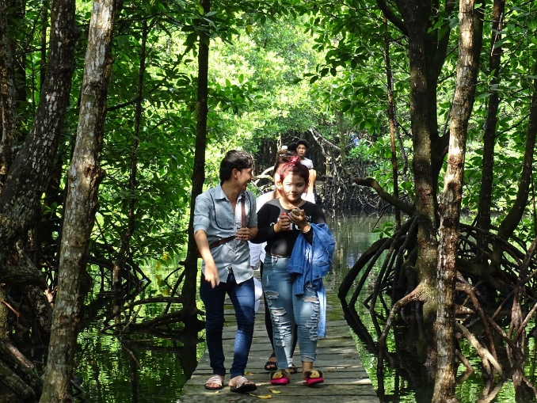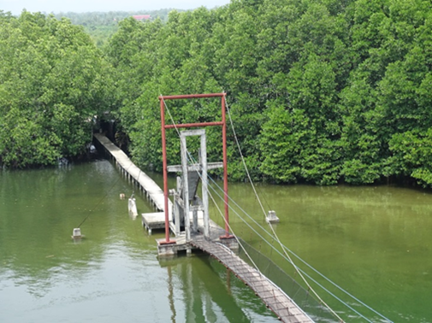
Above: Entrance and Ticket Office of the Peam Krasaop Community Mangrove Ecotourism site. Below: Mangrove Walkway and Bridge to the viewing tower.
The mangrove ecotourism initiative is both a model of co-management based on effective implementation of a community to government agreement (the CPA), It is also a working example showing the potential value of community-managed mangrove ecotourism.
The importance of the community ecotourism development is that it strongly supports the objectives of the Peam Krasaop CPA, as listed below:
The Objectives of the CPA
- To participate in the management and protection of coastal zone resources in Peam Krasaop Wildlife Sanctuary (PKWS) and its sustainable use for the present and future generations.
- To improve the natural resources in this area to maintain the natural balance.
- To take part in implementing policies of the Government on the Community-Based Natural Resources Protection and Conservation to contribute to the alleviation of community poverty.
- To strengthen cooperation among local people, local authorities, relevant institutions and local and international non-governmental organizations.
- To improve local communities' living conditions through ecotourism development.
Prior to the CPA, the economy of the two villages was dependent entirely on exploiting aquatic resources, mainly fishing and crab-trapping. The households were hesitant about joining the CPA at first, but as they saw the benefits being gained from the Mangrove Forest Ecotourism Site, everyone decided to become a CPA member, leading to a membership of more than 330 households.

The CPA agreement is supported by a list of permitted and prohibited uses of coastal natural resources, as listed in Table 1.
Community Mangrove Ecotourism Site
Practical activities of the CPA are conducted by different teams (e.g. a patrol team for mangrove protection, a sanitation team for cleaning, garbage removal and repairing the walkway). Each team is each under the direction of a team leader. For example, the sanitation team consists of eight people who were formerly jobless.
The team leaders, committee members and other CPA staff, are expected to meet every three months; community members meet twice per year and the minutes of the meetings are recorded.
The main infrastructure at the Mangrove Forest Ecotourism Site consists of an elevated walkway that runs for almost 700 metres through a natural Rhizophora mangrove forest; the walkway leads to a suspension bridge over a wide mangrove channel; and a tall viewing tower on the opposite side of the channel. There is also a ticket office at the site entrance, and several small shops, plus picnic and rest areas and small wooden chalets for day-use, near the bridge.

Visitors to the mangrove ecotourism site pay a small entrance fee approved by the provincial authorities (approximately USD 1.00 per person). The number of visitors to the ecotourism site is in the range 50,000 to 60,000 per year.
The ecotourism site has created employment for a sanitation team (for cleaning, garbage removal and repairing the walkway) of eight people who were formerly jobless.

The CPA fishermen work in small groups to provide boat trips for visitors. There are four groups, each with about 20 boats, and each group works at the ecotourism site for one week per month. They offer different boat tours all starting near the viewing tower, where the charges per boat are clearly displayed: A boat tour through the mangroves costs about USD 10. A high proportion of visitors to the ecotourism site also take a boat trip.

The boatmen work in turn and share the group’s income after their fuel costs are reimbursed and a small amount is paid into the community fund. Income from mangrove boat tours is highly seasonable according to the weather and is also variable on a day-by-day basis.

There is great variation in the overall number of visitors each day, which ranges from lows of 30-40 and 50-60 per day on weekdays and weekend days during the wet season; to 60-70 and 100-150 per day, respectively in the dry season. On certain holidays there can even be as many as 500 visitors.

There are stalls at the far end of the walkway where cooked food and snacks, seafood products, drinks, toys, souvenirs and general items like hats, sunglasses, raincoats and umbrellas are sold by women members of the CPA.

Benefits to the Community
Ticket sales for entry into the Mangrove Forest Ecotourism Site are more than USD 50,000 per annum and this income covers not only the site operating costs and the servicing of a bank loan for the investment in infrastructure, but also the cost of mangrove protection patrolling, as well as contributions to a community welfare fund. The additional on-site income from other expenditure by visitors (e.g. on food, drinks, souvenirs), is also significant and may reach USD 300,000 annually.

CPA members now earn at least one-third of their income from ecotourism activities. Ecotourism has created new income opportunities for women and well as for fishermen.

Moreover, the Peam Krasaop villagers now feel stronger as a community; they have more understanding of the socio-economic importance of mangroves; and the most vulnerable households are receiving assistance from a community fund supported by the visitor fees.
Through ecotourism the capacity of the CPA Committee members has increased and they have gained empowerment to cooperate and negotiate with government partners, and to make and influence decisions.

Ecotourism has also reduced fishing pressure to a modest degree, because the fishermen who provide boat trips for visitors no longer fish every day.

Table 1. Permitted and Prohibited Activities and Uses of Coastal Resources in Peam Krasaop.
Permitted activities and uses of coastal natural resources
- To serve the common benefits of the community with the approval from the community committee, environmental experts and local authorities;
- To support households such as house and bridge construction timber and scaffolds, which need to be permitted from the community committee and environmental experts;
- Timber to be used for fishing devices, firewood and medicinal purposes shall be allowed from the committee.
- Fishing activities, or the collection of fish within CPA, can be allowed with fishing gear considered legal.
- Aquaculture in CPA, including green mussel, fish, crab and shrimp farming cannot be allowed without permission from the community committee, local authority, Peam Krasoap Wildlife Sanctuary and Ministry of Environment.
Prohibited activities and uses of coastal natural resources
- The cutting of mangrove forests for commercial purposes;
- the clearance, encroachment and burning of mangrove forests within CPA;
- fishing activities by using illegal fishing devices such as machine push-nets, poison, all kinds of dynamite and small-mesh size fishing nets;
- Discharge liquid waste, fuel into the water;
- The use of crab traps with a size smaller than 6 cm mesh size;
- The use of crab fishing nets with a size smaller than 9 cm mesh size;
- Abandonment or maintenance of old broken fishing gear in the sea and channels;
- The discharge of solid waste, such as cans, bottles, old tires, plastic bags, rubber and all kinds of rubbish into the sea or channels
- The fishing of grouper and sea-bass fry with the size of less than 10cm;
- The catch and purchase and sale of small crabs with the number of 12 crabs/kg;
- Hunting or collection of wildlife within and outside the CPA by using all means;
- The establishment of charcoal kilns within or near CPA. They cannot be established unless permission is granted;
- The use of illegal fishing tools to collect fish;
- The fishing of dolphins, dugongs and all kinds of marine turtles;
- Complete sales, renting or family-scale distribution of CPA;
- Imports of all kinds of fish without the permission from General Department of Administration for Nature Conservation and Protection of the Ministry of Environment.

Annex 4: Potential Indicators for Monitoring Mangrove
Social-Ecological Systems
Potential Biological Indicators

Indicators | Positive trend |  | Negative trend
Mangrove forest tree species | - Multiple species forest (2-4 species) |  | - Mono species forest
Survival of planted mangroves | - 80% (good); 70% acceptable |  | - Less than 70%
Tree height and girth | - Measurable increase in height and/or girth |  | - Little or no increase
Natural regeneration | - Flowering and fruiting  - Increase in number of recruited seedlings/saplings |  | - No flowering and fruiting  - Little or no natural recruitment
Leaf colour and number | - Mainly green leaves, dense |  | - Mainly yellow/brown leaves, sparse
Leaf consumption by insects/crabs | - Moderate leaf consumption and leaf fall |  | - High leaf consumption and leaf fall
Intertidal fauna | - Molluscs present on tree stems and roots  - Numerous crab burrows  - Diverse species of fauna |  | - Molluscs rare or absent  - Crab burrows few or absent  - Low faunal species diversity
Fauna of mud flats and creeks | - Abundant prawns, crabs, fishes in fisher catches  - Diverse species present |  | - Low abundance of prawns, crabs, fishes in catches  - Low species diversity
Birdlife | - Abundant bird life  - Diverse bird species |  | - Few or no birds  - Low diversity of bird species
Mammals and reptiles | - Sightings or signs of mammals and reptiles  - Several species identified |  | - No sightings or signs of mammals or reptiles
Potential Physical Indicators

Indicators | Positive trend |  | Negative trend
Mangrove soil texture | - Muddy to muddy-sand texture  - Stable soil -no erosion |  | - Only sandy soil  - Soil loss by erosion/storms
Soil and water salinity | - Salinity ≤40 ppt  - Salinity stable over time |  | - Salinity >40 ppt  - Salinity increasing
Soil organic content | - Medium to high |  | - Low
Storm damage | - Little or no damage to mangrove trees |  | - Significant to severe damage to mangrove trees
Potential Social-Ecological Indicators

Mangrove forest degradation | - Little or no degradation from wood or fodder harvesting, livestock grazing | - Significant to severe degradation from wood or fodder harvesting, grazing
Indicators | Positive trend | Negative trend
Fishing methods | - Low or no use of illegal fishing gears | - Medium to high use of illegal fishing gears
Fishermen’s catches and income | - Catches and/or income are increasing | - Catches and/or income are low or decreasing
Mangrove-associated community livelihood activities | - Sources of livelihood other than fishing | - Livelihoods almost entirely dependent on fishing
Community engagement in mangrove rehabilitation/ conservation | - Community members, especially women, are involved in mangrove propagule collecting/ nurseries/planting  - Community is within a Ward and Watch system | - Little or no community involvement in mangrove rehabilitation activities  - No Watch and Ward system
Well-being of community members | - Quality of life indicators are good or improving (e.g. access to freshwater and health services) | - Quality of life indicators are poor or declining

Annex 5: Mangrove Stewardship Agreement
Mangroves Stewardship Agreement for The Protection, Conservation, Restoration and Sustainable Management of Planted Mangroves and Existing Forests, High Conservation Value Areas, Wildlife and Biodiversity in the Indus Delta Area, Sindh Province, Pakistan
This MANGROVE STEWARDSHIP AGREEMENT (hereinafter called the “MSA”) is made on the ______ day of the month of__________, between, on the one hand, the Delta Blue Carbon -1/ Sindh Forest Department, Government of Sindh/ (hereinafter called the “DBC-1/SFD”) and, on the other hand, Mr. _____________ CNIC No. ___________________of , of of District Thatta in Sindh Province, Pakistan (hereinafter called the “Mangrove Steward”).

WHEREAS

(a) The DBC-1/SFD has engaged the Mangrove Steward to provide certain services as defined in this MSA (hereinafter called the “Services”);

(b) The Mangrove Steward on his/her own behalf and on behalf of the community he/she is representing, having represented to the DBC-1/SFD that it has the required professional skills, and personnel and technical resources, has agreed to provide the Services on the terms and conditions set forth in this MSA.

NOW THEREFORE the parties hereto hereby agree as follows:

1. The following documents attached hereto shall be deemed to form an integral part of this MSA:
(a) The General and Special Conditions of MSA as given in Appendix-A;
2. The mutual rights and obligations of the DBC-1/SFD and the Mangrove Steward shall be as set forth in the MSA, in particular:
(a) the Mangrove Steward shall carry out the Services in accordance with the provisions of the MSA;
(b) the DBC-1/SFD shall make payments to the Mangrove Steward in accordance with the provisions of the MSA;
(c) Subject to subparagraph (d) hereunder, and notwithstanding any other provisions of this MSA, payments under this MSA shall not exceed ______________- in Pakistani Rupees, except as otherwise agreed between the DBC-1/SFD and the Mangrove Steward.
(d) The maximum amount specified in subparagraph (c) here above has been fixed on the understanding that the DBC-1/SFD will make payments to the Mangrove Steward on satisfactory performance of services by the Mangrove Steward and as verified by the relevant staff of DBC-1/SFD.
IN WITNESS WHEREOF, the Parties hereto have caused this MSA to be signed in their respective names as of the day and year first above written.

For and on behalf of DBC-1/SFD

Range Forest Officer Right Bank

APPENDIX-A
GENERAL AND SPECIAL CONDITIONS OF MSA
The SFD in partnership with the Indus Delta Capital (IDC) Limited is implementing the Delta Blue Carbon Project Phase-1 (DBC-1) for the duration of the project (February 2015 to February 2075) and is restoring wetland ecosystems (RWE) through afforestation, reforestation and re-vegetation of degraded wetland areas (ARR/RWE) in the DBC-1 Project Area as well as undertaking conservation of intact wetlands (CIW) in the DBC-1 Project Zone.
This MSA is executed with the said Mangrove Steward regarding the protection, conservation, restoration and sustainable management of planted mangroves, existing forests, high conservation value (HCV) areas, wildlife and terrestrial/coastal/marine biodiversity located in the jurisdiction of village in Taluka in District Thatta of Sindh Province as per map of the concerned planted area/existing forest/HCV area (Annexure-1) and over-all implementation of the Indus Delta Blue Carbon Project Phase-1 (DBC-1), Pakistan.
The SFD is the custodian of entire coastal wetland areas in the Indus Delta Area including degraded and restored wetlands, any forest produce as defined in the Forest Act, 1927 in its application to Sindh Province, and associated terrestrial, coastal and marine biodiversity and has responsibility for the implementation of Forest Act and DBC-1 Project, through Divisional Forest Officer Mr._______________, In-charge of Right Bank Forest Division in Thatta District an authority of the Government of Sindh having its office at Forest Campus, Jinnah Avenue, Model Colony, Karachi, Sindh; and
The Mangrove Steward has agreed to provide services to DBC-1/SFD regarding the protection, conservation, restoration and sustainable management of planted mangrove areas, existing mangrove forests, high conservation value areas, and terrestrial, coastal and marine biodiversity and providing community mobilization and organization-related assistance in the implementation of DBC-1 Project over an area of in the DBC-1 Project Area/Zone assigned to him/her under this MSA as per map given in Annexure-1.
The Parties wish to enter into this MSA in pursuit of protecting, conserving, restoring and sustainably managing natural and planted mangrove forests, conservation of HCVs, wildlife and biodiversity for different ecosystem services such as nature-based solutions to climate change mitigation and adaptation, biodiversity conservation, community and sustainable development and promotion of eco-tourism, etc. as given in the objectives of DBC-1 Project, and to that end they wish to establish the general and specific terms of their collaboration in this MSA.

A. PURPOSE
The purpose of this MSA is to establish a broad strategic framework and responsibilities for collaboration on behalf of the community that the Mangrove Steward is representing by and among the Parties for the long-term protection, conservation, restoration and sustainable management of both planted and existing mangrove forests, HCVs, wildlife, and biodiversity in Indus Delta Area, Sindh Province, Pakistan.
B. VISION
The Parties envision functioning mangrove forest ecosystems and wetland landscapes, restored across all portions of their range and extending over hectares on both existing natural and planted forests and landscapes and future anticipated forested and restored lands resulting from different restoration activities, with the scale, connectivity, structure, species composition, and other features that provide different ecosystem goods and services including provisioning services, regulating services, supporting services, and cultural, informational and recreational services, and sustain the livelihoods of local communities and other stakeholders dependent on these ecosystems, landscapes and biodiversity for their livelihoods.

C. GENERAL PROVISIONS
This MSA is signed between the Divisional Forest Officer Mr. ________ Forest Division, Sindh Forest Department & Community household member/representative of ____________ Community for the protection of mangroves, HCVs, wildlife, biodiversity, and various infrastructure and facilities of SFD over an area of_______ hectares in_ ____________ Creek System in the Indus Delta Area as per Map in Annexure-1.
Under this MSA, the community agrees to perform the above-mentioned services through its identified household member, hereinafter called Mangrove Steward, to SFD as per the following terms and conditions:
- This MSA shall come into force upon signing by both parties and shall be valid for five years from the date of signing.
- Under this MSA, SFD shall pay the remuneration of Pakistani Rs. _________per month paid through Acquaintance Roil/Form-32 duly signed by the Range Forest Officer and Divisional Forest Officer of Right Bank Forest Division as per the accounting procedure of SFD to the member/representative of community in his name duly acknowledged by him/her through signature or thumb impression. This payment/remuneration is primarily, given to create a watch and ward system of protecting mangroves from grazing, trampling and seed trapping and to create a sense of stewardship among local communities to reduce and subsequently, avoid use of mangrove wood for cooking and heating purposes.
D. SPECIFIC PROVISIONS
D.1. Roles and Responsibilities of SFD
D.1.1 SFD is responsible to engage a member of the household for watch and ward of designated planted areas through a consultative process with the help and cooperation of community heads etc.
D.1.2 SFD will prepare a map and give it to the Mangrove Steward and concerned community showing area and islands to be protected through a household member of the community (HHM)/Mangrove Steward to avoid duplication or overlapping.
D.1.3 SFD will be responsible for arranging monthly payment/remuneration from its allocated budget to continue receiving watch and ward services by the Mangrove Steward. In case of Non-payment of remuneration for three consecutive months, the HHM/Mangrove Steward would be authorized to terminate the agreement and receive his arrears through arbitration.
D.1.4 SFD will keep proper and transparent records of payment made for watch and ward system.
D.1.5 SFD shall organize field visits regularly through official team for monitoring and verification of the progress of watch and ward system on the ground. On satisfactory monitoring the payment will be disbursed to HHM/Mangrove Steward.
D.1.6 On unsatisfactory or poor performance by HHM/Mangrove Steward, the heads of community will be informed by SFD for immediate replacement to avoid further loss or damage to plantations, existing forests, HCVs, wildlife, biodiversity and assets and facilities of SFD.
D.1.7 SFD will also help facilitate the community to procure other services like education, health and hygiene from respective government departments.
D.2 Services to be provided by Mangrove Steward/HHM
D.2.1 Mangrove Steward/HHM will take all possible efforts and employ all his/her resources including household members, boats and other useful means to implement the Sindh Forest Act, Sindh Wildlife Act, Sindh Fisheries Laws and their supporting Rules, Regulations, Policies and Measures in the areas for which he/she has taken responsibility of protection. Specifically, he/she will be responsible for the controlling the following:
- Cutting of and otherwise damaging mangrove plants, grazing/pasturing of cattle, camels and other livestock in planted/regeneration areas, forest enclosures or other areas closed for grazing and pasturing of livestock;
- Felling, girdling, lopping, tapping or burning any trees, poles, bushes and shrubs, medicinal and aromatic plants, or strips off the propagules/fruit, flowers, bark, leaves form, uproots, or otherwise damages such vegetation;
- Extraction of medicinal and aromatic plants and other non-timber forest products;
- Damaging any natural re-generation, planted areas or existing mangrove and other vegetation;
- Quarrying of minerals, stones, sands, forest soil, or burning any lime or charcoal, or collecting, subjecting to any manufacturing process, or removal of any forest, wildlife or biodiversity produce as defined in the Sindh Forest Act, Sindh Wildlife Act, Non-Timber Forest Product Rules or other applicable laws, rules, regulations, policies or management plans;
- Clearing or breaking of land for aquaculture, cultivation or any other purpose;
- Setting of fire to forests, forest enclosures, regeneration areas, HCVs or protected areas or other wetland areas;
- Hunting, poaching or capturing any wildlife protected under the Sindh Wildlife Act;
- Illegal fishing, poisoning water, or using electric currents to capture fish;
- Establishing sale units for various mangrove vegetation products such as propagules, twigs, branches, leaves, etc.;
- Removing fencing or other assets and materials of SFD;
- Damaging departmental buildings and other assets; and
- Any other act prohibited by SFD in the area.
D.2.2 Help SFD in and play a role in and contribute to the implementation of mangroves and wetlands conservation strategy and program of action by SFD.
D.2.3 Provide timely information to SFD about any illegal activity or activity that is harmful and results in damages to planted areas, forested areas, HCVs areas, wildlife, biodiversity, and other assets and facilities of SFD, which are beyond his/her control for stopping.
D.2.4 The Mangrove Steward and his/her community will help in restocking and other required interventions in the areas for which he/she has taken responsibility.
D.2.5 The Mangrove Steward and his/her community will help SFD and DCB-1 Project team in conflict resolution on all such matters related to planting and protection of mangroves, HCVs, wildlife, biodiversity and other facilities and assets in the area.
D.2.6 The Steward and his/her community will perform their duties and responsibilities and provide the agreed services to the satisfaction of SFD to be eligible for receiving payment/ remuneration for their services under this MSA.
D.2.7 The Mangrove Steward will submit his/her progress about the provision of his/her services under this MSA on regular basis to the concerned forest officer as decided by the supervisory/controlling forest officer.
E. FORCE MAJEURE
E.1 Neither party to this MSA shall be liable for failure or delay in the performance of its obligations under this MSA due to reasons and causes beyond its control including but not limited to strikes, wars, revolutions, fires, floods, explosions, terrorist attack, earthquakes, withdrawal of fund/grant/loan, or governmental regulation.
F. MODIFICATIONS.
This MSA will be reviewed on need basis and modified as necessary by mutual agreement of the Parties to ensure the continued protection conservation, restoration and sustainable management of planted mangrove areas, existing forests, HCVs, wildlife and biodiversity including endemic, rare, vulnerable, threatened and sensitive species dependent on these forests and landscapes, and sustainable livelihoods of local communities.
- DISPUTE AND DISSOLUTION OF AGREEMENT
F.1 SFD shall have the right to terminate this MSA by serving 15 days written notice if the Mangrove Steward/HHM breaches any obligations set forth in this MSA.
F.2 In case, SFD serves a notice of cancellation of MSA and termination of watch and ward system, the Mangrove Steward/HHM shall be paid for the time he/she served prior to service of notice Similarly, if the Steward/HHM declines to provide future watch and ward services due to any reason, he/she will intimate 15 days prior to suspension of services provision.
F.3 Any dispute or conflict arising out of this MSA shall be resolved through mutual discussion and arbitration by the Chief Conservator of Forests and respective Community Head (s). A decision taken by both parties shall be the final and binding on both parties to this MSA.

ANNEXURE-1
MAP OF MANGROVE STEWARDSHIP AGREEMENT AREA

Co-management
Mangrove protection is the primary responsibility of the Sindh and Balochistan Forest Departments. However, they do not necessarily have sufficient staff or the financial resources to do this in an effective way, especially where there are travel difficulties involved to reach the more remote mangrove areas. The solution is to involve the households whose livelihoods depends on the use of mangrove resources and develop in them a shared sense of ownership with the Forest Departments to ensure that sustainable use of mangrove resources and effective mangrove protection can be achieved.
This can be realized through co-management, which is a form of shared governance over natural resources. Mangrove co-management has the aim of achieving sustainable use of mangrove resources for the benefit of the local communities, while at the same time maintaining the protection functions of the mangrove forest.
Definition and Application of Co-management
Co-management, or shared governance is a type of management/governance in which decision-making power, responsibility and accountability are shared between governmental agencies and other stakeholders, in particular the indigenous peoples and local communities, who depend on the natural resources culturally and/or for their livelihoods (Borrini-Feyerabend, et al., 2013).
Management is about what to do, whereas Governance is about who decides what to do. The principle of co-management is “shared governance” (also termed “collaborative governance”). That is, it involves joint decision-making about what to do.
Co-management in the context of mangrove ecosystem protection and sustainable use of mangrove natural resources is a partnership agreement in which a resource user group receives the right to sustainably use natural resources within a defined area of Protected Forest while being responsible for the sustainable management and protection of its resources. All stakeholders share the responsibility and authority for the management of a given area and a defined set of natural resources. Resource users and local authorities jointly negotiate a formal agreement on their respective management roles, responsibilities and rights.
Awareness raising about environmental issues, as well as clear and effective communication between stakeholders, are important prerequisites for the successful implementation of co-management activities. Under a co-management agreement, mangrove protection and sustainable resources use must also be monitored to ensure compliance. If compliance issues, are identified from monitoring, then adjustments to the responsibilities and accountability of the co-management partners may be necessary via adaptive management.
In summary: co-management is achieved through a process of negotiation where representatives of government, communities and other stakeholders (e.g. an NGO/CBO) meet, exchange views, find an accord about aims and solutions and develop a formal co-management agreement about sharing decision-making authority, responsibilities and accountability regarding a specified mangrove area and its natural resources.

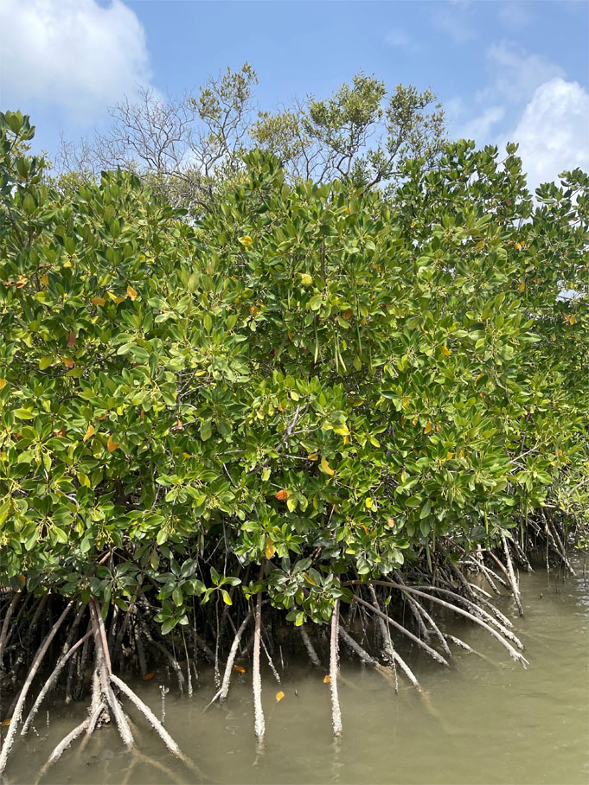
Project Management Unit
3rd Party M&E Consortium of IUCN,
FAO & WWF
70-A, Main Nazimuddin Road
F-7/4, Islamabad, Pakistan
Tel +92 (51) 2656991-97
Fax +92 (51) 2656998

Duke, N.C. and Lee, S.Y. (2024) have listed 68 true mangrove species, 12 hybrids and four subspecies.
Vulnerability is defined by IPCC (2007) as: “…the degree to which a system is susceptible to, and unable to cope with, adverse effects of climate change, including climate variability and extremes.”
https://dx.doi.org/10.2305/IUCN.UK.2010-2.RLTS.T178803A7610926.en
www.mangrovesforthefuture.org/grants/small-grant-facilities
Ecotourism is defined as responsible travel to natural areas that conserves the environment and sustains the well-being of local communities by prioritising conservation and sustainability.
Mission of the Ramsar Convention: “Conservation and wise use of all wetlands through local and national actions and international cooperation, as a contribution towards achieving sustainable development throughout the world.”

